Submission type: competitive paper

Title: Good or bad, we want it now: Resolution theory explains magnitude reversal in intertemporal choice

Primary contact info: David Hardisty
Stanford University
Graduate School of Business
655 Knight Way
Stanford, CA 94043
Phone: 650-498-4497
Email: dhardisty@stanford.edu

Names of co-authors: Kirstin C. Appelt (Columbia University), and Elke U. Weber (Columbia University), not presenting authors

Content area codes: Preference and choice, economic psychology, cognition, judgment and decision making, public policy / social issues

Methodological area codes: Experimental design, content analysis

Keywords (optional): Intertemporal choice, framing

Declaration: This submission has not been accepted for publication elsewhere.

Signed copyright release form:

Good or bad, we want it now: Resolution theory explains magnitude reversal in intertemporal choice

Across four studies, outcome magnitude has opposite effects on intertemporal choice for gains and losses: consumers discount small gains more than large gains, but discount small losses less than large losses. Thought listings show that this is mediated by consumers' desire to resolve gains and losses as soon as possible.

Consumers often discount future consequences, for multiple reasons (Lynch and Zauberman 2006). The "magnitude effect" describes the fact that large gains are discounted more than small gains (Chapman and Elstein 1995; Estle et al. 2006; Thaler 1981). For example, someone might choose $10 today versus $11 in a year, yet prefer to wait for $11,000 in a year rather than take an immediate $10,000, even though in both cases the later amount is 10% larger than the sooner amount. In these earlier studies, the choice options always paired a smaller, sooner amount with a larger, later amount, so it was impossible for participants to express zero or negative discount rates. Thus, although some people might rather pay $10 immediately rather than $9 in a year (to get the loss over with), this preference could never be expressed. A pilot study we ran suggests that when negative discount rates are allowed, losses may show a reverse magnitude effect: Consumers considering small losses were indifferent between paying $10 today and $9.70 in six months (a -6% discount rate), whereas those considering large losses were indifferent between paying $1,000 today and $1,070 in six months (a 13% discount rate).
Although several models have been proposed to explain the magnitude effect (al-Nowaihi and Dhami 2009; Benhabib, Bisin, and Schotter 2010; Loewenstein and Prelec 1992; Scholten and Read 2010), none predict the interaction of magnitude and sign. To fill this gap, we propose resolution theory: Consumers have a psychological desire to resolve both gains and losses immediately, and this desire is combined with multiple other factors (such as uncertainty, see Table 1) to ultimately predict time preference. In the case of gains, people want the gain immediately to satisfy their desire for positive outcomes and to avoid feelings of deprivation while waiting (Hoch and Loewenstein 1991). When combined with other factors, which also favor the immediate gain, the resulting discount rate is high. In the case of losses, people want to get the loss over with immediately to close their mental books on the loss and avoid having to allocate attention and emotional capacity (e.g., dread) to looming future losses (Harris 2010; Loewenstein 1987). When balanced against other factors, which instead favor the delayed loss, the resulting discount rate is low. In both cases, the desire to resolve gains and losses is relatively insensitive to magnitude; it is a constant that is added to other attractions of the immediate reward (an assumption supported by Benhabib et al., 2010, for the domain of gains), rather than a parameter that multiplies the immediate reward’s utility.
Importantly, resolution theory makes the prediction that negative discounting of losses will occur when amounts are small enough, because the cost of waiting is a constant that is added to the disutility of the larger later loss. Negative discounting implies that outcome values intensify (i.e., positives become more positive and negatives become more negative) the further they lie in the future; in the case of losses, negative discounting means a preference to have losses sooner rather than later. For example, some people might rather pay $10 immediately rather than $9 in a year, to satisfy their desire to get the loss over with. In this case, a full reversal of the magnitude effect when comparing small and large losses is understandable.

Table 1. Summary of major factors hypothesized to determine intertemporal choices for gains and losses.
Motivational Factor | Description | Makes people prefer to have… | Scales with magnitude?
Opportunity cost and investment  (Franklin 1748; Samuelson 1937) | Resources can be invested and earn interest or otherwise grow over time | Gains now and losses later | Yes
Uncertainty  (Patak and Reynolds 2007; Takahashi, Ikeda, and Hasegawa 2007) | Delayed gains and losses may never be realized | Gains now and losses later | Yes
Resource slack  (Zauberman and Lynch 2005) | Expecting to have more resources in the future means that immediate resources are more dear than future resources | Gains now and losses later | Yes
Resolution  (Benhabib et al. 2010; Harris 2010; Loewenstein 1987; O'Donoghue and Rabin 1999) | Psychological desire to resolve events immediately | Both gains and losses now | No
Other factors, such as social norms and ideals  (Krantz and Kunreuther 2007) | Variable, but often suggest that individuals ought to delay gratification | Variable, but often postponing gains and attending to losses immediately | Variable

Method
In four separates studies (total N = 856), participants made a series of choices between immediate and future gains and losses of different amounts. Three of these studies were run online with national samples and hypothetical outcomes, and one study was run in the lab with a student sample and real intertemporal gains and losses (in the range of $5 to $100). In two studies participants used an established type-aloud protocol (Hardisty, Johnson, and Weber 2010; Weber et al. 2007) to record their thoughts before making their decisions. Participants subsequently categorized their own previously recorded thoughts according to the factors listed in Table 1.
Results
In all four studies, participants discounted small gains more than large gains, replicating the magnitude effect, and discounted small losses less than large losses, reliably establishing the reverse effect of magnitude on losses (see Figures 1 - 4). Zero and negative discount rates were quite common when considering small losses; 78% of participants expressed this preference. In contrast, only 23% of those considering large losses, 2% of those considering small gains, and 2% of those considering large gains showed zero or negative discount rates.
Prior to making their choices, participants listed an average of 3.4 thoughts. As predicted by Resolution Theory, the proportion of resolution thoughts was significantly lower for large magnitude outcomes than for small magnitude outcomes. In other words, when participants considered $10, they frequently mentioned their psychological desire to resolve the situation as soon as possible, whereas when participants considered $10,000, other concerns were more prominent. Also as predicted, the proportion of resolution thoughts mediated the effect of magnitude on discount rates for gains and losses.

Figure 1. Mean discount rates (k) for hypothetical gains and losses of different sizes, in Study 1. Error bars show +/- one standard error.
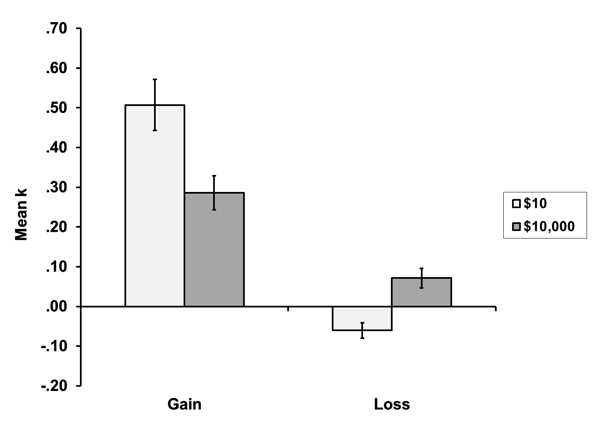
Figure 2. Mean discount rates (k) for hypothetical gains and losses of different sizes, in Study 2. Error bars show +/- one standard error.
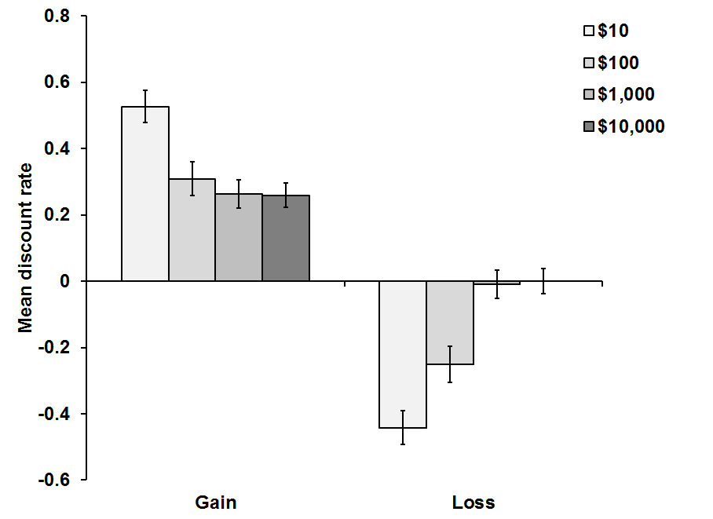
Figure 3. Mean discount rates (k) for hypothetical gains and losses of different sizes, in Study 3. Error bars show +/- one standard error.
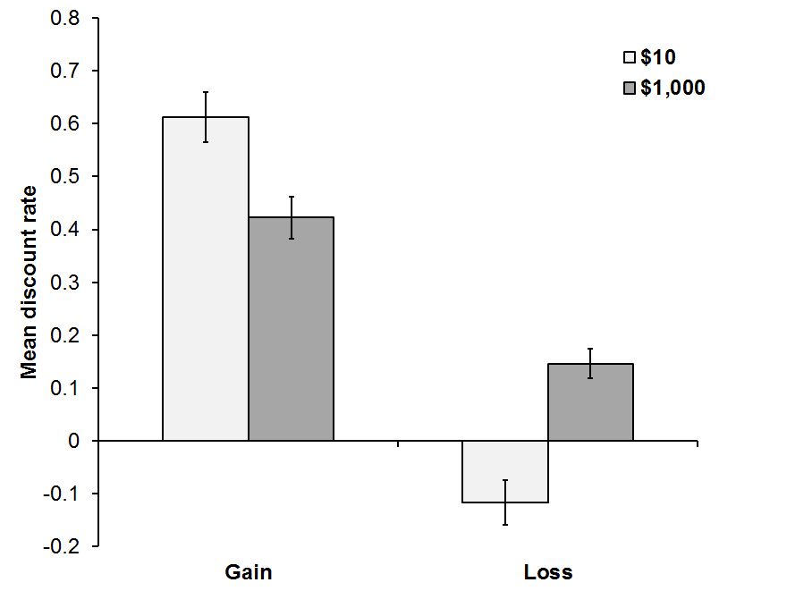
Figure 4. Mean discount rates (k) for real gains and losses of different sizes, in Study 4. Error bars show +/- one standard error.
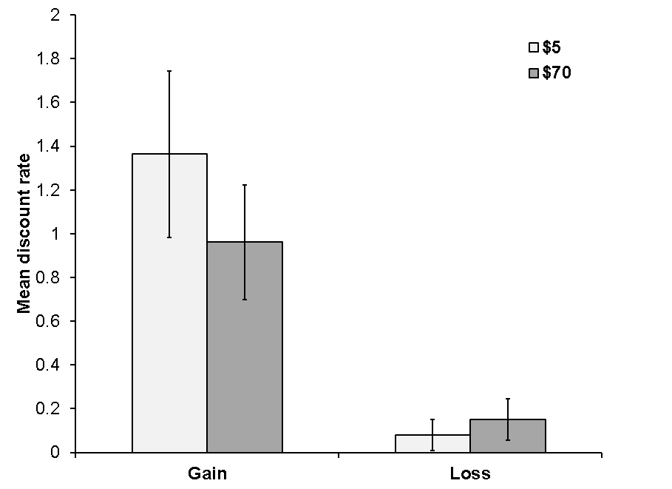

Discussion
Our findings may offer some guidance to policy-makers hoping to encourage future-oriented decision making (i.e., low discount rates). As suggested by both previous research and the present findings, patience for gains may be encouraged by focusing on large magnitude outcomes. For example, an individual may be encouraged to save for retirement if the benefits of saving are aggregated over ten years of savings, rather than one year or one month. As the present research shows, however, the same strategy should not be applied to losses; consumers are motivated to take care of small losses immediately, but large losses are likely to be postponed until later. Therefore, a strategy of aggregating credit card debt or other debt into one large lump sum may be counterproductive, and lead consumers to delay paying off the large debt. Rather, breaking the problem down into smaller pieces that can be taken care of immediately should be more effective. Consumers will often choose to get losses over with immediately, but only if they are small and manageable.

References
al-Nowaihi, A. and S. Dhami (2009), "A Value Function That Explains the Magnitude and Sign Effects," Economic Letters, 105, 224-29.
Benhabib, J., A. Bisin, and A. Schotter (2010), "Present-Bias, Quasi-Hyperbolic Discounting, and Fixed Costs," Games and economic behavior, 69 (2), 205-23.
Chapman, Gretchen B. and A. S. Elstein (1995), "Valuing the Future: Discounting Health and Money," Medical Decision Making, 15, 373-86.
Estle, S. J., L. Green, J. Myerson, and D. D. Holt (2006), "Differential Effects of Amount on Temporal and Probability Discounting of Gains and Losses," Memory & Cognition, 34, 914-28.
Franklin, Benjamin (1748), "Advice to a Young Tradesman."
Hardisty, D. J., E. J. Johnson, and E. U. Weber (2010), "A Dirty Word or a Dirty World? Attribute Framing, Political Affiliation, and Query Theory," Psychological Science, 21 (1), 86-92.
Harris, Christine R. (2010), "Feelings of Dread and Intertemporal Choice," Journal of Behavioral Decision Making.
Hoch, Stephen J. and George Loewenstein (1991), "Time-Inconsistent Preferences and Consumer Self-Control," Journal of Consumer Research, 17 (4), 492-507.
Krantz, David H. and Howard C. Kunreuther (2007), "Goals and Plans in Decision Making," Judgment and Decision Making, 2, 137-68.
Loewenstein, George (1987), "Anticipation and the Valuation of Delayed Consumption," Economic Journal, 97, 666-84.
Loewenstein, George and Drazen Prelec (1992), "Anomalies in Intertemporal Choice: Evidence and Interpretation," The Quarterly Journal of Economics, 107 (2), 573-97.
Lynch, J. G. and G. Zauberman (2006), "When Do You Want It? Time, Decisions, and Public Policy," Journal of Public Policy & Marketing, 25 (1), 67-78.
O'Donoghue, Ted and M. Rabin (1999), "Doing It Now or Later," American Economic Review, 89, 103-24.
Patak, M. and B. Reynolds (2007), "Question-Based Assessments of Delay Discounting: Do Respondents Spontaneously Incorporate Uncertainty into Their Valuations for Delayed Rewards?," Addictive Behaviors, 32, 351-57.
Samuelson, P (1937), "A Note on Measurement of Utility," Review of Economic Studies, 4, 155-61.
Scholten, M. and Daniel Read (2010), "The Psychology of Intertemporal Tradeoffs," Psychological Review, 117 (3), 925-44.
Takahashi, T., Koki Ikeda, and Toshikazu Hasegawa (2007), "A Hyperbolic Decay of Subjective Probability of Obtaining Delayed Rewards," Behavioral and Brain Functions, 3, 52.
Thaler, Richard (1981), "Some Empirical Evidence on Dynamic Inconsistency," Economics Letters, 8, 201-07.
Weber, E. U., E. J. Johnson, K. F. Milch, H. Chang, J. C. Brodscholl, and D. G. Goldstein (2007), "Asymmetric Discounting in Intertemporal Choice," Psychological Science, 18 (6), 516-23.
Zauberman, G. and J. J. G. Lynch (2005), "Resource Slack and Propensity to Discount Delayed Investments of Time Versus Money," Journal of Experimental Psychology: General, 134 (1), 23-37.

