Precommitment as a Nudge
Supplemental Studies and Materials

This document has several sections. The first part has three supplemental studies, S1-S3. The second part has details for the thought coding process and analyses used in main manuscript Study 1. The third part has the complete experimental materials used in all studies.

Contents
Study S1: Separated vs Aggregated Displays and Gains vs Losses 2
Study S2: Probability levels 7
Study S3: Alternate manipulation of planning & changing the EV 11
Code book definitions used in Study 1 17
Coding category reliability ratings in Study 1 22
Study 1 - Think-Aloud Study: Materials 25
Study 2 - Probability Education: Materials 36
Study 3 – Number of Rounds: Materials 47
Study 4 - Non-Binding Precommitment: Materials 68
Study 5 – Process Study: Materials 84
Study 6 – Social Dilemma Study: Materials 99
Study S1 - Gain Loss: Study Materials 122
Study S2 - Probability levels: Study Materials 134
Study S3 - Time-horizon manipulation: Study Materials 137

Study S1: Separated vs Aggregated Displays and Gains vs Losses

In this study, we rule out a confound that is present in other studies. Typically, the repeated and precommited conditions display the choices in different ways, with only one choice visible in the repeated condition, and 20 choices visible at once in the precommitted condition. Therefore, in this study we tested whether this display confound was important. We systematically varied the display of the choices to be separated or aggregated, fully crossing this with repeated versus precommitted choice.
We also investigated a second novel variation in this study: gains versus losses. All of the other studies in this project investigate the effect of precommitment in the “loss” domain. It is illuminating to investigate the effects in the “gain” domain, as well. If the payment structured is mirrored (i.e., take a sure gain of +1,400 Rp, or a 4% chance of +40,000 Rp), the impact of precommitment on risk preferences may be eliminated or even reversed for gains. We explore this possibility in Study S1.
Finally, in this study we measured self-report of probability perceptions at the beginning of every block, as a test of H3.
Study S1: Methods
355 participants (63.7% female, M_{age} = 23.50) were recruited from student pools at two large North American universities. Participants played a game with incentive compatible outcomes. Participants were randomly assigned one condition in a 2 (choice structure: precommited versus repeated) by 2 (choice display: separate versus aggregate) by 2 (scenario domain: loss versus gain) between-participants design.
Scenario Domain
The procedure was same as Study 1 with slight changes to the scenario so that the same cover story could be used for both the gain domain and the loss domain. We adjusted the base endowment in the gain condition (down from 8,500 Rp to 5,500 Rp) so that the expected payout in the gain and loss conditions would the same (given a 50% choice proportion). The numeric amounts in the payoff matrix were mirrored between gain and loss, thus the expected values were mirrored: in the loss condition, the EV maximizing choice was to choose the certain loss, but in the gain condition, the EV maximizing choice was to choose the risky gain.
Choice display
We varied the display of the choices such that in the separate display conditions, participants saw one choice at a time, regardless of whether they were precommitting their choices or not, whereas in the aggregate display conditions, all the choices were displayed to the participants, but they either precommitted their choices or did one choice at a time, depending on the choice condition to which they had been assigned. For example, participants in the separate/precommitted choice condition saw the choices one at a time, but did not receive feedback until they precommitted all 20 choices. On the other hand, participants in the aggregate/repeated choice saw a table of all 20 choice options but made their choices one at a time and received feedback right after the choice, and then they made the next choice on the same table (where they could see both past and future choices, which were grayed out so that only the current round could be chosen). Note that feedback format was identical across conditions (as in previous studies): all participants saw both round-by-round feedback and a summary table at the end of each block. At the end, the participants responded to a few demographic questions.
Study S1: Results
The main effect of choice display (separated vs aggregated) was not significant F(1,166) = .30 , p = .59, nor did it interact with any other factor F(1,166) = .39, p = .54, therefore we collapse across choice display in the analyses to follow. A 2 (choice structure) by 2 (domain) by 4 repeated (blocks) ANOVA with investment proportion in each block as the DV found a main effect of precommitment on investment rates (M_{rep} = .51 vs M_{pre} = .59, F(1,348)= 6.49 , p = .01), as seen in Figure S1. Also, there was a significant main effect of the scenario domain such that participants in the gain scenario invested more than those in the loss scenario (M_{loss} = .44 vs. M_{gain} = .67, F(1,348)= 50.83, p < .001). More interesting is the interaction of scenario domain and choice structure F(1,348) = 16.72 , p<.001. As seen in Figure S1, while precommitment increases investment rates in the loss domain (M_{rep} = .33 vs. M_{pre} = .55, t(170)= 4.85, p<.001), this effect is directionally reversed in the gain domain (M_{pre} = .64 vs. M_{rep} = .70, t(181)= -1.15, p = .25). Looking at the same interaction from another angle, we can compare the effect of domain as a function of choice structure. Looking at the repeated condition only, we see that participants chose the safe option much more often in the gain condition (M_{gain} = .33) than the loss condition (M_{loss} = .70, t(181)=8.01, p<.001). In the precommitted condition, participants chose the safe option a bit more often in the gain condition (M_{gain} = .64) than the loss condition (M_{loss} = .55, t(170)=2.13, p=.04), but the effect size is much smaller.
Figure S1: Mean proportion choosing the certain (no-risk) option in precommited versus repeated conditions and loss vs gain conditions in Study S1. Error bars show +/- 1 SE.

Study S1: Subjective probability results
At the beginning of each block and before participants made their decisions, they were asked: “How worried [hopeful] are you that the large loss [gain] would occur? Slider or a 1-10 horizontal multiple choice with labels. 0=not at all to 10=extremely)” and “How likely do you feel it is that the large loss [gain] occurs? Slider or a 1-10 horizontal multiple choice with labels. 0=not at all to 10=extremely)”. These were intended to explore the effect of precommitment on subjective probability of the big loss happening in participants’ minds.
Two (choice structure: Repeated vs. Precommitment) by four (blocks) repeated measures ANOVAs revealed no significant effect for either worry (F(1,350)= .05, p= .83) or likelihood (F(1,350)= .59, p= .44).
Study S1: Discussion
The effect of precommitment was replicated such that individuals who precommitted their decisions chose the safer option more often than those who made their choices round-by-round. However, this effect was eliminated and even slightly reversed for individuals considering risky gains, rather than risky losses. In other words, while precommitment makes risky losses (with lower expected value) less attractive, it has no effect on risky gains (of higher expected value), or perhaps makes them slightly more attractive.
The observed pattern of results may be interpreted in a number of different ways. We have argued that precommitment leads to a focus on cumulative outcomes. However, it is not clear whether people want to maximize the expected value of their cumulative payout, or satisfice and seek some acceptable threshold, or a combination. Likely, some individuals are seeking to maximize, and others are seeking to satisfice and play it safe with their cumulative payout. In the loss domain, both of those goals lead to safer choices, because the safer choices is also better in expected value. However, in the gain domain, the safer choice is lower expected value. Therefore, maximizing and satisficing goals may cancel each other out (either across people, or as conflicting motives within the same person), leading to the observed null result.
Another angle when looking at the interaction is to look at differences in the effect of gain versus loss domain, as a function of choice structure. Perhaps the impact of gain versus losses is bigger in repeated choice than in precommitted choice. For example, when making decisions one by one, the decision may be in a more heuristic, system 1 mindset, and be more subject to reference points and domain effects, but when precommitting, the person may be in a more cognitive, system 2 mindset, and be less influenced by reference points and domain effects.
Study S1 also addressed a confound and ruled out a possible alternative explanation: the display format. We found it is not the way individuals “see” the choices (each on a separate page or all on one page) that matters, rather it is the way they “make” the choices (one at a time or all at once) that drives differences in risk preference.
Finally, Study S1 found no evidence that precommitment influences subjective probability perceptions, consistent with H3.

Study S2: Probability levels
While other studies have focused on low probability events (4%), it is also interesting to explore the effect of precommitment for higher probability losses. Therefore, in Study S2 we compared 4% chance of loss to 20% chance of loss and 50% chance of loss, adjusting the size of the loss accordingly to maintain expected value.
We have hypothesized that participants in the repeated condition typically have a narrowly bracketed focus on doing well in the next round. When the chance of loss is only 4%, people will most often come out better if they take the risk. However, when the risk is 50%, the risky option is equally likely to turn out better or worse, thus it should be less attractive, and people should invest in the safe option more often. Furthermore, as in other studies, the EV of the sure loss is slightly better than the risky loss. When the chance of loss is 50%, the EV is easier to calculate, which may also drive people towards the safe choice in this context.
The effect of high probability risk on the precommitment effect is difficult to predict, but overall (and according to H1), we generally expect precommitment to lead to more planning, an increased focus on cumulative outcomes, and therefore to safer and smarter choices. However, if the base rate of safe behavior is already high in the 50% condition, this could introduce a ceiling effect. We investigate these possibilities in Study S2.
Study S2: Participants and methods
421 participants (43.5% female, M_{age} = 35) were recruited via Amazon’s Mechanical Turk. Six participants did not finish the game and were excluded from data analysis. Participants played the same scenario as the loss-framed solo game in study 1 with a 2 (choice structure: Precommitted versus Repeated) by 3 (Probability of the big loss: 4% versus 20% versus 50%) between-subjects design. The amount of the large loss was adjusted between conditions (to be 40,000, 8,000, or 3,200) to keep the expected value constant. All choices were hypothetical; participants were compensated a flat amount for participating. After making their choices, participants completed demographic measures.
Study S2: Results
A 2 (choice structure:repeated vs precommited) by 3 (probability of large loss: .04 vs .20 vs .50) by 4 (question block: 1-4) repeated-measures ANOVA with proportion of safe choices as the DV revealed main effects of choice structure and probability, and an interaction, as seen in Figures S2a and S2b.
Participants who precommited their choices chose the safer option (M_{pre} = .57) more often than those who made their choices round-by-round (M_{rep} = .48), F(1,409)= 7.25, p<.01. Also, as the probability of big loss increased, participants chose the safer option more often F(2,409)= 14.32, p<.001. More specifically and as illustrated in Figure S2a, post-hoc tests revealed that those in the 50% condition invested more (M_{50%} = .63) than those in the 20% (M_{20%} = .53, p= .01) and 4% conditions (M_{4%} = .42, p<.001). Process Model 1 analysis revealed a marginal two-way interaction (B= -.07, SE= .04, p = .09). We conducted follow-up tests of choice structure effect at different levels of probability. At 4% level, precommiting choices had a significant positive effect on investment in the safer option (B= .16, p<.01, 95% CI= [.06, .26]). At 20% level the precommitment effect became weaker but was still significant (B= .09, p<.01, 95% CI= [.03, .16]). At 50% level, however, the precommitment effect became insignificant (B= .02, p = .64, 95% CI= [-.08, .12]. This reduction in the effect of precommitment can be seen in Figure S2a.
Figure S2a: Mean investment proportion in the safer option for precommitted versus repeated choices across varying probabilities of the big loss in Study S2. Error bars show +/- 1 SE.

The main effect of question block F(2.64,1080.49)= 1.51, p= .22 as well as its two-way interaction with the probability factor F(5.28,1080.49)= 1.29, p= .26 were not significant. But the two-way interaction of blocks with choice structure factor (F(2.64,1080.49)= 3.04, p= .03) was significant, as seen in Figure S2b, showing that the effect of precommitment became weaker in later choice blocks.
Furthermore, the three-way interaction of block, precommitment, and probability level was significant (F(5.28,1080.49)=2.33, p= .04), as seen in Table S2. The three-way interaction indicates that the effect of precommitment over blocks remained strong in the 4% condition, but the effect of precommitment grew weaker over time in the 20% and 50% conditions.
As discussed in the main manuscript, these order effect interactions are not reliable across studies and do not bear on our key hypotheses, so we do not dwell on them further.

Figure S2b: Investment proportion in the safer option for varying probabilities of the big loss across 4 blocks of playing the game in Study S2b. Error bars show +/- 1 SE.

Table S2. Proportion of safe choices in all conditions in Study S2, illustrating the 3-way interaction between blocks, probabilities, and choice structure.
Choice structure | Blocks | Prob: 4-96 |  | Prob: 20-80 |  | Prob: 50-50
 |  | Mean | SE | Mean | SE | Mean | SE
Repeated | 1 | 0.34 | 0.04 | 0.49 | 0.04 | 0.58 | 0.04
 | 2 | 0.35 | 0.05 | 0.49 | 0.05 | 0.61 | 0.04
 | 3 | 0.32 | 0.05 | 0.50 | 0.05 | 0.61 | 0.04
 | 4 | 0.31 | 0.05 | 0.49 | 0.05 | 0.65 | 0.04
Precommited | 1 | 0.50 | 0.04 | 0.64 | 0.04 | 0.69 | 0.04
 | 2 | 0.52 | 0.04 | 0.51 | 0.05 | 0.63 | 0.05
 | 3 | 0.50 | 0.04 | 0.53 | 0.05 | 0.67 | 0.05
 | 4 | 0.49 | 0.04 | 0.56 | 0.05 | 0.60 | 0.05

Study S2: Discussion
Individuals chose the safer option more often when the probability of the large loss increased (and the amount of the loss decreased accordingly). We speculate that this happens because, as the risk gets higher, the risky option becomes less likely to yield a superior outcome in a single play, thus those in the repeated condition choose it less often. Furthermore, especially in the 50% condition, the EV is easier to calculate, which may lead people to the safe option, which has superior EV.
When the probability of the large loss is high (i.e., 50%), precommitment does not have a significant effect, though it still trends towards safer behavior. This is seemingly inconsistent with H1. It may be that when the safe option is already somewhat attractive in narrowly bracketed, individual choices, using precommitment to promote broad bracketing has little effect.

Study S3: Alternate manipulation of planning & changing the EV

The purpose of study S3 is twofold. First, it provides process evidence for the theory that an increase in planning and an increased focus on cumulative outcomes leads to safer behavior, and that this process underpins the precommitment effect (H2). We manipulate the planning and consideration of multiple outcomes by prompting the participants to think about all the 20 rounds of the game, and what would serve them best overall. We expect this manipulation to increase the proportion of safe choices, even when participants make their decisions round-by-round. Furthermore, this planning prompt should have no effect in the precommitment condition, as precommitting participants should already be planning ahead and considering broad outcomes.
Second, this study examines the pattern of effects when the risky loss has an advantage in expected value. In all the previous studies, the certain loss had an advantage over the risky loss (fixed cost of 1,400 versus 4% chance of paying 40,000 which translates into an expected cost of 1,600). In the current study, we investigate the effect of precommitment and the effect of the planning prompts in a situation where the risky choice has a slightly better expected value (4% chance of paying 30,000 which translates into an expected cost of 1,200). This sheds light on the question of whether precommitment leads to “safer” choices, “profit maximizing” choices, or some combination.
Study S3: Methods
567 participants (53.2% female, Mage = 32.8) were recruited from Prolific Academic participant pool in exchange for a fixed monetary compensation. Participants played the same game as in previous studies in a 2 (choice structure: precommitted versus repeated) by 2 (Planning: Control versus Planning: Prompted) design by 2 (choice advantage: Safe versus Risky).
Choice advantage
The procedure was same as previous studies, but with changes to the big loss amount to manipulate the expected value of the risky choice. We adjusted the big loss in the “risky choice advantage” condition (down from 40,000 Rp to 30,000 Rp) so that the expected value in the risky choice improves from -1,600 Rp to -1,200 Rp. The expected payout of the safe option was the same as before at -1,400 Rp, in both conditions. In the “risky choice advantage” condition, the EV maximizing choice was to choose the risky choice, but in the “safe choice advantage” condition, the EV maximizing choice was to choose the safe choice.
Planning prompt
We manipulated the planning and outcome focus of the participants by urging them to think about all 20 rounds of the game, and what would serve them best. The participants were asked two questions: “Before you start, think about all 20 rounds that you are about to play. What strategy do you think would serve you best across all 20 rounds?” and “How many out of the 20 rounds do you think you should invest?”. Participants in the control condition did not read anything. At the end, the participants responded to a few demographic questions.
Study S3: Results
A 2 (choice structure: repeated versus precommitment) by 2 (choice advantage: risky versus safe) by 2 (planning: control versus prompted) by 4 repeated (blocks) ANOVA with investment proportion in each block as the DV found a main effect of precommitment (M_{rep} = .31 vs M_{pre} = .49, F(1,559)= 43.45, p < .001), choice advantage (M_{safe} = .43 vs M_{risky} = .37, F(1,559)= 5.15, p =.02), and planning prompt (M_{control} = .37 versus M_{prompted} = .43, F(1,559)= 3.89, p = .049) on investment rates. More intriguing is the interaction of time-horizon focus and choice structure F(1,559) = 5.50, p = .02. As seen in Figure S3a, while a planning prompt increases investment rates in the repeated condition (M_{control} = .25 vs. M_{prompted} = .37, t(258.24)= 3.25, p=.001), it does not have any effect in the precommitted condition (M_{control} = .49 vs. M_{prompted} = .48, t(280.66)= -.24, p = .81). Also, there was a marginally significant interaction between the choice advantage and planning prompt factors F(1,559) = 3.21, p = .07. As illustrated in Figure S3b, while a planning prompt increases investment rates in the “safe choice advantage” condition (M_{control} = .38 vs. M_{prompted} = .48, t(280.39)= 2.68, p =.01), this does not have any effect in the “risky choice advantage” condition (M_{control} = .36 vs. M_{prompted} = .37, t(275.19)= .19, p = .85). The interaction between the choice structure and choice advantage factors, as well as the three-way interaction were not significant (both Fs < 1).
Figure S3a. Proportion of safe choices in Study S3, illustrating the effect of planning prompts in repeated choice versus repeated choice. Error bars show +/- one standard error.

Figure S3b. Proportion of safe choices in Study S3, illustrating the effect of planning prompts in the safe choice advantage scenario vs the risky choice advantage scenario. Error bars show +/- one standard error.

Study S3: Discussion
The main effect of precommitment was replicated such that individuals who precommitted their choices chose the safer option more often than those who made their choices round-by-round (supporting H1). Moreover, urging individuals to consider the entire decision-making time-horizon increased the choice of the safe option. This is a form of “manipulating the mediator” and finding the same effect, supporting H2. Furthermore, the fact that the planning prompt did not have the same effect in the precommitment condition further supports H2. Since precommitment has already increased individuals’ planning and outcome focus, the prompt has no effect.
Improving the expected value of the risky option lead people to choose it more often. This is not surprising. However, the fact that the planning prompt manipulation increased the choice of safe option in the “safe choice advantage” condition but had no effect in the “risky choice advantage” condition requires further discussion. The explanation may be similar to the explanation of the null precommitment effect observed in the gain scenario in Study S1 (where the risky option also had superior EV). The logic in this study would go as follows: when the safe option has superior EV, then encouraging people to think about all 20 rounds and improve their overall outcome will lead both maximizers and satisficers to choose the safe option more frequently. However, when the risky option has superior EV, urging people to plan ahead and consider the overall outcome may make maximizers riskier, yet still make satisficers safer, resulting in a null effect.

Code book definitions used in Study 1

Think Aloud Code Book
Exclusion Criteria
As you do the coding, please ignore any text where the participant is simply reading the instructions (such as “please say aloud every thought that comes to your mind”) or reading a marker sentence that we told them to say out loud (such as “starting block one now”). However, if they are reading a result (even if reading it off the page), such as “the big loss didn’t occur”), please DO code it. When in doubt, code it.
Please ignore any text that is not about the decision scenario (for example, if they say “can you hear me?” or “I wonder if I should get the experimenter” or “I’m hungry”). Finally, please ignore any text in block 4 that comes after all their choices have been made (for example, a reaction to how much they earned for doing the study).
If an entire text block is blank (for example, if the text for block 4 is blank), or essentially blank (only containing instructions and marker words, for example), do not code it. Rather, write NA for all the codes. (By putting “NA”, rather than leaving it blank, we know that you have done that section and marked that there is nothing to code.)
Calculated Questions
numwords: Number of words/characters, overall and for each section
choicesfollowplan: Do their choices follow their plan? If plan below is different than “n” (no plan), examine their choices (the actual choices, not the think-aloud transcript) to see if they match the plan they specified.

Global Questions
This section has “global” coding questions, that look across all of the participants’ answers, including block 1 to block 4.
mathev: Do they try to use math?
NA = there is no text at all for this participant (other than instructions); there is nothing to code
y = yes; they use math
n = no; they do not use math
uselogic: Do they mention trying to be "logical", doing what "makes sense", be “rational”, think “statistically” or similar?
NA = there is no text at all for this participant (other than instructions); there is nothing to code
y = yes; they clearly mention trying to be logical, make sense, rational, or similar
n = no; they do not clearly mention trying to be logical, make sense, rational, or similar; if you aren’t sure if they are “y” or “n, choose “n”
usefeelings: Do they mention using feelings to guide their choices, such as “I'm going to trust my intuition” or “my gut says…”
NA = there is no text at all for this participant (other than instructions); there is nothing to code
y = yes; they clearly mention using their feelings to guide their choices
n = no; they do not clearly mention using their feelings to guide their choices; if you aren’t sure if they are “y” or “n, choose “n”
Outcomes: Whether participants spoke about outcomes (individual or overall) while they were planning.
0 = did not mention outcomes
1 = mentioned outcomes
Section-by-Section Questions
These items will be coded multiple times per participant, once for each section. For example, for the first item, prob, there will be separate scores for block 1, block 2, etc.
planatstart: At the beginning of the section, do they explicitly lay out a plan for how they will choose? If so, what plan do they lay out? Safe, Risky, debt-avoiding, random, or other mixed strategy? Note: if they mention different plans at different times, code the first plan they settle on & commit to. If they are making choices and mention a group (such as, “I’m going to play safe on the next few”), that is NOT a plan.
NA = there is no text in the whole block or section; there is nothing to code
n = no plan; they don’t mention any plan for how they will play, or it’s not clear if they mention a plan (In other words, if you aren’t sure how to code this item, choose “n”)
s = safe; choosing the certain option
u = unsafe; choosing the uncertain option
d = debt-avoiding; play safe for several rounds to build up a cushion, and then take risks
r = random; choose randomly
o = other mixed strategy; any other plan that involves a combination of safe choices and risky choices
NOTE: To improve reliability, this variable was later dichotomized into a binary variable named Plan_safer such that:
Plan_safer = 1: if planatstart was coded “s”, “o”, or “d”, =0 otherwise.
prob: How many times do they mention probability, chance, or luck?
NA = there is no text in the whole block or section; there is nothing to code
# = the number of times that they mention probability or chance
prob-nonindep: How often do they mention that one round may influence the probability of another round (non-independence)? (Colloquial phrases that indicate non-independence also count, for example “I’ll push my luck”)
NA = not applicable; prob was zero or NA, so this code is irrelevant
# = the number of times that they mention some form of non-independence
prob-luck: How often do they mention "getting lucky" or similar? Could be in the future or the past.
NA = not applicable; prob was zero or NA, so this code is irrelevant
# = the number of times that they mention "getting lucky" or similar
prob-unluck: How often do they mention "getting unlucky" or similar? Could be in the future or the past.
NA = not applicable; prob was zero or NA, so this code is irrelevant
# = the number of times that they mention "getting unlucky" or similar
bl: How many times did they mention or refer to the big loss (or similar, such as “40,000 Rp”). If they mention the same big loss twice, this counts as “2”.
NA = there is no text in the whole block or section; there is nothing to code
# = the number of times that they mention the big loss or similar
bl-avoid: how often do they mention a positive response to avoiding the big loss?
NA = not applicable; bl was zero or NA, so this code is irrelevant
# = the number of times that they mention a positive response to avoiding the big loss
bl-comfort: Did they mention comforting themselves about suffering the big loss? Example, “it’s ok”
NA = not applicable; bl was zero or NA, so this code is irrelevant
# = the number of times that they mention a positive response to avoiding the big loss
bl-change: Did they mention changing behavior as a result of the big loss? Example, after a big loss, they say “ok, I better play it safe now”
NA = not applicable; bl was zero or NA, so this code is irrelevant
# = the number of times that they mention changing behavior after the big loss
bl-lowerchanceloss: How many times do they mention a low or lower chance of the big loss? Example, “it probably won’t happen”
NA = not applicable; bl was zero or NA, so this code is irrelevant
# = the number of times that they mention a low or lower chance of loss
bl-higherchanceloss: How many times do they mention a high or higher chance of the big loss? Example, “it will probably happen”
NA = not applicable; bl was zero or NA, so this code is irrelevant
# = the number of times that they mention a high or higher chance of loss
bl-eventuallyornever: Mentions the big loss is likely to happen eventually (or likely-to-happen-at least once), or unlikely to ever happen. Example, “the 40,000 loss will happen sooner or later” or “the 40,000 loss will probably never happen.”
NA = not applicable; bl was zero or NA, so this code is irrelevant
n = not mentioned; they don’t mention either that the big loss will is likely-to-happen-at-least-once OR unlikely ever happen
l = likely; they mention the big loss is likely-to-happen-at-least-once
u = unlikely; they mention the big loss is unlikely ever happen
b = both; they mention both that it is likely-to-happen-at-least-once, and that it is unlikely to ever happen
singlechoice: How many times do they mention an individual choice (or an ambiguous number of choices). Example, “I’ll choose unknown.” If they talk about a specific choice a couple times, it still just counts as one. In other words, the max score for singlechoice is 20, because there are 20 choices.
NA = there is no text in the whole block or section; there is nothing to code
# = the number of times that they mention an individual choice
singleresult: how many times do they mention an individual outcome (in other words, an individual result) or an ambiguous number of outcomes. Example, “ok, it didn’t happen.” If they talk about a specific result a couple times, it still just counts as one. In other words, the max score for singleresult is 20, because there are 20 choices.
NA = there is no text in the whole block or section; there is nothing to code
# = the number of times that they mention an individual result or outcome
multichoice: How many times do they mention a group of choices or multiple choice together? Example, “For the first five rounds, I’ll play it safe” or “overall, I think it’s best to take the risk”. Even a pair of choices counts, if they are linked together, for example “Last time I chose unknown and this time I’ll choose unknown again” would count. (Conversely, this would NOT count: “Last time I chose known. This time I’ll choose unknown”, because the two choices are not explicitly linked together.)
NA = there is no text in the whole block or section; there is nothing to code
# = the number of times that they mention multiple choices
multiresult: How many times do they mention a group of outcomes or multiple outcomes together? Example, “If I choose to invest, I’ll never face the big loss” or “I think playing it safe will yield the highest rewards overall”. Even a pair of outcomes counts, if they are linked together, for example “Last time I got a 42 but this time I got a 71”. (However, if they say “Last time I got a 42. This time I got a 71.”, that does not count.) If they mention the cumulative outcome for a block (e.g., “I made 90,000 overall”), this counts as a multiresult.
NA = there is no text in the whole block or section; there is nothing to code
# = the number of times that they mention a group of outcomes or multiple outcomes together.
nerves: How often do they mention nervousness, anxiety, panic, or similar?
NA = there is no text in the whole block or section; there is nothing to code
# = the number of times that they mention nervousness or similar
gains: How many times do they mention how much they would make, or similar? (It could be the gain amount each round or the gain amount at the end.)
NA = there is no text in the whole block or section; there is nothing to code
# = the number of times that they mention gaining, earning or receiving money

Coding category reliability ratings in Study 1

Note: in the following tables, we present both block-by-block reliability ratings, and also aggregate reliability ratings (for the totals, summed across blocks). The aggregate ratings have superior reliability, so we relied on these for our data analysis, including the results presented in Study 1 in the main manuscript.
General:
Variable | Cohen’s Kappa | Correlation
Mathev | .802 | NA
uselogic | .380 | NA
usefeelings | .284 | NA
C_outcomes | .817 | NA

Block1:
Variable | Cohen’s Kappa | Correlation
planatstart | .520
Plan_Safer | .590
prob |  | .821
prob-nonindep |  | .481
prob-luck |  | .724
prob-unluck |  | .580
bl |  | .873
bl-avoid |  | .871
bl-comfort |  | .412
bl-change |  | -0.014
bl-lowerchanceloss |  | .341
bl-higherchanceloss |  | Cannot be computed: Kavita’s all zeros.
bl-eventuallyornever | .487
singlechoice |  | .961
singleresult |  | .942
multichoice |  | .495
multiresult |  | .431
nerves |  | .906
gains |  | .697

Block2:
Variable | Cohen’s Kappa | Correlation
planatstart | .575
Plan_Safer | .536
prob |  | .768
prob-nonindep |  | .116
prob-luck |  | .802
prob-unluck |  | .704
bl |  | .880
bl-avoid |  | .496
bl-comfort |  | .850
bl-change |  | Cannot be computed: Tiffany’s all zeros.
bl-lowerchanceloss |  | .443
bl-higherchanceloss |  | .593
bl-eventuallyornever | .553
singlechoice |  | .896
singleresult |  | .870
multichoice |  | .579
multiresult |  | .611
nerves |  | .918
gains |  | .616

Block3:
Variable | Cohen’s Kappa | Correlation
planatstart | .663
Plan_Safer | .727
prob |  | .882
prob-nonindep |  | -0.034
prob-luck |  | .917
prob-unluck |  | 1
bl |  | .807
bl-avoid |  | .674
bl-comfort |  | .704
bl-change |  | .272
bl-lowerchanceloss |  | -0.049
bl-higherchanceloss |  | .379
bl-eventuallyornever | .619
singlechoice |  | .948
singleresult |  | .946
multichoice |  | .524
multiresult |  | .549
nerves |  | .614
gains |  | .755

Block4:
Variable | Cohen’s Kappa | Correlation
planatstart | .624
Plan_Safer | .573
prob |  | .897
prob-nonindep |  | .333
prob-luck |  | .943
prob-unluck |  | 1
bl |  | .847
bl-avoid |  | .829
bl-comfort |  | .656
bl-change |  | .264
bl-lowerchanceloss |  | .164
bl-higherchanceloss |  | -0.02
bl-eventuallyornever | .580
singlechoice |  | .979
singleresult |  | .925
multichoice |  | .449
multiresult |  | .484
nerves |  | .863
gains |  | .689

Aggregated: (Reliability of the two coders on aggregated variables across four blocks)
Variable | Cohen’s Kappa (% disagreement) | Correlation
planatstart | NA | NA
Plan_Safer |  | .807
prob |  | .764
prob-nonindep |  | .385
prob-luck |  | .866
prob-unluck |  | .703
bl |  | .895
bl-avoid |  | .749
bl-comfort |  | .630
bl-change |  | .131
bl-lowerchanceloss |  | .221
bl-higherchanceloss |  | .479
bl-eventuallyornever | NA | NA
singlechoice |  | .976
singleresult |  | .959
multichoice |  | .633
multiresult |  | .729
nerves |  | .926
gains |  | .791

Study 1 - Think-Aloud Study: Materials

This is a "Think-aloud" study. Please say aloud every thought that comes to your mind while doing this study. This includes while reading the instructions, answering comprehension test questions, making choices, and viewing the feedback.

Instructions (pg 1 of 5)
Your choices will determine the payment you receive for participating. Therefore, you should pay careful attention to the instructions which follow.

Scenario: Imagine you own a mining company in Indonesia and you extract minerals from different regions each month. You receive a base income of 8,500 Rp income per month, regardless of your choice of region. You must also pay an amount each month, depending on which region you choose.

You must decide between investing in the “Known” regions or in the “Unknown” regions. In the Known regions, the conditions are stable, and you will pay a fixed amount of 1,400 Rp for maintenance that month. In the Unknown regions, the conditions are uncertain. There is a 4% chance that you will pay 40,000 Rp for maintenance that month, otherwise you will pay nothing that month.

Instructions (pg 2 of 5)
This is a scenario in which the outcomes of your decisions depend on what you do and on random chance. Over the course of 20 "months" (ie, rounds), you will earn money and then make a decision about whether to invest in the Known region or in the Unknown one. Gains and losses will be measured in the Indonesian currency, the rupiah (or Rp).

Instructions (pg 3 of 5)
Here is a summary of the possible outcomes, depending on your choice:

- Each month, you will each earn a base income of 8,500 Rp (you will always receive this income, no matter what else happens).

- If you choose the Known region, then you must pay 1,400 Rp, and there is a 0% chance that the large loss will occur.

- If you choose the Unknown region, then there is a 4% chance you will lose 40,000 Rp and there is a 96% chance of losing 0 Rp.

Probabilistic outcomes will be determined by a random number generator, where it is equally likely that any number between 1 and 100 is chosen. In other words, the computer fairly and randomly selects a random number. The large loss will occur if lower numbers are chosen. In other words, if there is a 4% chance of the large loss occurring, it will occur when the number randomly chosen is a 1, 2, 3 or 4.

Instructions (pg 4 of 5)

You will play 4 sessions, of 20 months each. At the end of the study, we will randomly choose 1 of the 4 sessions you completed and convert the Rupiah (Rp) earned in that session to Canadian dollars, at the rate of 13632 Rp = $1, and pay it out for real money. This will be your payment for participating in the study. Because any session could potentially be paid out for real money, you should take all your choices seriously.

Instructions (pg 5 of 5)
Repeated Condition: You will play one month at a time. After each month, you will learn the random number chosen by the computer, and whether the large loss occurred in that month. After all 20 months, you will see a summary for the entire session, including your choices and the outcomes in each month.
Precommitted Condition: You will see the decision options for all 20 months of the session and you will precommit your choices for all 20 months in the session. After you make your choices, all 20 months will be played out at once. You will learn the random number chosen by the computer for each month, and whether the large loss occurred in that month. Then, you will see a summary for the entire session, including your choices and the outcomes in each month.

<<page break>>

All Conditions:
Please say "end of instructions" now.

<<page break>>
Summary and Comprehension Check
No matter what, you will earn a base pay of 8,500 Rp each month. Here is a table summarizing the possible additional outcomes, depending on your decision (whether to mine the Known region or the Unknown region):
Month
Known region | You definitely lose 1,400 Rp, and have a 0% chance of the large loss occurring.
Unknown region | You have a 4% chance of losing 40,000 Rp and a 96% chance of losing 0 Rp.

If you decide to mine the Known region, how many Rp would you definitely lose? (please give your answer as an integer)
[text entry box]

If you mine the Unknown region, what is the percent chance that you will suffer a big loss in any given month? (please give your answer as an integer)
[text entry box]

If you mine the Unknown region, and you do suffer a loss, how many Rp would this cause you lose? (please give your answer as an integer)
[text entry box]

If you decide to mine the Unknown region, what is the percent chance that you will NOT suffer a big loss in any given month? (please give your answer as an integer)
[text entry box]

<<page break>>

Reminder: This is a "Think-aloud" study. Please say aloud every thought that comes to your mind while doing this study.

Please say "starting block 1" now.

<<page break>>

No matter what, you will earn a base pay of 8,500 Rp each month. Here is a table summarizing the possible additional outcomes, depending on your decision (whether to mine the Known region or the Unknown region):
Known region | You definitely lose 1,400 Rp, and have a 0% chance of the large loss occurring.
Unknown region | You have a 4% chance of losing 40,000 Rp and a 96% chance of losing 0 Rp.

<<page break>>

Repeated Condition:

Month 1
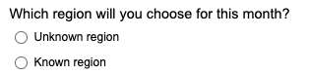

<<page break>>

Month 1
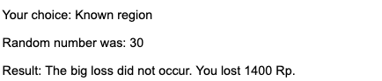

<<page break>>

Month 2

<<page break>>

Month 2
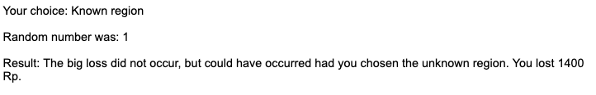

<<page break>>

Month 3

<<page break>>

Month 3
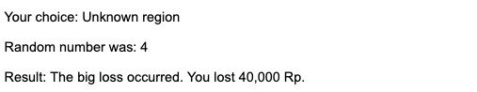
<<page break>>
.
.
.
Month 20

<<page break>>

Month 20
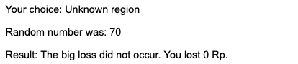

Precommitted Condition:

Month 1

Month 2

Month 3
.
.
.
.
Month 20

<<page break>>

Month 1
<<page break>>

Month 2
<<page break>>

Month 3
<<page break>>
.
.
.
Month 20
<<page break>>

All Choice Conditions:

Here is a Summary of 20 months:

Month number | Your choice | Random number | Large loss | Your combined payout | Cumulative Payout
1 | Unknown region | 75 | Did not occur. | 8,500 Rp | 8,500 Rp
2 | Unknown region | 50 | Did not occur. | 8,500 Rp | 17,000 Rp
3 | Unknown region | 87 | Did not occur. | 8,500 Rp | 25,500 Rp
4 | Unknown region | 36 | Did not occur. | 8,500 Rp | 34,000 Rp
5 | Unknown region | 89 | Did not occur. | 8,500 Rp | 42,500 Rp
6 | Unknown region | 76 | Did not occur. | 8,500 Rp | 51,000 Rp
7 | Unknown region | 59 | Did not occur. | 8,500 Rp | 59,500 Rp
8 | Unknown region | 48 | Did not occur. | 8,500 Rp | 68,000 Rp
9 | Unknown region | 65 | Did not occur. | 8,500 Rp | 76,500 Rp
10 | Unknown region | 37 | Did not occur. | 8,500 Rp | 85,000 Rp
11 | Known region | 21 | Did not occur. | 7,100 Rp | 92,100 Rp
12 | Known region | 98 | Did not occur. | 7,100 Rp | 99,200 Rp
13 | Known region | 21 | Did not occur. | 7,100 Rp | 106,300 Rp
14 | Known region | 63 | Did not occur. | 7,100 Rp | 113,400 Rp
15 | Known region | 39 | Did not occur. | 7,100 Rp | 120,500 Rp
16 | Known region | 62 | Did not occur. | 7,100 Rp | 127,600 Rp
17 | Known region | 31 | Did not occur. | 7,100 Rp | 134,700 Rp
18 | Known region | 45 | Did not occur. | 7,100 Rp | 141,800 Rp
19 | Known region | 65 | Did not occur. | 7,100 Rp | 148,900 Rp
20 | Known region | 86 | Did not occur. | 7,100 Rp | 156,000 Rp

<<page break>>

All Choice Conditions:

Please say "starting demographic questions" now.

What is your gender?
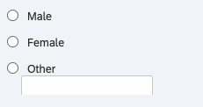

What is your age?
[text entry box]

What is your ethnicity?
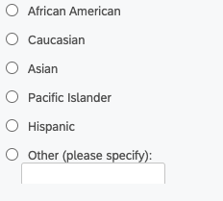

<<page break>>

Thanks for completing the study! Here's a summary of your payment for the study:

Randomly Selected Session Number To Pay Out: 2
Payout In Rupia For That Game: 170000 Rp
Payout In Dollars: $12.47

Thank you for participating! If you have friends who might participate in the study, please don't tell them about your experiences until after they participate, as they may be put in a different experimental condition than you.

Please open the door now and tell the survey administrator that you have finished.
(Please do NOT advance to the last page.)

Study 2 - Probability Education: Materials

Instructions (pg 1 of 5)
Your choices will determine the results of our research and are very important to us. Therefore, please pay careful attention to the instructions which follow.
Scenario: Imagine you own a mining company in Indonesia and you extract minerals from different regions each month. You receive a base income of 8,500 Rp income per month, regardless of your choice of region. You must also pay an amount each month, depending on which region you choose.
You must decide between investing in the “Known” regions or in the “Unknown” regions. In the Known regions, the conditions are stable, and you will pay a fixed amount of 1,400 Rp for maintenance that month. In the Unknown regions, the conditions are uncertain. There is a 4% chance that you will pay 40,000 Rp for maintenance that month, otherwise you will pay nothing that month.

<<page break>>
Instructions (pg 2 of 5)

This is a scenario in which the outcomes of your decisions depend on what you do and on random chance. Over the course of 20 "months" (ie, rounds), you will earn money and then make a decision about whether to invest in the Known region or in the Unknown one. Gains and losses will be measured in the Indonesian currency, the rupiah (or Rp).

<<page break>>

Instructions (pg 3 of 5)
Repeated – Control: and Precommitted – Control:

Here is a summary of the possible outcomes, depending on your choice:

- Each month, you will each earn a base income of 8,500 Rp (you will always receive this income, no matter what else happens).

- If you choose the Known region, then you must pay 1,400 Rp, and there is a 0% chance that the large loss will occur.

- If you choose the Unknown region, then there is a 4% chance you will lose 40,000 Rp and there is a 96% chance of losing 0 Rp.

Probabilistic outcomes will be determined by a random number generator, where it is equally likely that any number between 1 and 100 is chosen. In other words, the computer fairly and randomly selects a random number. The large loss will occur if lower numbers are chosen. In other words, if there is a 4% chance of the large loss occurring, it will occur when the number randomly chosen is a 1, 2, 3 or 4.

Repeated – Education: and Precommitted – Education:

Here is a summary of the possible outcomes, depending on your choice:

- Each month, you will each earn a base income of 8,500 Rp (you will always receive this income, no matter what else happens).

- If you choose the Known region, then you must pay 1,400 Rp, and there is a 0% chance that the large loss will occur.

- If you choose the Unknown region, then there is a 4% chance you will lose 40,000 Rp and there is a 96% chance of losing 0 Rp (this means that there is a 56% chance of the 40,000 payment happening at least once during 20 months).

Probabilistic outcomes will be determined by a random number generator, where it is equally likely that any number between 1 and 100 is chosen. In other words, the computer fairly and randomly selects a random number. The large loss will occur if lower numbers are chosen. In other words, if there is a 4% chance of the large loss occurring, it will occur when the number randomly chosen is a 1, 2, 3 or 4.

<<page break>>

All Conditions:
Instructions (pg 4 of 5)
You will play 4 sessions, of 20 months each. At the end of the study, we will randomly choose 1 of the 4 sessions you completed and record that as your performance in this game. This will be compared to what others did in the study. Because any session could potentially be recorded as your performance session, you should take all your choices seriously.

<<page break>>

Instructions (pg 5 of 5)
Repeated - Control: and Repeated – Education:
You will play one month at a time. After each month, you will learn the random number chosen by the computer, and whether the large loss occurred in that month. After all 20 months, you will see a summary for the entire session, including your choices and the outcomes in each month.

Precommitted - Control: and Precommitted – Education:
You will see the decision options for all 20 months of the session and you will precommit your choices for all 20 months in the session. After you make your choices, all 20 months will be played out at once. You will learn the random number chosen by the computer for each month, and whether the large loss occurred in that month. Then, you will see a summary for the entire session, including your choices and the outcomes in each month.

<<page break>>

Summary and Comprehension Check

Repeated – Control: and Precommitted – Control:
No matter what, you will earn a base pay of 8,500 Rp each month. Here is a table summarizing the possible additional outcomes, depending on your decision (whether to mine the Known region or the Unknown region):
Month
Known region | You definitely lose 1,400 Rp, and have a 0% chance of the large loss occurring.
Unknown region | You have a 4% chance of losing 40,000 Rp and a 96% chance of losing 0 Rp.

Repeated – Education: and Precommitted – Education:

No matter what, you will earn a base pay of 8,500 Rp each month. Here is a table summarizing the possible additional outcomes, depending on your decision (whether to mine the Known region or the Unknown region):
Known region | You definitely lose 1,400 Rp, and have a 0% chance of the large loss occurring.
Unknown region | You have a 4% chance of losing 40,000 Rp and a 96% chance of losing 0 Rp (56% probability of losing 40,000 at least once over 20 months).

All Conditions:

If you decide to mine the Known region, how many Rp would you definitely lose? (please give your answer as an integer)
[text entry box]

If you mine the Unknown region, what is the percent chance that you will suffer a big loss in any given month? (please give your answer as an integer)
[text entry box]

If you mine the Unknown region, and you do suffer a loss, how many Rp would this cause you lose? (please give your answer as an integer)
[text entry box]

If you decide to mine the Unknown region, what is the percent chance that you will NOT suffer a big loss in any given month? (please give your answer as an integer)
[text entry box]

Repeated – Education: and Precommitted – Education:

What is the probability of the big loss happening once over the 20 months?
[text entry box]

<<page break>>

Repeated – Control: and Precommitted – Control:

No matter what, you will earn a base pay of 8,500 Rp each month. Here is a table summarizing the possible additional outcomes, depending on your decision (whether to mine the Known region or the Unknown region):
Month
Known region | You definitely lose 1,400 Rp, and have a 0% chance of the large loss occurring.
Unknown region | You have a 4% chance of losing 40,000 Rp and a 96% chance of losing 0 Rp.

Repeated – Education: and Precommitted – Education:

No matter what, you will earn a base pay of 8,500 Rp each month. Here is a table summarizing the possible additional outcomes, depending on your decision (whether to mine the Known region or the Unknown region):
Known region | You definitely lose 1,400 Rp, and have a 0% chance of the large loss occurring.
Unknown region | You have a 4% chance of losing 40,000 Rp and a 96% chance of losing 0 Rp (56% probability of losing 40,000 at least once over 20 months).

<<page break>>

Repeated - Control: and Repeated – Education:

Month 1

<<page break>>

Month 1

<<page break>>

Month 2

<<page break>>

Month 2

<<page break>>

Month 3

<<page break>>

Month 3
<<page break>>
.
.
.
Month 20
<<page break>>

Month 20

Precommitted – Control: and Precommitted – Education:

Month 1

Month 2

Month 3
.
.
.
.
Month 20

<<page break>>

Month 1
<<page break>>

Month 2
<<page break>>

Month 3
<<page break>>
.
.
.
Month 20

<<page break>>

All Conditions:

Here is a Summary of 20 months:

Month number | Your choice | Random number | Large loss | Your combined payout | Cumulative Payout
1 | Unknown region | 75 | Did not occur. | 8,500 Rp | 8,500 Rp
2 | Unknown region | 50 | Did not occur. | 8,500 Rp | 17,000 Rp
3 | Unknown region | 87 | Did not occur. | 8,500 Rp | 25,500 Rp
4 | Unknown region | 36 | Did not occur. | 8,500 Rp | 34,000 Rp
5 | Unknown region | 89 | Did not occur. | 8,500 Rp | 42,500 Rp
6 | Unknown region | 76 | Did not occur. | 8,500 Rp | 51,000 Rp
7 | Unknown region | 59 | Did not occur. | 8,500 Rp | 59,500 Rp
8 | Unknown region | 48 | Did not occur. | 8,500 Rp | 68,000 Rp
9 | Unknown region | 65 | Did not occur. | 8,500 Rp | 76,500 Rp
10 | Unknown region | 37 | Did not occur. | 8,500 Rp | 85,000 Rp
11 | Known region | 21 | Did not occur. | 7,100 Rp | 92,100 Rp
12 | Known region | 98 | Did not occur. | 7,100 Rp | 99,200 Rp
13 | Known region | 21 | Did not occur. | 7,100 Rp | 106,300 Rp
14 | Known region | 63 | Did not occur. | 7,100 Rp | 113,400 Rp
15 | Known region | 39 | Did not occur. | 7,100 Rp | 120,500 Rp
16 | Known region | 62 | Did not occur. | 7,100 Rp | 127,600 Rp
17 | Known region | 31 | Did not occur. | 7,100 Rp | 134,700 Rp
18 | Known region | 45 | Did not occur. | 7,100 Rp | 141,800 Rp
19 | Known region | 65 | Did not occur. | 7,100 Rp | 148,900 Rp
20 | Known region | 86 | Did not occur. | 7,100 Rp | 156,000 Rp

<<page break>>

All Conditions:

What is your gender?

What is your age?
[text entry box]

What is your ethnicity?
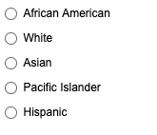

Study 3 – Number of Rounds: Materials

Instructions (pg 1 of 5)
Your choices will determine the results of our research and are very important to us. Therefore, please pay careful attention to the instructions which follow.
Scenario: Imagine you own a mining company in Indonesia and you extract minerals from different regions each month. You receive a base income of 8,500 Rp income per month, regardless of your choice of region. You must also pay an amount each month, depending on which region you choose.
You must decide between investing in the “Known” regions or in the “Unknown” regions. In the Known regions, the conditions are stable, and you will pay a fixed amount of 1,400 Rp for maintenance that month. In the Unknown regions, the conditions are uncertain. There is a 4% chance that you will pay 40,000 Rp for maintenance that month, otherwise you will pay nothing that month.

Instructions (pg 2 of 5)

Repeated / 20 rounds: and Precommitted / 20 rounds:

This is a scenario in which the outcomes of your decisions depend on what you do and on random chance. Over the course of 20 "months" (ie, rounds), you will earn money and then make a decision about whether to invest in the Known region or in the Unknown one. Gains and losses will be measured in the Indonesian currency, the rupiah (or Rp).

Repeated / 10 rounds: and Precommitted / 10 rounds:

This is a scenario in which the outcomes of your decisions depend on what you do and on random chance. Over the course of 10 "months" (ie, rounds), you will earn money and then make a decision about whether to invest in the Known region or in the Unknown one. Gains and losses will be measured in the Indonesian currency, the rupiah (or Rp).

Repeated / 5 rounds: and Precommitted / 5 rounds:

This is a scenario in which the outcomes of your decisions depend on what you do and on random chance. Over the course of 5 "months" (ie, rounds), you will earn money and then make a decision about whether to invest in the Known region or in the Unknown one. Gains and losses will be measured in the Indonesian currency, the rupiah (or Rp).

All Conditions:

Instructions (pg 3 of 5)
Here is a summary of the possible outcomes, depending on your choice:

- Each month, you will each earn a base income of 8,500 Rp (you will always receive this income, no matter what else happens).

- If you choose the Known region, then you must pay 1,400 Rp, and there is a 0% chance that the large loss will occur.

- If you choose the Unknown region, then there is a 4% chance you will lose 40,000 Rp and there is a 96% chance of losing 0 Rp.

Probabilistic outcomes will be determined by a random number generator, where it is equally likely that any number between 1 and 100 is chosen. In other words, the computer fairly and randomly selects a random number. The large loss will occur if lower numbers are chosen. In other words, if there is a 4% chance of the large loss occurring, it will occur when the number randomly chosen is a 1, 2, 3 or 4.

Instructions (pg 4 of 5)

Repeated / 20 rounds: and Precommitted / 20 rounds:
You will play 4 sessions, of 20 months each. At the end of the study, we will randomly choose 1 of the 4 sessions you completed and record that as your performance in this game. This will be compared to what others did in the study. Because any session could potentially be recorded as your performance session, you should take all your choices seriously.
Repeated / 10 rounds: and Precommitted / 10 rounds:

You will play 4 sessions, of 10 months each. At the end of the study, we will randomly choose 1 of the 4 sessions you completed and record that as your performance in this game. This will be compared to what others did in the study. Because any session could potentially be recorded as your performance session, you should take all your choices seriously.

Repeated / 5 rounds: and Precommitted / 5 rounds:

You will play 4 sessions, of 5 months each. At the end of the study, we will randomly choose 1 of the 4 sessions you completed and record that as your performance in this game. This will be compared to what others did in the study. Because any session could potentially be recorded as your performance session, you should take all your choices seriously.

Instructions (pg 5 of 5)
Repeated / 20 rounds:
You will play one month at a time. After each month, you will learn the random number chosen by the computer, and whether the large loss occurred in that month. After all 20 months, you will see a summary for the entire session, including your choices and the outcomes in each month.

Precommitted / 20 rounds:
You will see the decision options for all 20 months of the session and you will precommit your choices for all 20 months in the session. After you make your choices, all 20 months will be played out at once. You will learn the random number chosen by the computer for each month, and whether the large loss occurred in that month. Then, you will see a summary for the entire session, including your choices and the outcomes in each month.

Repeated / 10 rounds:
You will play one month at a time. After each month, you will learn the random number chosen by the computer, and whether the large loss occurred in that month. After all 10 months, you will see a summary for the entire session, including your choices and the outcomes in each month.

Precommitted / 10 rounds:

You will see the decision options for all 10 months of the session and you will precommit your choices for all 10 months in the session. After you make your choices, all 10 months will be played out at once. You will learn the random number chosen by the computer for each month, and whether the large loss occurred in that month. Then, you will see a summary for the entire session, including your choices and the outcomes in each month.

Repeated / 5 rounds:
You will play one month at a time. After each month, you will learn the random number chosen by the computer, and whether the large loss occurred in that month. After all 5 months, you will see a summary for the entire session, including your choices and the outcomes in each month.

Precommitted / 5 rounds:

You will see the decision options for all 5 months of the session and you will precommit your choices for all 5 months in the session. After you make your choices, all 5 months will be played out at once. You will learn the random number chosen by the computer for each month, and whether the large loss occurred in that month. Then, you will see a summary for the entire session, including your choices and the outcomes in each month.

All Conditions:
Summary and Comprehension Check
No matter what, you will earn a base pay of 8,500 Rp each month. Here is a table summarizing the possible additional outcomes, depending on your decision (whether to mine the Known region or the Unknown region):
Month
Known region | You definitely lose 1,400 Rp, and have a 0% chance of the large loss occurring.
Unknown region | You have a 4% chance of losing 40,000 Rp and a 96% chance of losing 0 Rp.

If you decide to mine the Known region, how many Rp would you definitely lose? (please give your answer as an integer)
[text entry box]

If you mine the Unknown region, what is the percent chance that you will suffer a big loss in any given month? (please give your answer as an integer)
[text entry box]

If you mine the Unknown region, and you do suffer a loss, how many Rp would this cause you lose? (please give your answer as an integer)
[text entry box]

If you decide to mine the Unknown region, what is the percent chance that you will NOT suffer a big loss in any given month? (please give your answer as an integer)
[text entry box]

<<page break>>

No matter what, you will earn a base pay of 8,500 Rp each month. Here is a table summarizing the possible additional outcomes, depending on your decision (whether to mine the Known region or the Unknown region):
Known region | You definitely lose 1,400 Rp, and have a 0% chance of the large loss occurring.
Unknown region | You have a 4% chance of losing 40,000 Rp and a 96% chance of losing 0 Rp.

<<page break>>

Repeated / 20 rounds:

Month 1

<<page break>>

Month 1

<<page break>>

Month 2

<<page break>>

Month 2

<<page break>>

Month 3

<<page break>>

Month 3
<<page break>>
.
.
.
Month 20

<<page break>>

Month 20

<<page break>>

Precommitted / 20 rounds:

Month 1

Month 2

Month 3
.
.
.
.
Month 20

<<page break>>

Month 1
<<page break>>

Month 2
<<page break>>

Month 3
<<page break>>
.
.
.
Month 20
<<page break>>

Repeated / 10 rounds:

Month 1

<<page break>>

Month 1

<<page break>>

Month 2

<<page break>>

Month 2
<<page break>>

Month 3

<<page break>>

Month 3
<<page break>>
.
.
.
Month 10

<<page break>>

Month 10

<<page break>>

Precommitted / 10 rounds:

Month 1

Month 2

Month 3
.
.
.
.
Month 10

<<page break>>

Month 1
<<page break>>

Month 2
<<page break>>

Month 3
<<page break>>
.
.
.
Month 10
<<page break>>

Repeated / 5 rounds:

Month 1

<<page break>>

Month 1

<<page break>>

Month 2

<<page break>>

Month 2
<<page break>>

Month 3

<<page break>>

Month 3
<<page break>>

Month 4
<<page break>>

Month 4
<<page break>>

Month 5

<<page break>>

Month 5

<<page break>>

Precommitted / 5 rounds:

Month 1

Month 2

Month 3

Month 4

Month 5

<<page break>>

Month 1
<<page break>>

Month 2
<<page break>>

Month 3
<<page break>>

Month 4

<<page break>>

Month 5

<<page break>>

Repeated / 20 rounds: and Precommitted / 20 rounds:

Here is a Summary of 20 months:

Month number | Your choice | Random number | Large loss | Your combined payout | Cumulative Payout
1 | Unknown region | 75 | Did not occur. | 8,500 Rp | 8,500 Rp
2 | Unknown region | 50 | Did not occur. | 8,500 Rp | 17,000 Rp
3 | Unknown region | 87 | Did not occur. | 8,500 Rp | 25,500 Rp
4 | Unknown region | 36 | Did not occur. | 8,500 Rp | 34,000 Rp
5 | Unknown region | 89 | Did not occur. | 8,500 Rp | 42,500 Rp
6 | Unknown region | 76 | Did not occur. | 8,500 Rp | 51,000 Rp
7 | Unknown region | 59 | Did not occur. | 8,500 Rp | 59,500 Rp
8 | Unknown region | 48 | Did not occur. | 8,500 Rp | 68,000 Rp
9 | Unknown region | 65 | Did not occur. | 8,500 Rp | 76,500 Rp
10 | Unknown region | 37 | Did not occur. | 8,500 Rp | 85,000 Rp
11 | Known region | 21 | Did not occur. | 7,100 Rp | 92,100 Rp
12 | Known region | 98 | Did not occur. | 7,100 Rp | 99,200 Rp
13 | Known region | 21 | Did not occur. | 7,100 Rp | 106,300 Rp
14 | Known region | 63 | Did not occur. | 7,100 Rp | 113,400 Rp
15 | Known region | 39 | Did not occur. | 7,100 Rp | 120,500 Rp
16 | Known region | 62 | Did not occur. | 7,100 Rp | 127,600 Rp
17 | Known region | 31 | Did not occur. | 7,100 Rp | 134,700 Rp
18 | Known region | 45 | Did not occur. | 7,100 Rp | 141,800 Rp
19 | Known region | 65 | Did not occur. | 7,100 Rp | 148,900 Rp
20 | Known region | 86 | Did not occur. | 7,100 Rp | 156,000 Rp

Repeated / 10 rounds: and Precommitted / 10 rounds:

Here is a summary of 10 months:

Month number | Your choice | Random number | Large loss | Your combined payout | Cumulative Payout
1 | Unknown region | 40 | Did not occur. | 8,500 Rp | 8,500 Rp
2 | Known region | 14 | Did not occur. | 7,100 Rp | 15,600 Rp
3 | Unknown region | 78 | Did not occur. | 8,500 Rp | 24,100 Rp
4 | Known region | 44 | Did not occur. | 7,100 Rp | 31,200 Rp
5 | Unknown region | 96 | Did not occur. | 8,500 Rp | 39,700 Rp
6 | Known region | 29 | Did not occur. | 7,100 Rp | 46,800 Rp
7 | Unknown region | 25 | Did not occur. | 8,500 Rp | 55,300 Rp
8 | Known region | 72 | Did not occur. | 7,100 Rp | 62,400 Rp
9 | Unknown region | 44 | Did not occur. | 8,500 Rp | 70,900 Rp
10 | Known region | 74 | Did not occur. | 7,100 Rp | 78,000 Rp

Repeated / 5 rounds: and Precommitted / 5 rounds:

Here is a summary of 5 months:

Month number | Your choice | Random number | Large loss | Your combined payout | Cumulative Payout
1 | Unknown region | 70 | Did not occur. | 8,500 Rp | 8,500 Rp
2 | Unknown region | 64 | Did not occur. | 8,500 Rp | 17,000 Rp
3 | Unknown region | 57 | Did not occur. | 8,500 Rp | 25,500 Rp
4 | Unknown region | 53 | Did not occur. | 8,500 Rp | 34,000 Rp
5 | Unknown region | 53 | Did not occur. | 8,500 Rp | 42,500 Rp

All Conditions:

What is your gender?
What is your age?
[text entry box]

What is your ethnicity?

Study 4 - Non-Binding Precommitment: Materials

Instructions (pg 1 of 3)
Scenario: Imagine you own a mining company in Indonesia and you extract minerals from different regions each month. You receive a base income of 8,500 Rupiah (Rp is the Indonesian currency) income per month, regardless of your choice of region. You must also pay an amount each month, depending on which region you choose.
You must decide between investing in the "Known" regions or in the "Unknown" regions. In the Known regions, the conditions are stable, and you will pay a fixed amount of 1,400 Rp for maintenance that month. In the Unknown regions, the conditions are uncertain. There is a 4% chance that you will pay 40,000 Rp for maintenance that month, otherwise you will pay nothing that month.

Instructions (pg 2 of 3)
Here is a summary of the possible outcomes, depending on your choice:
- Each month, you will earn a base income of 8,500 Rp (you will always receive this income, no matter what else happens).
- If you choose the Known region, then you must pay 1,400 Rp, and there is a 0% chance that the large loss will occur.
- If you choose the Unknown region, then there is a 4% chance you will lose 40,000 Rp and there is a 96% chance of losing 0 Rp.
Probabilistic outcomes will be determined by a random number generator, where it is equally likely that any number between 1 and 100 is chosen. In other words, the computer fairly and randomly selects a random number. The large loss will occur if lower numbers are chosen. For example, if there is a 5% chance of the large loss occurring, it will occur when the number randomly chosen is a 1, 2, 3, 4 or 5 (out of 100).

Instructions (pg 3 of 3)

Repeated Condition:

You will play one month at a time. After each month, you will learn the random number chosen by the computer, and whether the large loss occurred in that month. After all 20 months, you will see a summary for the entire session, including your choices and the outcomes in each month.

Precommitted Condition:

You will see the decision options for all 20 months of the session and you will precommit your choices for all 20 months in the session. After you make your choices, all 20 months will be played out at once. You will learn the random number chosen by the computer for each month, and whether the large loss occurred in that month. Then, you will see a summary for the entire session, including your choices and the outcomes in each month.

Non-Binding Precommitment Condition:

You will see the decision options for all 20 months of the session and you will precommit your choices for all 20 months in the session. After the first month is played, you will return to the choice page and have the option to change your choices for months 2-20 if you wish (or stay with your original choices). Same goes for after second month is played till the end. You will learn the random number chosen by the computer for each month, and whether the large loss occurred in that month as well as a summary for the entire session once all 20 months are played.
All Conditions:

Summary and Comprehension Check
No matter what, you will earn a base pay of 8,500 Rp each month. Here is a table summarizing the possible additional outcomes, depending on your decision (whether to choose the KNOWN region or the UNKNOWN region):
Each Month

KNOWN REGION | - You definitely lose 1,400 Rp, and have a 0% chance of the large loss occurring.
UNKNOWN REGION | - You have a 4% chance of losing 40,000 Rp and a 96% chance of losing 0 Rp.
1. If you decide to mine the Known region, how many Rp would you definitely lose? (please give your answer as an integer)
[text box entry] Rp
2a. If you mine the Unknown region, what is the percent chance that you will suffer the big loss in any given month? (please give your answer as an integer)
[text box entry] %
2b. If you mine the Unknown region, and you do suffer the big loss, how many Rp would this cause you to lose? (please give your answer as an integer)
[text box entry] Rp
3. If you decide to mine the Unknown region, what is the percent chance that you will NOT suffer the big loss in any given month? (please give your answer as an integer)
[text box entry] %

<<page break>>
Congratulations!
Good work! You answered all the comprehension questions correctly. You will now move on to the main study.

Repeated Condition:

No matter what, you will earn a base pay of 8,500 Rp this month. Here is a table summarizing the possible additional outcomes, depending on your decision (whether to mine the Known region or the Unknown region):

KNOWN REGION | - You definitely lose 1,400 Rp, and have a 0% chance of the large loss occurring.
UNKNOWN REGION | - You have a 4% chance of losing 40,000 Rp and a 96% chance of losing 0 Rp.

<<page break>>
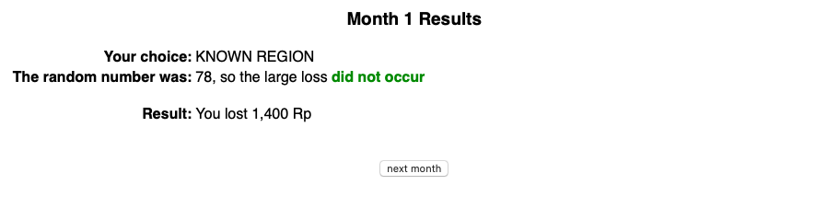
<<page break>>

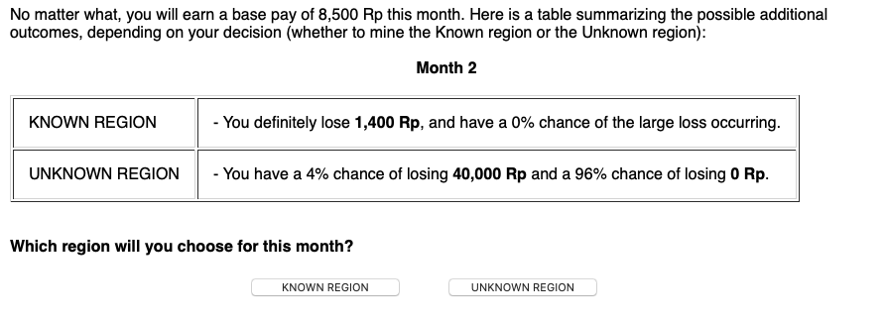

<<page break>>
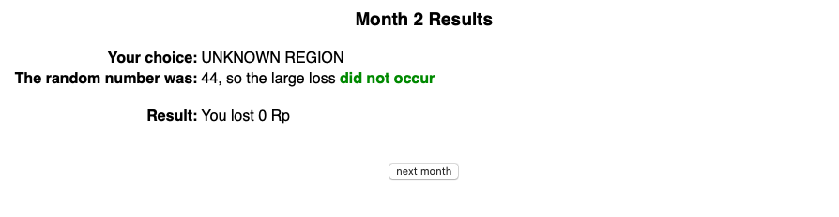
<<page break>>

No matter what, you will earn a base pay of 8,500 Rp this month. Here is a table summarizing the possible additional outcomes, depending on your decision (whether to mine the Known region or the Unknown region):

Month 3

KNOWN REGION | - You definitely lose 1,400 Rp, and have a 0% chance of the large loss occurring.
UNKNOWN REGION | - You have a 4% chance of losing 40,000 Rp and a 96% chance of losing 0 Rp.

<<page break>>
<<page break>>
.
.
No matter what, you will earn a base pay of 8,500 Rp this month. Here is a table summarizing the possible additional outcomes, depending on your decision (whether to mine the Known region or the Unknown region):

Month 20

KNOWN REGION | - You definitely lose 1,400 Rp, and have a 0% chance of the large loss occurring.
UNKNOWN REGION | - You have a 4% chance of losing 40,000 Rp and a 96% chance of losing 0 Rp.

<<page break>>
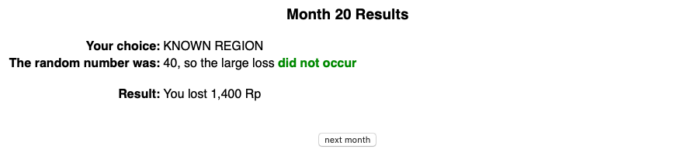

Precommitted Condition:
No matter what, you will earn a base pay of 8,500 Rp each month. Here is a table summarizing the possible additional outcomes, depending on your decision (whether to mine the Known region or the Unknown region):

Each Month

KNOWN REGION | - You definitely lose 1,400 Rp, and have a 0% chance of the large loss occurring.
UNKNOWN REGION | - You have a 4% chance of losing 40,000 Rp and a 96% chance of losing 0 Rp.
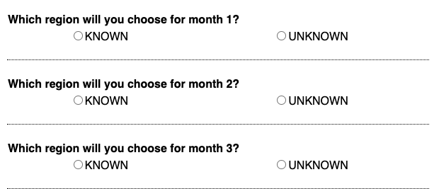
.
.
.
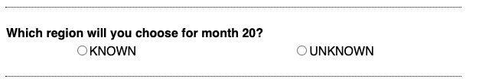
<<page break>>
<<page break>>
<<page break>>
<<page break>>
.
.
.
<<page break>>

Non-Binding Precommitment Condition:

No matter what, you will earn a base pay of 8,500 Rp this month. Here is a table summarizing the possible additional outcomes, depending on your decision (whether to mine the Known region or the Unknown region):

Each Month

KNOWN REGION | - You definitely lose 1,400 Rp, and have a 0% chance of the large loss occurring.
UNKNOWN REGION | - You have a 4% chance of losing 40,000 Rp and a 96% chance of losing 0 Rp.

.
.
.
<<page break>>

<<page break>>
No matter what, you will earn a base pay of 8,500 Rp this month. Here is a table summarizing the possible additional outcomes, depending on your decision (whether to mine the Known region or the Unknown region):

Each Month

KNOWN REGION | - You definitely lose 1,400 Rp, and have a 0% chance of the large loss occurring.
UNKNOWN REGION | - You have a 4% chance of losing 40,000 Rp and a 96% chance of losing 0 Rp.

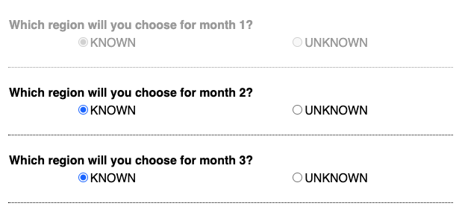
.
.
.
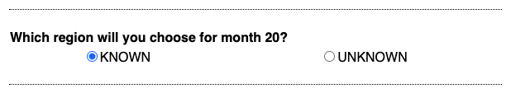
<<page break>>
<<page break>>
No matter what, you will earn a base pay of 8,500 Rp this month. Here is a table summarizing the possible additional outcomes, depending on your decision (whether to mine the Known region or the Unknown region):

Each Month

KNOWN REGION | - You definitely lose 1,400 Rp, and have a 0% chance of the large loss occurring.
UNKNOWN REGION | - You have a 4% chance of losing 40,000 Rp and a 96% chance of losing 0 Rp.

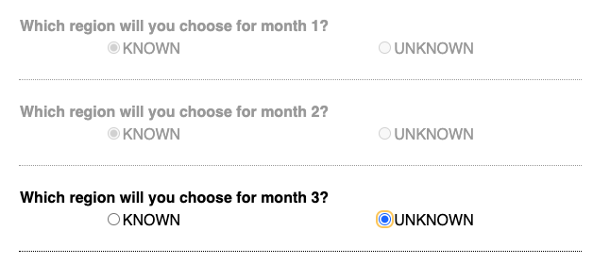
.
.
.
<<page break>>
<<page break>>
.
.
.
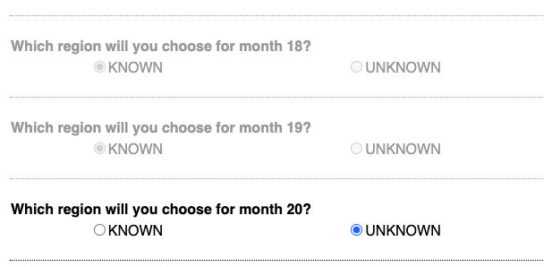
<<page break>>
<<page break>>
All Conditions:
You've finished the 20 months of block #1. Here's a month by month summary of what happened:
Day # | Your choice | Random Number | Large Loss | Your Payout | Cumulative Payout
1 | KNOWN REGION | 3 | did not occur, but would have occured if you had chosen the Unknown region | 7,100 | 7,100
2 | KNOWN REGION | 73 | did not occur | 7,100 | 14,200
3 | UNKNOWN REGION | 27 | did not occur | 8,500 | 22,700
4 | KNOWN REGION | 98 | did not occur | 7,100 | 29,800
5 | KNOWN REGION | 41 | did not occur | 7,100 | 36,900
6 | KNOWN REGION | 57 | did not occur | 7,100 | 44,000
7 | KNOWN REGION | 44 | did not occur | 7,100 | 51,100
8 | KNOWN REGION | 42 | did not occur | 7,100 | 58,200
9 | KNOWN REGION | 61 | did not occur | 7,100 | 65,300
10 | KNOWN REGION | 40 | did not occur | 7,100 | 72,400
11 | KNOWN REGION | 36 | did not occur | 7,100 | 79,500
12 | KNOWN REGION | 100 | did not occur | 7,100 | 86,600
13 | KNOWN REGION | 6 | did not occur | 7,100 | 93,700
14 | KNOWN REGION | 42 | did not occur | 7,100 | 100,800
15 | KNOWN REGION | 4 | did not occur, but would have occured if you had chosen the Unknown region | 7,100 | 107,900
16 | KNOWN REGION | 73 | did not occur | 7,100 | 115,000
17 | KNOWN REGION | 94 | did not occur | 7,100 | 122,100
18 | KNOWN REGION | 61 | did not occur | 7,100 | 129,200
19 | KNOWN REGION | 53 | did not occur | 7,100 | 136,300
20 | UNKNOWN REGION | 35 | did not occur | 8,500 | 144,800

<<page break>>>

Block 1 Complete
Your cumulative payout for Block 1 was:
144,800 Rp
You will now complete the same scenario again. You will complete 4 blocks in total.

<<page break>>
Additional Questions

You have finished the main portion of the study. Now we will ask you a few follow-up questions.
What are your thoughts on playing the game? Please give a brief summary of how/why you chose the Known vs Unknown region:
[text entry box]
How happy are you with your choices and the outcomes of the game?
[Multiple Choice] Very Unhappy/Somewhat Unhappy/A Little Unhappy/A Little Happy/Somewhat Happy/Very Happy
<<page break>>
Demographics

Please complete the following information about yourself.
Age
[text entry box]
Gender
[Multiple Choice] Male/Female/Other
Ethnicity (optional)
[Multiple Choice] Aboriginal/Asian or Pacific Islander/Black or African/Caucasian or White/Hispanic or Latino/ Other
Highest level of educational achievement? (optional)
[Multiple Choice] Some highschool/High school diploma/Some college/2-year degree/4-year degree/Master's degree/Professional degree/Doctoral degree
This is the end of the study. After you click the button below to submit the survey, you will be redirected to the Prolific website. Thank you!

Study 5 – Process Study: Materials

Instructions (pg 1 of 4)
Scenario: Imagine you own a mining company in Indonesia and you extract minerals from different regions each day. You receive a base income of 8,500 Rupiah (Rp is the Indonesian currency) income per day, regardless of your choice of region. You must also pay an amount each day, depending on which region you choose.
You must decide between investing in the "Known" regions or in the "Unknown" regions. In the Known regions, the conditions are stable, and you will pay a fixed amount of 1,400 Rp for maintenance that day. In the Unknown regions, the conditions are uncertain. There is a 4% chance that you will pay 40,000 Rp for maintenance that day, otherwise you will pay nothing that day.

Instructions (pg 2 of 4)
Here is a summary of the possible outcomes, depending on your choice:
- Each day, you will earn a base income of 8,500 Rp (you will always receive this income, no matter what else happens).
- If you choose the Known region, then you must pay 1,400 Rp, and there is a 0% chance that the large loss will occur.
- If you choose the Unknown region, then there is a 4% chance you will lose 40,000 Rp and there is a 96% chance of losing 0 Rp.
Probabilistic outcomes will be determined by a random number generator, where it is equally likely that any number between 1 and 100 is chosen. In other words, the computer fairly and randomly selects a random number. The large loss will occur if lower numbers are chosen. For example, if there is a 4% chance of the large loss occurring, it will occur when the number randomly chosen is a 1, 2, 3, or 4 (out of 100).

Instructions (pg 3 of 4)

You will play 4 blocks, of 20 days each. The blocks are independent; each time you finish a block of 20 days, you will start the next one with a clean slate.
At the end of the study, we will randomly choose one participant and pay them a bonus based on performance in the task. If you are chosen for the bonus, we will randomly select 1 of the 4 blocks you completed and convert the Rupiah (Rp) earned in that block to pounds sterling (GBP), at the current exchange rate of 17,815 Rp = £1, and pay it out for real money as a bonus for participating. Therefore, any block could potentially be paid out for real money and you should take all your choices seriously.

Instructions (pg 4 of 4)

Repeated Condition:
You will play one day at a time. After each day, you will learn the random number chosen by the computer, and whether the large loss occurred in that day. After all 20 days, you will see a summary for the entire block, including your choices and the outcomes in each day.

Non-Binding Precommitted Condition:
You will see the decision options for all 20 days of the block and you will precommit your choices for all 20 days in the block. After the first day is played, you will return to the choice page and have the option to change your choices for days 2-20 if you wish (or stay with your original choices). Same goes for after the second day is played, until the end of the block. You will learn the random number chosen by the computer for each day, and whether the large loss occurred in that day as well as a summary for the entire block once all 20 days are played.

<<page break>>

Both Conditions:
Summary and Comprehension Check

No matter what, you will earn a base pay of 8,500 Rp each day. Here is a table summarizing the possible additional outcomes, depending on your decision (whether to choose the KNOWN region or the UNKNOWN region):
Each Day

KNOWN REGION | - You definitely lose 1,400 Rp, and have a 0% chance of the large loss occurring.
UNKNOWN REGION | - You have a 4% chance of losing 40,000 Rp and a 96% chance of losing 0 Rp.

1. If you decide to mine the Known region, how many Rp would you definitely lose? (please give your answer as an integer)
[text box entry] Rp
2a. If you mine the Unknown region, what is the percent chance that you will suffer the big loss in any given month? (please give your answer as an integer)
[text box entry] %
2b. If you mine the Unknown region, and you do suffer the big loss, how many Rp would this cause you to lose? (please give your answer as an integer)
[text box entry] Rp
3. If you decide to mine the Unknown region, what is the percent chance that you will NOT suffer the big loss in any given month? (please give your answer as an integer)
[text box entry] %

<<page break>>
Congratulations!
Good work! You answered all the comprehension questions correctly. You will now move on to the main study.

<<page break>>

Repeated Condition:
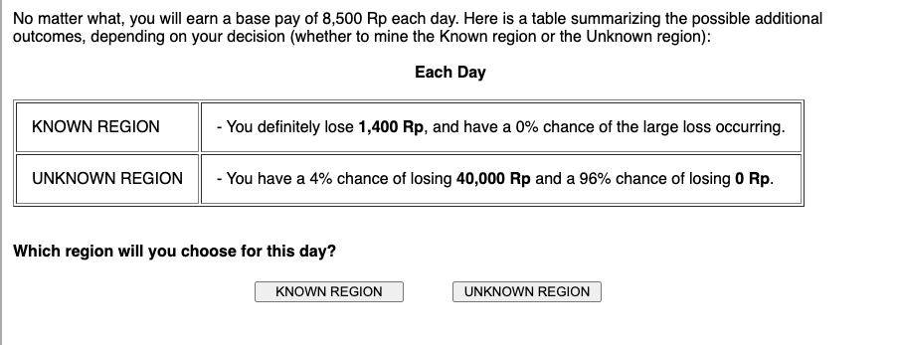
<<page break>>
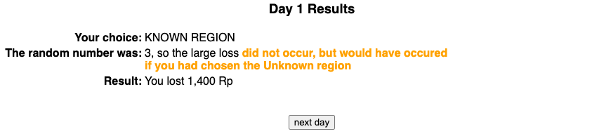
<<page break>>

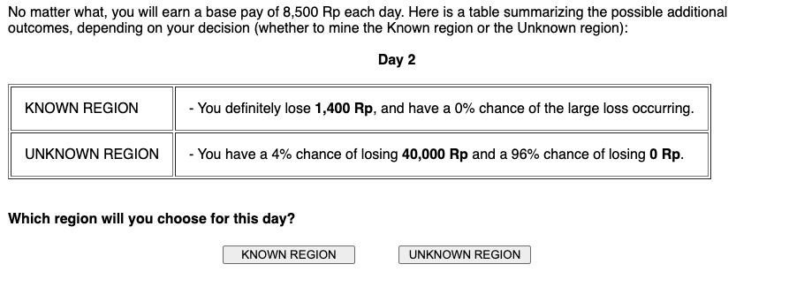

<<page break>>
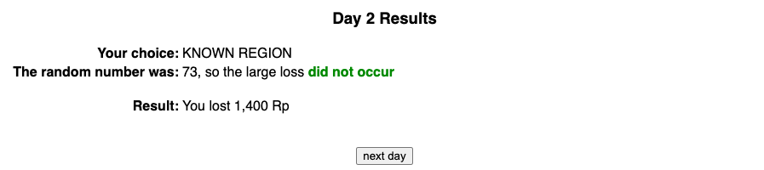
<<page break>>
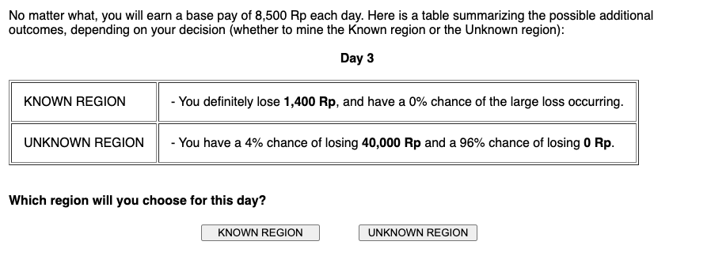
<<page break>>
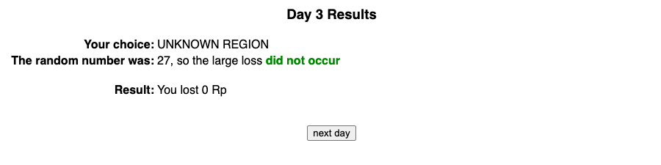
<<page break>>
.
.
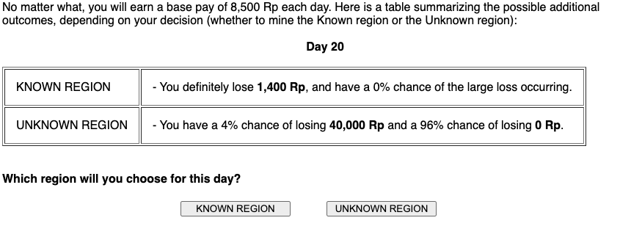
<<page break>>
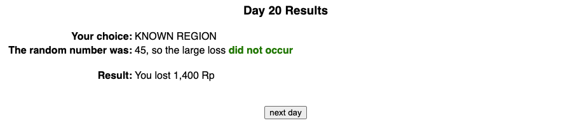
<<page break>>

Non-Binding Precommitted Condition:

No matter what, you will earn a base pay of 8,500 Rp each day. Here is a table summarizing the possible additional outcomes, depending on your decision (whether to mine the Known region or the Unknown region):

Each Day

KNOWN REGION | - You definitely lose 1,400 Rp, and have a 0% chance of the large loss occurring.
UNKNOWN REGION | - You have a 4% chance of losing 40,000 Rp and a 96% chance of losing 0 Rp.

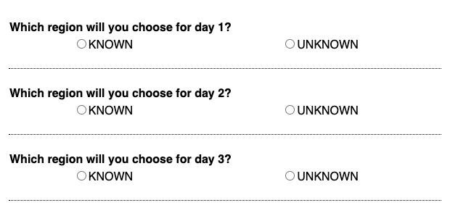
.
.
.
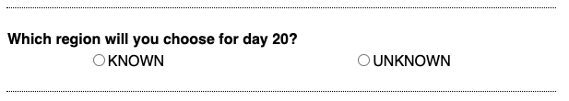
<<page break>>

<<page break>>
No matter what, you will earn a base pay of 8,500 Rp each day. Here is a table summarizing the possible additional outcomes, depending on your decision (whether to mine the Known region or the Unknown region):

Each Day

KNOWN REGION | - You definitely lose 1,400 Rp, and have a 0% chance of the large loss occurring.
UNKNOWN REGION | - You have a 4% chance of losing 40,000 Rp and a 96% chance of losing 0 Rp.
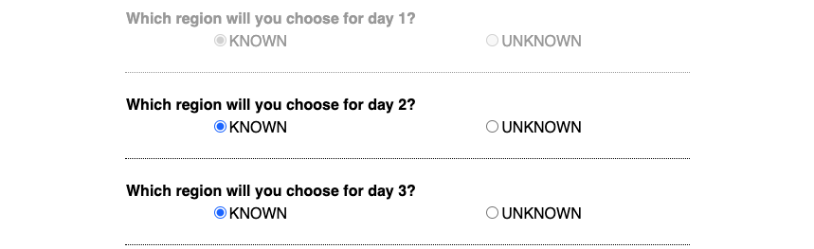
.
.
.
<<page break>>
<<page break>>
No matter what, you will earn a base pay of 8,500 Rp each day. Here is a table summarizing the possible additional outcomes, depending on your decision (whether to mine the Known region or the Unknown region):

Each Day

KNOWN REGION | - You definitely lose 1,400 Rp, and have a 0% chance of the large loss occurring.
UNKNOWN REGION | - You have a 4% chance of losing 40,000 Rp and a 96% chance of losing 0 Rp.

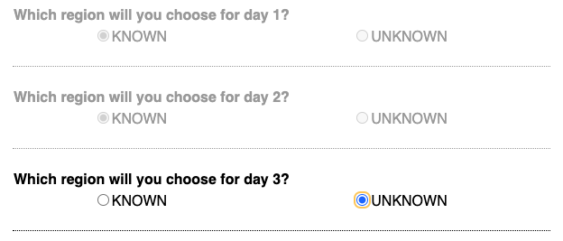
.
.
.
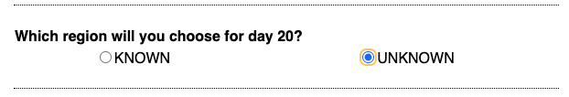
<<page break>>
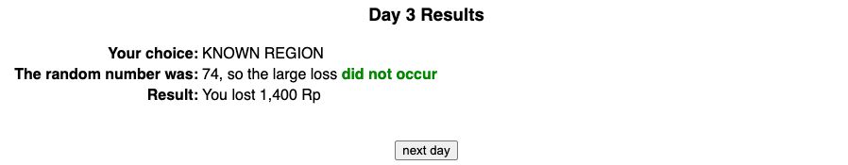
<<page break>>
.
.
.
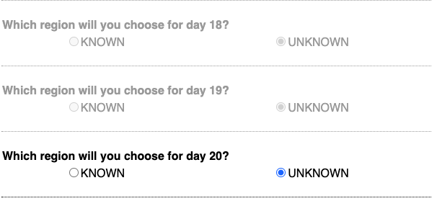
<<page break>>
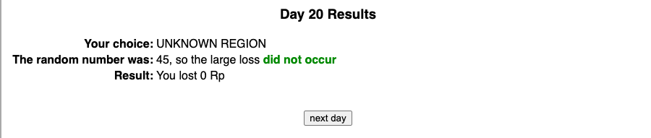
<<page break>>
Both Conditions:
You've finished the 20 days of block #1. Here's a day by day summary of what happened:
Day # | Your choice | Random Number | Large Loss | Your Payout | Cumulative Payout
1 | KNOWN REGION | 3 | did not occur, but would have occured if you had chosen the Unknown region | 7,100 | 7,100
2 | KNOWN REGION | 73 | did not occur | 7,100 | 14,200
3 | UNKNOWN REGION | 27 | did not occur | 8,500 | 22,700
4 | KNOWN REGION | 98 | did not occur | 7,100 | 29,800
5 | KNOWN REGION | 41 | did not occur | 7,100 | 36,900
6 | KNOWN REGION | 57 | did not occur | 7,100 | 44,000
7 | KNOWN REGION | 44 | did not occur | 7,100 | 51,100
8 | KNOWN REGION | 42 | did not occur | 7,100 | 58,200
9 | KNOWN REGION | 61 | did not occur | 7,100 | 65,300
10 | KNOWN REGION | 40 | did not occur | 7,100 | 72,400
11 | KNOWN REGION | 36 | did not occur | 7,100 | 79,500
12 | KNOWN REGION | 100 | did not occur | 7,100 | 86,600
13 | KNOWN REGION | 6 | did not occur | 7,100 | 93,700
14 | KNOWN REGION | 42 | did not occur | 7,100 | 100,800
15 | KNOWN REGION | 4 | did not occur, but would have occured if you had chosen the Unknown region | 7,100 | 107,900
16 | KNOWN REGION | 73 | did not occur | 7,100 | 115,000
17 | KNOWN REGION | 94 | did not occur | 7,100 | 122,100
18 | KNOWN REGION | 61 | did not occur | 7,100 | 129,200
19 | KNOWN REGION | 53 | did not occur | 7,100 | 136,300
20 | UNKNOWN REGION | 35 | did not occur | 8,500 | 144,800

<<page break>>

Block 1 Complete
Your cumulative payout for Block 1 was:
144,800 Rp
You will now complete the same scenario again. You will complete 4 blocks in total.

<<page break>>

<<to be completed after block 2>>

No matter what, you will earn a base pay of 8,500 Rp each day. Here is a table summarizing the possible additional outcomes, depending on your decision (whether to mine the Known region or the Unknown region):

Each Day

KNOWN REGION | - You definitely lose 1,400 Rp, and have a 0% chance of the large loss occurring.
UNKNOWN REGION | - You have a 4% chance of losing 40,000 Rp and a 96% chance of losing 0 Rp.

As you are getting ready to make your next choice, please answer the following questions about your decision process. Please carefully read all questions and all answer options on this page:

- How complicated is this decision task?

- How difficult is it to decide which region to mine?

- How much information do you need to consider to make your decision?

- How important is it to actually read these questions? On the question below, please choose extremely important, to show you are reading.

- Do you prefer to mine in the same region each time, or diversify the regions that you mine in?
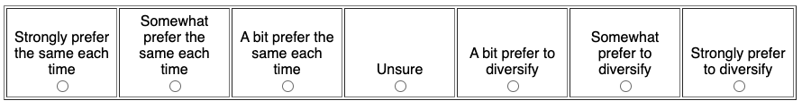

- Do you think it is useful to use math or calculations to make your decision in the task?

- Did you actually do math or calculations to help you make your decision?

- How much do you agree with the following statement: “I set out a plan at the beginning of the block, and I follow it.

<<page break>>

<<to be completed after block 4>>

Additional Questions

You have finished the main portion of the study. Now we will ask you a few follow-up questions.
What are your thoughts on playing the game? Please give a brief summary of how/why you chose the Known vs Unknown region:
[text entry box]
How happy are you with your choices and the outcomes of the game?
[Multiple Choice] Very Unhappy/Somewhat Unhappy/A Little Unhappy/A Little Happy/Somewhat Happy/Very Happy
<<page break>>
Demographics

Please complete the following information about yourself.
Age
[text entry box]
Gender
[Multiple Choice] Male/Female/Other
Ethnicity (optional)
[Multiple Choice] Aboriginal/Asian or Pacific Islander/Black or African/Caucasian or White/Hispanic or Latino/ Other
Highest level of educational achievement? (optional)
[Multiple Choice] Some highschool/High school diploma/Some college/2-year degree/4-year degree/Master's degree/Professional degree/Doctoral degree
This is the end of the study. After you click the button below to submit the survey, you will be redirected to the Prolific website. Thank you!

Study 6 – Social Dilemma Study: Materials

Instructions (pg 1 of 5)
Your choices will determine the payment you receive for participating. Therefore, you should pay careful attention to the instructions which follow.
Scenario: Imagine you are an investor in Indonesia and you have a risky joint venture that earns 8,500 Rp per day. However, there is a 4% chance that you and your counterpart will suffer a loss of 40,000 Rp in a given day. You have the option to pay 1,400 Rp for a safety measure each day to protect against the possible loss. However, you will only be fully protected if both you and your counterpart invest in protection. The loss has an equal chance of happening each day, regardless of whether it occurred in the previous day.

Instructions (pg 2 of 5)
This is a scenario in which the outcomes of your decisions depend not only on what you do, but also on what your counterpart does and on random chance. You will be paired with other participants in the room (just like yourself) whose identities are not known to you. Over the course of 20 "days" (ie, rounds), you and your counterpart will each earn money and independently make decisions about whether or not to invest funds to avoid losses from low probability negative events. Gains and losses will be measured in the Indonesian currency, the rupiah (or Rp). 13,632 Rp = $1.

Instructions (pg 3 of 5)
Here is a summary of the possible outcomes, depending on your choice and the choice of your counterpart:
- Each day, you and your counterpart will each earn a base income of 8,500 Rp (you will always receive this income, no matter what else happens).
- If both you and your counterpart choose to INVEST, then you must each pay 1,400 Rp (this is the cost of protection from the negative event), and there is a 0% chance that the large loss will occur.
- If both you and your counterpart choose to NOT INVEST, then there is a 4% chance each of you will lose 40,000 Rp and there is a 96% chance of losing 0 Rp.
- If one of you INVESTS and the other does NOT INVEST, the investor must pay 1,400 Rp and has a 1% probability of losing additional 40,000 Rp. In other words, the investor has a 1% probability of losing 41,400 Rp and a 99% probability of losing 1,400 Rp. The noninvestor will have a 3% probability of losing 40,000 Rp.
Probabilistic outcomes will be determined by a random number generator, where it is equally likely that any number between 1 and 100 is chosen. In other words, the computer fairly and randomly selects a random number. The large loss will occur if lower numbers are chosen. In other words, if there is a 4% chance ofthe large loss occuring, it will occur when the number randomly chosen is a 1, 2, 3 or 4, while if there is a 1% chance, it will occur when the number randomly chosen is a 1.
Instructions (pg 4 of 5)
You will play 3 sessions, of 20 days each. Each time you finish a session of 20 days, you will be randomly paired with a new counterpart. At the end of the study, we will randomly choose 1 of the 3 sessions you completed and convert the Rupiah (Rp) earned in that session to Canadian dollars (CAD), at the rate of 13,632 Rp = $1, and pay it out for real money. This will be your payment for participating in the study. Because any session could potentially be paid out for real money, you should take all your choices seriously.
Payments for the study are often in the neighborhood of $10. In the very unlikely event that you finish with negative dollars, we would ask you to stay and volunteer to complete other studies, at the rate of 25 cents a minute, to pay back what you owe. For example, if you finish the study down $5, we would ask you to stay for an additional 20 minutes.

Instructions (pg 5 of 5)

Repeated Condition:

You will play one day at a time, as will your counterpart. After each day, you will learn the decision of your counterpart (to invest or not). You will also learn what number was randomly generated (determining whether the loss occurred, in the event that you or your counterpart did not invest) and your payout. After all 20 days, you will see a summary for the entire session, including your choices, your counterpart's choices, and the outcomes for each day. Then you will be randomly paired with a counterpart again for the next session.

Precommitted Condition:
You will see the decision options for all 20 days of the session and you will precommit your choices for all 20 days in the session, as will your counterpart. After you make your choices, all 20 days will be played out at once. You will learn the decisions of your counterpart (to invest or not). You will also learn what number was randomly generated (determining whether the loss occurred, in the event that you or your counterpart did not invest) and your payout. After all 20 days, you will see a summary for the entire session, including your choices, your counterpart's choices, and the outcomes for each day. Then you will be randomly paired with a counterpart again for the next session.

Non-Binding Precommitment Condition:

You will see the decision options for all 20 days of the session and you will precommit your choices for all 20 days in the session, as will your counterpart. After you make your choices, all 20 days will be played out at once. You will learn the decisions of your counterpart (to invest or not). You will also learn what number was randomly generated (determining whether the loss occurred, in the event that you or your counterpart did not invest) and your payout. After all 20 days, you will see a summary for the entire session, including your choices, your counterpart's choices, and the outcomes for each day. Then you will be randomly paired with a counterpart again for the next session.

<<page break>>

All Conditions:
Summary and Comprehension Check
No matter what, you will earn a base pay of 8,500 Rp each day. Here is a table summarizing the possible additional outcomes, depending on your decision (whether to invest or not) and the decision of your counterpart:
Each Day

 |  | Your Counterpart
 |  | INVEST | NOT INVEST
You | INVEST | - You definitely lose 1,400 Rp, and have a 0% chance of the large loss occurring.  - Your counterpart definitely loses 1,400 Rp, and has a 0% chance of the large loss occurring. | - You definitely lose 1,400 Rp and have a 1% chance of losing an additional 40,000 Rp.  - Your counterpart has a 3% chance of losing 40,000 Rp and a 97% chance of losing 0 Rp
 | NOT INVEST | - You have a 3% chance of losing 40,000 Rp and a 97% chance of losing 0 Rp.  - Your counterpart definitely loses 1,400 Rp and has a 1% chance of losing an additional 40,000 Rp. | - You have a 4% chance of losing 40,000 Rp and a 96% chance of losing 0 Rp.  - Your counterpart has a 4% chance of losing 40,000 Rp and a 96% chance of losing 0 Rp.
Top of Form
1. If both you and your counterpart decide to invest, how many Rp would you definitely lose? (please give your answer as an integer)
text entry box] Rp
2a. If your counterpart invests, but you do not, what is the percent chance that you will suffer a loss in any given day? (please give your answer as an integer)
[text entry box] %
2b. If your counterpart invests, but you do not, and you do suffer a loss, how many Rp would you lose? (please give your answer as an integer)
[text entry box] Rp
3. If neither you nor your counterpart decide to invest, what is the percent chance that your counterpart will suffer a loss in any given day? (please give your answer as an integer)
[text entry box] %

<<page break>>
Correct!
Good work! You answered all the comprehension questions correctly. You will now move on to the main study. (However, you may have to wait awhile for other participants, so you can all begin together.) Please click the "continue" button below.

<<page break>>

Repeated Condition:

No matter what, you will earn a base pay of 8,500 Rp this day. Here is a table summarizing the possible additional outcomes, depending on your decision (whether to invest or not) and the decision of your counterpart:

Day 1

 |  | Your Counterpart
 |  | INVEST | NOT INVEST
You | INVEST | - You definitely lose 1,400 Rp, and have a 0% chance of the large loss occurring.  - Your counterpart definitely loses 1,400 Rp, and has a 0% chance of the large loss occurring. | - You definitely lose 1,400 Rp and have a 1% chance of losing an additional 40,000 Rp.  - Your counterpart has a 3% chance of losing 40,000 Rp and a 97% chance of losing 0 Rp
 | NOT INVEST | - You have a 3% chance of losing 40,000 Rp and a 97% chance of losing 0 Rp.  - Your counterpart definitely loses 1,400 Rp and has a 1% chance of losing an additional 40,000 Rp. | - You have a 4% chance of losing 40,000 Rp and a 96% chance of losing 0 Rp.  - Your counterpart has a 4% chance of losing 40,000 Rp and a 96% chance of losing 0 Rp.

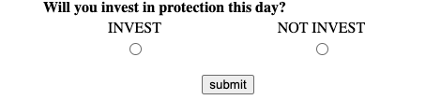
<<page break>>
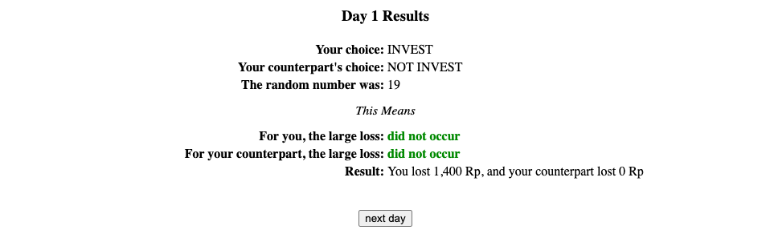
<<page break>>

No matter what, you will earn a base pay of 8,500 Rp this day. Here is a table summarizing the possible additional outcomes, depending on your decision (whether to invest or not) and the decision of your counterpart:

Day 2

 |  | Your Counterpart
 |  | INVEST | NOT INVEST
You | INVEST | - You definitely lose 1,400 Rp, and have a 0% chance of the large loss occurring.  - Your counterpart definitely loses 1,400 Rp, and has a 0% chance of the large loss occurring. | - You definitely lose 1,400 Rp and have a 1% chance of losing an additional 40,000 Rp.  - Your counterpart has a 3% chance of losing 40,000 Rpand a 97% chance of losing 0 Rp
 | NOT INVEST | - You have a 3% chance of losing 40,000 Rp and a 97% chance of losing 0 Rp.  - Your counterpart definitely loses 1,400 Rp and has a 1% chance of losing an additional 40,000 Rp. | - You have a 4% chance of losing 40,000 Rp and a 96% chance of losing 0 Rp.  - Your counterpart has a 4% chance of losing 40,000 Rpand a 96% chance of losing 0 Rp.

<<page break>>
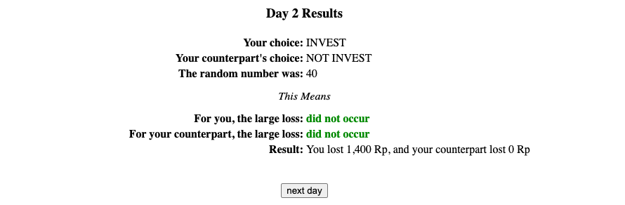
<<page break>>

No matter what, you will earn a base pay of 8,500 Rp this day. Here is a table summarizing the possible additional outcomes, depending on your decision (whether to invest or not) and the decision of your counterpart:

Day 3

 |  | Your Counterpart
 |  | INVEST | NOT INVEST
You | INVEST | - You definitely lose 1,400 Rp, and have a 0% chance of the large loss occurring.  - Your counterpart definitely loses 1,400 Rp, and has a 0% chance of the large loss occurring. | - You definitely lose 1,400 Rp and have a 1% chance of losing an additional 40,000 Rp.  - Your counterpart has a 3% chance of losing 40,000 Rpand a 97% chance of losing 0 Rp
 | NOT INVEST | - You have a 3% chance of losing 40,000 Rp and a 97% chance of losing 0 Rp.  - Your counterpart definitely loses 1,400 Rp and has a 1% chance of losing an additional 40,000 Rp. | - You have a 4% chance of losing 40,000 Rp and a 96% chance of losing 0 Rp.  - Your counterpart has a 4% chance of losing 40,000 Rpand a 96% chance of losing 0 Rp.

<<page break>>
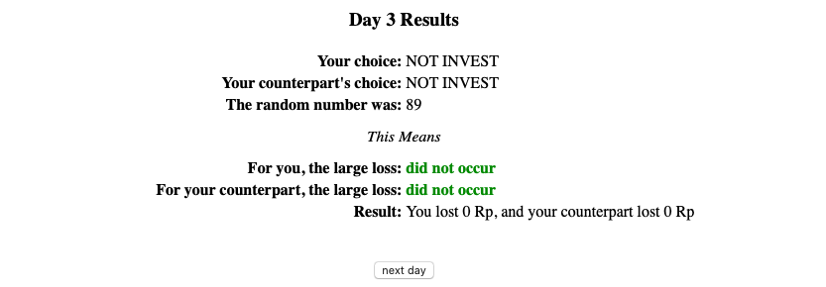
<<page break>>
.
.
.
No matter what, you will earn a base pay of 8,500 Rp this day. Here is a table summarizing the possible additional outcomes, depending on your decision (whether to invest or not) and the decision of your counterpart:

Day 20

 |  | Your Counterpart
 |  | INVEST | NOT INVEST
You | INVEST | - You definitely lose 1,400 Rp, and have a 0% chance of the large loss occurring.  - Your counterpart definitely loses 1,400 Rp, and has a 0% chance of the large loss occurring. | - You definitely lose 1,400 Rp and have a 1% chance of losing an additional 40,000 Rp.  - Your counterpart has a 3% chance of losing 40,000 Rpand a 97% chance of losing 0 Rp
 | NOT INVEST | - You have a 3% chance of losing 40,000 Rp and a 97% chance of losing 0 Rp.  - Your counterpart definitely loses 1,400 Rp and has a 1% chance of losing an additional 40,000 Rp. | - You have a 4% chance of losing 40,000 Rp and a 96% chance of losing 0 Rp.  - Your counterpart has a 4% chance of losing 40,000 Rpand a 96% chance of losing 0 Rp.

<<page break>>
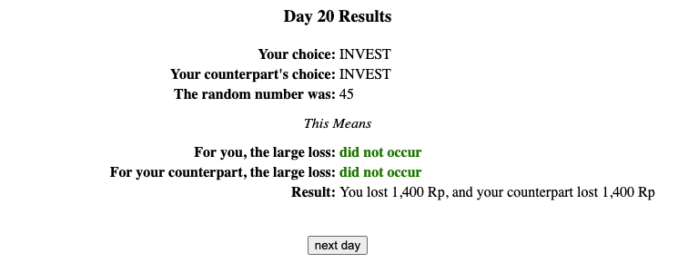
<<page break>>

Precommitted Condition:

No matter what, you will earn a base pay of 8,500 Rp each day. Here is a table summarizing the possible additional outcomes, depending on your decision (whether to invest or not) and the decision of your counterpart:

Each day

 |  | Your Counterpart
 |  | INVEST | NOT INVEST
You | INVEST | - You definitely lose 1,400 Rp, and have a 0% chance of the large loss occurring.  - Your counterpart definitely loses 1,400 Rp, and has a 0% chance of the large loss occurring. | - You definitely lose 1,400 Rp and have a 1% chance of losing an additional 40,000 Rp.  - Your counterpart has a 3% chance of losing 40,000 Rp and a 97% chance of losing 0 Rp
 | NOT INVEST | - You have a 3% chance of losing 40,000 Rp and a 97% chance of losing 0 Rp.  - Your counterpart definitely loses 1,400 Rp and has a 1% chance of losing an additional 40,000 Rp. | - You have a 4% chance of losing 40,000 Rp and a 96% chance of losing 0 Rp.  - Your counterpart has a 4% chance of losing 40,000 Rp and a 96% chance of losing 0 Rp.

Now you will make your choices for all 20 days:
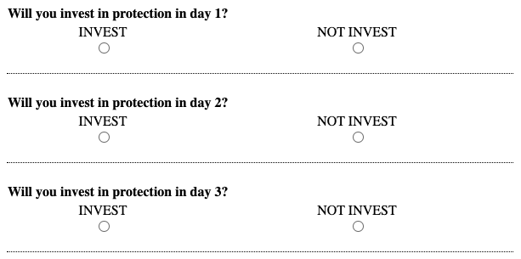
.
.
.
<<page break>>
<<page break>>
<<page break>>
<<page break>>
.
.
.
<<page break>>

Non-Binding Precommitment Condition:

No matter what, you will earn a base pay of 8,500 Rp this day. Here is a table summarizing the possible additional outcomes, depending on your decision (whether to invest or not) and the decision of your counterpart:
Each day

 |  | Your Counterpart
 |  | INVEST | NOT INVEST
You | INVEST | - You definitely lose 1,400 Rp, and have a 0% chance of the large loss occurring.  - Your counterpart definitely loses 1,400 Rp, and has a 0% chance of the large loss occurring. | - You definitely lose 1,400 Rp and have a 1% chance of losing an additional 40,000 Rp.  - Your counterpart has a 3% chance of losing 40,000 Rp and a 97% chance of losing 0 Rp
 | NOT INVEST | - You have a 3% chance of losing 40,000 Rp and a 97% chance of losing 0 Rp.  - Your counterpart definitely loses 1,400 Rp and has a 1% chance of losing an additional 40,000 Rp. | - You have a 4% chance of losing 40,000 Rp and a 96% chance of losing 0 Rp.  - Your counterpart has a 4% chance of losing 40,000 Rp and a 96% chance of losing 0 Rp.

Now you will make your choices for the next 20 days:
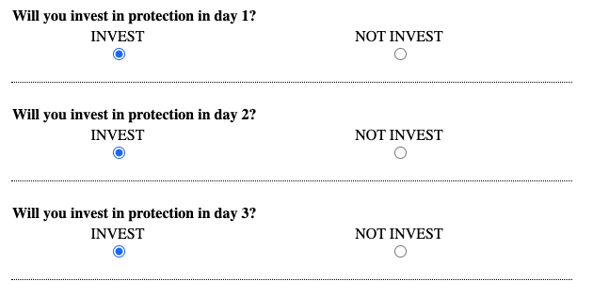
.
.
.
<<page break>>
<<page break>>

No matter what, you will earn a base pay of 8,500 Rp this day. Here is a table summarizing the possible additional outcomes, depending on your decision (whether to invest or not) and the decision of your counterpart:
Each day

 |  | Your Counterpart
 |  | INVEST | NOT INVEST
You | INVEST | - You definitely lose 1,400 Rp, and have a 0% chance of the large loss occurring.  - Your counterpart definitely loses 1,400 Rp, and has a 0% chance of the large loss occurring. | - You definitely lose 1,400 Rp and have a 1% chance of losing an additional 40,000 Rp.  - Your counterpart has a 3% chance of losing 40,000 Rp and a 97% chance of losing 0 Rp
 | NOT INVEST | - You have a 3% chance of losing 40,000 Rp and a 97% chance of losing 0 Rp.  - Your counterpart definitely loses 1,400 Rp and has a 1% chance of losing an additional 40,000 Rp. | - You have a 4% chance of losing 40,000 Rp and a 96% chance of losing 0 Rp.  - Your counterpart has a 4% chance of losing 40,000 Rp and a 96% chance of losing 0 Rp.

Now you will make your choices for the next 19 days:

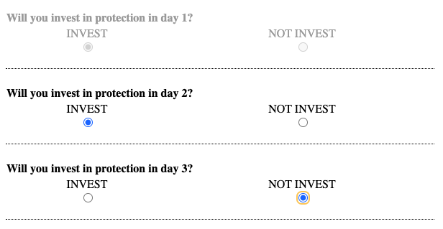
.
.
.
<<page break>>

<<page break>>

No matter what, you will earn a base pay of 8,500 Rp this day. Here is a table summarizing the possible additional outcomes, depending on your decision (whether to invest or not) and the decision of your counterpart:
Each day

 |  | Your Counterpart
 |  | INVEST | NOT INVEST
You | INVEST | - You definitely lose 1,400 Rp, and have a 0% chance of the large loss occurring.  - Your counterpart definitely loses 1,400 Rp, and has a 0% chance of the large loss occurring. | - You definitely lose 1,400 Rp and have a 1% chance of losing an additional 40,000 Rp.  - Your counterpart has a 3% chance of losing 40,000 Rp and a 97% chance of losing 0 Rp
 | NOT INVEST | - You have a 3% chance of losing 40,000 Rp and a 97% chance of losing 0 Rp.  - Your counterpart definitely loses 1,400 Rp and has a 1% chance of losing an additional 40,000 Rp. | - You have a 4% chance of losing 40,000 Rp and a 96% chance of losing 0 Rp.  - Your counterpart has a 4% chance of losing 40,000 Rp and a 96% chance of losing 0 Rp.

Now you will make your choices for the next 18 days:

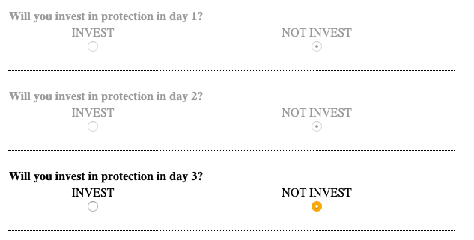
.
.
.
<<page break>>
<<page break>>
.
.
.
No matter what, you will earn a base pay of 8,500 Rp this day. Here is a table summarizing the possible additional outcomes, depending on your decision (whether to invest or not) and the decision of your counterpart:
Each day

 |  | Your Counterpart
 |  | INVEST | NOT INVEST
You | INVEST | - You definitely lose 1,400 Rp, and have a 0% chance of the large loss occurring.  - Your counterpart definitely loses 1,400 Rp, and has a 0% chance of the large loss occurring. | - You definitely lose 1,400 Rp and have a 1% chance of losing an additional 40,000 Rp.  - Your counterpart has a 3% chance of losing 40,000 Rp and a 97% chance of losing 0 Rp
 | NOT INVEST | - You have a 3% chance of losing 40,000 Rp and a 97% chance of losing 0 Rp.  - Your counterpart definitely loses 1,400 Rp and has a 1% chance of losing an additional 40,000 Rp. | - You have a 4% chance of losing 40,000 Rp and a 96% chance of losing 0 Rp.  - Your counterpart has a 4% chance of losing 40,000 Rp and a 96% chance of losing 0 Rp.

Now you will make your choices for the next 1 days:
.
.
.
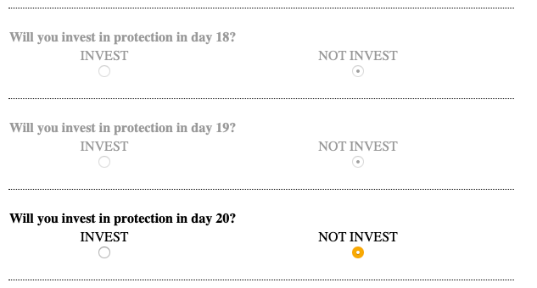
<<page break>>
<<page break>>

All Conditions:

You've finished the 20 days of the session. Here's a day by day summary of what happened:
Day # | Your Choice | Counterpart's Choice | Random Number | Large Loss | Your Payout | Counterpart's Payout | Your Cumulative Payout
1 | invest | not invest | 19 | Did not occur to you. Did not occur to your counterpart. | 7,100 | 8,500 | 7,100
2 | invest | not invest | 40 | Did not occur to you. Did not occur to your counterpart. | 7,100 | 8,500 | 14,200
3 | not invest | not invest | 89 | Did not occur to you. Did not occur to your counterpart. | 8,500 | 8,500 | 22,700
4 | invest | not invest | 38 | Did not occur to you. Did not occur to your counterpart. | 7,100 | 8,500 | 29,800
5 | invest | not invest | 14 | Did not occur to you. Did not occur to your counterpart. | 7,100 | 8,500 | 36,900
6 | invest | not invest | 69 | Did not occur to you. Did not occur to your counterpart. | 7,100 | 8,500 | 44,000
7 | invest | not invest | 72 | Did not occur to you. Did not occur to your counterpart. | 7,100 | 8,500 | 51,100
8 | invest | not invest | 60 | Did not occur to you. Did not occur to your counterpart. | 7,100 | 8,500 | 58,200
9 | invest | not invest | 10 | Did not occur to you. Did not occur to your counterpart. | 7,100 | 8,500 | 65,300
10 | invest | not invest | 18 | Did not occur to you. Did not occur to your counterpart. | 7,100 | 8,500 | 72,400
11 | invest | not invest | 10 | Did not occur to you. Did not occur to your counterpart. | 7,100 | 8,500 | 79,500
12 | invest | not invest | 85 | Did not occur to you. Did not occur to your counterpart. | 7,100 | 8,500 | 86,600
13 | invest | not invest | 71 | Did not occur to you. Did not occur to your counterpart. | 7,100 | 8,500 | 93,700
14 | invest | not invest | 46 | Did not occur to you. Did not occur to your counterpart. | 7,100 | 8,500 | 100,800
15 | invest | not invest | 29 | Did not occur to you. Did not occur to your counterpart. | 7,100 | 8,500 | 107,900
16 | invest | not invest | 6 | Did not occur to you. Did not occur to your counterpart. | 7,100 | 8,500 | 115,000
17 | invest | not invest | 88 | Did not occur to you. Did not occur to your counterpart. | 7,100 | 8,500 | 122,100
18 | invest | not invest | 96 | Did not occur to you. Did not occur to your counterpart. | 7,100 | 8,500 | 129,200
19 | invest | not invest | 53 | Did not occur to you. Did not occur to your counterpart. | 7,100 | 8,500 | 136,300
20 | invest | not invest | 42 | Did not occur to you. Did not occur to your counterpart. | 7,100 | 8,500 | 143,400

Additional Questions
You have finished the main portion of the study. Now we will ask you some follow-up questions and demographics.
What are your thoughts on playing the game? Please give a brief summary of why you chose to invest or not invest. Please tell us about your decision processes and underlying reasons:
[text entry box]
How happy are you with your choices and the outcomes of the game?
[Multiple Choice] Very Unhappy/Somewhat Unhappy/A Little Unhappy/A Little Happy/Somewhat Happy/Very Happy
If you knew for sure that your counterpart would invest every round, regardless of your choices, how many times out of 20 would you invest?
[text entry box]
If you knew for sure that your counterpart would NOT invest every round, regardless of your choices, how many times out of 20 would you invest?
[text entry box]
How important was it for you to invest so as not to cause the other person loss?
[Multiple Choice] Not at all important/A little important/Somewhat important/Very important

<<page break>>

Demographics

Please complete the following information about yourself.
Age (e.g., 22)
[text entry box]
Gender
[Multiple Choice] Male/Female/Other
Occupation
[Multiple Choice] Student/Other Education Related Job/Other
If student, your major or field of study
[Multiple Choice] Biological sciences/ Business/Computer/Science/Economics/Engineering/ (Government/Political Science)/Health professions /Language & Literature /Psychology Other
Ethnicity
[Multiple Choice] Asian /Black or African /Hispanic or Latino/ Indigenous /Pacific Islander /White or Caucasian /Other
<<page break>>
Payment & Debriefing

Here's a summary of your payment for the study:
Randomly Selected Session Number To Pay Out: | 1
Payout In Rupia For That Game: | 143,400 Rp
Payout In Dollars: | $10.52
Thank you for participating! If you have friends who might participate in the study, please don't tell them about your experiences until after they participate, as they may be put in a different experimental condition than you.

<<page break>>

Finished
You are all done! Please see the experimenter to receive your payment and sign the receipt of payment form. If you have questions at any time, please ask the study administrator.

Study S1 - Gain Loss: Study Materials
Solo Game – Loss Scenario [Gain Scenario]
Instructions (pg 1 of 5)
Your choices will determine the payment you receive for participating. Therefore, you should pay careful attention to the instructions which follow.

Scenario: Imagine you own a mining company in Indonesia and you extract minerals from different regions each month. You receive a base income of 8,500 Rp [5,500 Rp] income per month, regardless of your choice of region. You must [may] also pay an [receive an additional] amount each month, depending on which region you choose.
You must decide between investing in the “Known” regions or in the “Unknown” regions. In the Known regions, the conditions are stable, and you will pay a fixed amount of 1,400 Rp for maintenance [receive a fixed amount of 1,400 from extraction] that month. In the Unknown regions, the conditions are uncertain. There is a 4% chance that you will pay 40,000 Rp for maintenance [receive 40,000 Rp from extraction] that month, otherwise you will pay[receive] nothing that month.

Instructions (pg 2 of 5)
This is a scenario in which the outcomes of your decisions depend on what you do and on random chance. Over the course of 20 "months" (ie, rounds), you will earn money and then make a decision about whether to invest in the Known region or in the Unknown one. Gains and losses will be measured in the Indonesian currency, the rupiah (or Rp). Exchange rate: 13632 Rp. = $1.
Instructions (pg 3 of 5)
Here is a summary of the possible outcomes, depending on your choice:

- Each month, you will each earn a base income of 8,500 Rp [5,500 Rp] (you will always receive this income, no matter what else happens).

- If you choose the Known region, then you must pay 1,400 Rp [will earn 1,400 Rp], and there is a 0% chance that the large loss [gain] will occur.

- If you choose the Unknown region, then there is a 4% chance you will lose [earn] 40,000 Rp and there is a 96% chance of losing [earning] 0 Rp.

Probabilistic outcomes will be determined by a random number generator, where it is equally likely that any number between 1 and 100 is chosen. In other words, the computer fairly and randomly selects a random number. The large loss [gain] will occur if lower numbers are chosen. In other words, if there is a 4% chance of the large loss [gain] occurring, it will occur when the number randomly chosen is a 1, 2, 3 or 4.
Instructions (pg 4 of 5)
You will play 4 sessions, of 20 months each. At the end of the study, we will randomly choose 1 of the 4 sessions you completed and convert the Rupiah (Rp) earned in that session to Canadian dollars, at the rate of 13632 Rp = $1, and pay it out for real money. This will be your payment for participating in the study. Because any session could potentially be paid out for real money, you should take all your choices seriously.

Payments for the study are often in the neighborhood of $10. In the very unlikely event that you finish with negative dollars, we would ask you to stay and volunteer to complete other studies, at the rate of 25 cents a minute, to pay back what you owe. For example, if you finish the study down $5, we would ask you to stay for an additional 20 minutes.
Instructions (pg 5 of 5)
Choice decision: Repeated / Choice display: Separate: You will play one month at a time. After each month, you will learn the random number chosen by the computer, and whether the large loss [gain] occurred in that month. After all 20 months, you will see a summary for the entire session, including your choices and the outcomes in each month.

Choice decision: Repeated / Choice display: aggregate: You will see the decision options for all 20 months of the session, but you will play only one month at a time. After each month, you will learn the random number chosen by the computer, and whether the large loss [gain] occurred in that month. Then, you will be re-directed to the choice table and make your decision for next month. After all 20 months, you will see a summary for the entire session, including your choices and the outcomes in each month.

Choice decision: Precommitted/ Choice display: aggregated: You will see the decision options for all 20 months of the session and you will precommit your choices for all 20 months in the session. After you make your choices, all 20 months will be played out at once. You will learn the random number chosen by the computer for each month, and whether the large loss [gain] occurred in that month. Then, you will see a summary for the entire session, including your choices and the outcomes in each month.

Choice decision: Precommitted/ Choice display: separate: You will precommit your choices for all 20 months in the session, one choice on each screen. After you make your choices, all 20 months will be played out at once. You will learn the random number chosen by the computer for each month separately, and whether the large loss [gain] occurred in that month. Then, you will see a summary for the entire session, including your choices and the outcomes in each month.

Summary and Comprehension Check
No matter what, you will earn a base pay of 8,500 Rp [5,500 Rp.] each month. Here is a table summarizing the possible additional outcomes, depending on your decision (whether to mine the Known region or the Unknown region):
Month
Known region | You definitely lose 1,400 Rp, and have a 0% chance of the large loss occurring.  [You definitely receive 1,400 Rp, and have a 0% chance of the large gain occurring.]
Unknown region | You have a 4% chance of losing 40,000 Rp and a 96% chance of losing 0 Rp.  [You have a 4% chance of receiving 40,000 Rp and a 96% chance of receiving 0 Rp.]

1. If you decide to mine the Known region, how many Rp would you definitely lose [receive]? (please give your answer as an integer)
*Text entry box*
2a. If you mine the Unknown region, what is the percent chance that you will suffer a big loss [receive a big gain] in any given month? (please give your answer as an integer)
*Text entry box*
2b. If you mine the Unknown region, and you do suffer a loss [receive the big gain], how many Rp would this cause you lose [to receive]? (please give your answer as an integer)
*Text entry box*
3. If you decide to mine the Unknown region, what is the percent chance that you will NOT suffer a big loss [receive a big gain] in any given month? (please give your answer as an integer)
*Text entry box*

Experimental Materials for Choice Options

Solo Game – Choice decision: Repeated / Choice display: Separate
No matter what, you will earn a base pay of 8,500 Rp [5,500 Rp.] each month. Here is a table summarizing the possible additional outcomes, depending on your decision (whether to mine the Known region or the Unknown region):
Month 1
Known region | You definitely lose 1,400 Rp, and have a 0% chance of the large loss occurring.  [You definitely receive 1,400 Rp, and have a 0% chance of the large gain occurring.]
Unknown region | You have a 4% chance of losing 40,000 Rp and a 96% chance of losing 0 Rp.  [You have a 4% chance of receiving 40,000 Rp and a 96% chance of receiving 0 Rp.]

<<<<Page break>>>>
How worried [hopeful] are you that the large loss [gain] would occur? Slider or a 1-10 horizontal multiple choice with labels. 0=not at all to 10=extremely)

How likely do you feel it is that the large loss [gain] occurs? Slider or a 1-10 horizontal multiple choice with labels. 0=not at all to 10=extremely)
<<<<Page break>>>>

Which region will you choose for this month?
Known region - Unknown region

Solo Game – Choice decision: Repeated / Choice display: aggregate
No matter what, you will earn a base pay of 8,500 Rp [5,500 Rp.] each month. Here is a table summarizing the possible additional outcomes, depending on your decision (whether to mine the Known region or the Unknown region):
Month 1
Known region | You definitely lose 1,400 Rp, and have a 0% chance of the large loss occurring.  [You definitely receive 1,400 Rp, and have a 0% chance of the large gain occurring.]
Unknown region | You have a 4% chance of losing 40,000 Rp and a 96% chance of losing 0 Rp.  [You have a 4% chance of receiving 40,000 Rp and a 96% chance of receiving 0 Rp.]

<<<<Page break>>>>
How worried [hopeful] are you that the large loss [gain] would occur? Slider or a 1-10 horizontal multiple choice with labels. 0=not at all to 10=extremely)

How likely do you feel it is that the large loss [gain] occurs? Slider or a 1-10 horizontal multiple choice with labels. 0=not at all to 10=extremely)
<<<<Page break>>>>
Month1
Which region will you choose for this month?
Known region - Unknown region
Month2
Which region will you choose for this month?
Known region - Unknown region
.
.
.
Month20
Which region will you choose for this month?
Known region - Unknown region

Solo Game – Choice decision: Precommitted/ Choice display: aggregated
No matter what, you will earn a base pay of 8,500 Rp [5,500 Rp.] each month. Here is a table summarizing the possible additional outcomes, depending on your decision (whether to mine the Known region or the Unknown region):
Each Month
Known region | You definitely lose 1,400 Rp, and have a 0% chance of the large loss occurring.  [You definitely receive 1,400 Rp, and have a 0% chance of the large gain occurring.]
Unknown region | You have a 4% chance of losing 40,000 Rp and a 96% chance of losing 0 Rp.  [You have a 4% chance of receiving 40,000 Rp and a 96% chance of receiving 0 Rp.]

<<<<Page break>>>>
How worried [hopeful] are you that the large loss [gain] would occur? Slider or a 1-10 horizontal multiple choice with labels. 0=not at all to 10=extremely)

How likely do you feel it is that the large loss [gain] occurs? Slider or a 1-10 horizontal multiple choice with labels. 0=not at all to 10=extremely)
<<<<Page break>>>>

Which region will you choose for month 1?
Known region - Unknown region

Which region will you choose for month2?
Known region - Unknown region

Which region will you choose for month3?
Known region - Unknown region

Which region will you choose for month4?
Known region - Unknown region

Which region will you choose for month5?
Known region - Unknown region

Which region will you choose for month6?
Known region - Unknown region

Which region will you choose for month7?
Known region - Unknown region

Which region will you choose for month8?
Known region - Unknown region

Which region will you choose for month9?
Known region - Unknown region

Which region will you choose for month10?
Known region - Unknown region

Which region will you choose for month11?
Known region - Unknown region

Which region will you choose for month12?
Known region - Unknown region

Which region will you choose for month13?
Known region - Unknown region

Which region will you choose for month14?
Known region - Unknown region

Which region will you choose for month15?
Known region - Unknown region

Which region will you choose for month16?
Known region - Unknown region

Which region will you choose for month17?
Known region - Unknown region

Which region will you choose for month18?
Known region - Unknown region

Which region will you choose for month19?
Known region - Unknown region

Which region will you choose for month20?
Known region - Unknown region

Solo Game – Choice decision: Precommitted/ Choice display: separate
No matter what, you will earn a base pay of 8,500 Rp [5,500 Rp.] each month. Here is a table summarizing the possible additional outcomes, depending on your decision (whether to mine the Known region or the Unknown region):
Each Month
Known region | You definitely lose 1,400 Rp, and have a 0% chance of the large loss occurring.  [You definitely receive 1,400 Rp, and have a 0% chance of the large gain occurring.]
Unknown region | You have a 4% chance of losing 40,000 Rp and a 96% chance of losing 0 Rp.  [You have a 4% chance of receiving 40,000 Rp and a 96% chance of receiving 0 Rp.]

<<<<Page break>>>>
How worried [hopeful] are you that the large loss [gain] would occur? Slider or a 1-10 horizontal multiple choice with labels. 0=not at all to 10=extremely)

How likely do you feel it is that the large loss [gain] occurs? Slider or a 1-10 horizontal multiple choice with labels. 0=not at all to 10=extremely)
<<<<Page break>>>>

Which region will you choose for month 1?
Known region - Unknown region
<<<<Page break>>>>

Which region will you choose for month2?
Known region - Unknown region
<<<<Page break>>>>

Which region will you choose for month3?
Known region - Unknown region
<<<<Page break>>>>

Which region will you choose for month4?
Known region - Unknown region
<<<<Page break>>>>

Which region will you choose for month5?
Known region - Unknown region
<<<<Page break>>>>

Which region will you choose for month6?
Known region - Unknown region
<<<<Page break>>>>

Which region will you choose for month7?
Known region - Unknown region
<<<<Page break>>>>

Which region will you choose for month8?
Known region - Unknown region
<<<<Page break>>>>

Which region will you choose for month9?
Known region - Unknown region
<<<<Page break>>>>

Which region will you choose for month10?
Known region - Unknown region
<<<<Page break>>>>

Which region will you choose for month11?
Known region - Unknown region
<<<<Page break>>>>

Which region will you choose for month12?
Known region - Unknown region
<<<<Page break>>>>

Which region will you choose for month13?
Known region - Unknown region

Which region will you choose for month14?
Known region - Unknown region
<<<<Page break>>>>

Which region will you choose for month15?
Known region - Unknown region
<<<<Page break>>>>

Which region will you choose for month16?
Known region - Unknown region
<<<<Page break>>>>

Which region will you choose for month17?
Known region - Unknown region
<<<<Page break>>>>

Which region will you choose for month18?
Known region - Unknown region
<<<<Page break>>>>

Which region will you choose for month19?
Known region - Unknown region
<<<<Page break>>>>

Which region will you choose for month20?
Known region - Unknown region
<<<<Page break>>>>
[All conditions]
Demographic questions block:
What is your gender? [choice] Male/Female/Other
What is your age? [text entry box]
What is your ethnicity? [choice] White / Hispanic or Latino / Black or African American / Native American or American Indian /Asian or Pacific Islander / Other
What is your major? [text entry box]
How comfortable you feel with mathematics? 1-not at all to 7-very

Study S2 - Probability levels: Study Materials
4% condition, [20% condition], [50% condition]
Instructions (pg 1 of 5)
Your choices will determine the objectives of our research and are very important to us. Therefore, please pay careful attention to the instructions which follow.

Scenario: Imagine you own a mining company in Indonesia and you extract minerals from different regions each month. You receive a base income of 8,500 Rp income per month, regardless of your choice of region. You must also pay an amount each month, depending on which region you choose.
You must decide between investing in the “Known” regions or in the “Unknown” regions. In the Known regions, the conditions are stable, and you will pay a fixed amount of 1,400 Rp for maintenance that month. In the Unknown regions, the conditions are uncertain. There is a 4% [20%] [50%] chance that you will pay 40,000 [8000] [3200] Rp for maintenance that month, otherwise you will pay nothing that month.

Instructions (pg 2 of 5)
This is a scenario in which the outcomes of your decisions depend on what you do and on random chance. Over the course of 20 "months" (ie, rounds), you will earn money and then make a decision about whether to invest in the Known region or in the Unknown one. Gains and losses will be measured in the Indonesian currency, the rupiah (or Rp). Exchange rate: 13632 Rp. = $1.
Instructions (pg 3 of 5)
Here is a summary of the possible outcomes, depending on your choice:

- Each month, you will each earn a base income of 8,500 Rp (you will always receive this income, no matter what else happens).

- If you choose the Known region, then you must pay 1,400 Rp, and there is a 0% chance that the additional loss will occur.

- If you choose the Unknown region, then there is a 4% [20%] [50%] chance you will lose 40,000 [8000] [3200] Rp and there is a 96% [80%] [50%] chance of losing 0 Rp.

Probabilistic outcomes will be determined by a random number generator, where it is equally likely that any number between 1 and 100 is chosen. In other words, the computer fairly and randomly selects a random number. The additional loss will occur if lower numbers are chosen. In other words, if there is a 4% [20%] [50%] chance of the additional loss occurring, it will occur when the number randomly chosen is a 1, 2, 3 or 4 [is between 1 through 20] [is between 1 through 50] .
Instructions (pg 4 of 5)
You will play 4 sessions, of 20 months each. At the end of the study, we will randomly choose 1 of the 4 sessions you completed and convert the Rupiah (Rp) earned in that session to Canadian dollars, at the rate of 13632 Rp = $1, and record that as your performance in this game. This will be compared to what others did in the study. Because any session could potentially be recorded as your performance session, you should take all your choices seriously.

Instructions (pg 5 of 5)
Choice decision: Repeated: You will play one month at a time. After each month, you will learn the random number chosen by the computer, and whether the additional loss occurred in that month. After all 20 months, you will see a summary for the entire session, including your choices and the outcomes in each month.

Choice decision: Precommitted: You will see the decision options for all 20 months of the session and you will precommit your choices for all 20 months in the session. After you make your choices, all 20 months will be played out at once. You will learn the random number chosen by the computer for each month, and whether the additional loss occurred in that month. Then, you will see a summary for the entire session, including your choices and the outcomes in each month.

Summary and Comprehension Check
No matter what, you will earn a base pay of 8,500 Rp each month. Here is a table summarizing the possible additional outcomes, depending on your decision (whether to mine the Known region or the Unknown region):
Month
Known region | You definitely lose 1,400 Rp, and have a 0% chance of the additional loss occurring.
Unknown region | You have a 4% [20%] [50%] chance of losing 40,000 [8000] [3200] Rp and a 96% [80%] [50%] chance of losing 0 Rp.

1. If you decide to mine the Known region, how many Rp would you definitely lose ? (please give your answer as an integer)
*Text entry box* answer should be 1400
2a. If you mine the Unknown region, what is the percent chance that you will suffer an additional loss in any given month? (please give your answer as an integer)
*Text entry box*Answers for the 4, 20, and 50 percent conditions should be “4”, “20”, and “50”, respectively.
2b. If you mine the Unknown region, and you do suffer an additional loss , how many Rp would this cause you lose? (please give your answer as an integer)
*Text entry box* Answers should be 40000, 8000, and 3200, respectively.
3. If you decide to mine the Unknown region, what is the percent chance that you will NOT suffer an additional loss in any given month? (please give your answer as an integer)
*Text entry box* Answers should be 96, 80, and 50, respectively.

Choice materials are similar to those of repeated and precommitment conditions in the previous studies.

Study S3 - Time-horizon manipulation: Study Materials
Big loss=40K [Big loss=30K]
Instructions (pg 1 of 5)
Your choices will determine the objectives of our research and are very important to us. Therefore, please pay careful attention to the instructions which follow.
Scenario: Imagine you own a mining company in Indonesia and you extract minerals from different regions each month. You receive a base income of 8,500 Rp income per month, regardless of your choice of region. You must also pay an amount each month, depending on which region you choose.
You must decide between investing in the “Known” regions or in the “Unknown” regions. In the Known regions, the conditions are stable, and you will pay a fixed amount of 1,400 Rp for maintenance that month. In the Unknown regions, the conditions are uncertain. There is a 4% chance that you will pay 40,000 [30,000] Rp for maintenance that month, otherwise you will pay nothing that month.

Instructions (pg 2 of 5)
This is a scenario in which the outcomes of your decisions depend on what you do and on random chance. Over the course of 20 "months" (ie, rounds), you will earn money and then make a decision about whether to invest in the Known region or in the Unknown one. Gains and losses will be measured in the Indonesian currency, the rupiah (or Rp). Exchange rate: 13632 Rp. = $1.
Instructions (pg 3 of 5)
Here is a summary of the possible outcomes, depending on your choice:

- Each month, you will each earn a base income of 8,500 Rp (you will always receive this income, no matter what else happens).

- If you choose the Known region, then you must pay 1,400 Rp, and there is a 0% chance that the large loss will occur.

- If you choose the Unknown region, then there is a 4% chance you will lose 40,000 [30,000] Rp and there is a 96% chance of losing 0 Rp.

Probabilistic outcomes will be determined by a random number generator, where it is equally likely that any number between 1 and 100 is chosen. In other words, the computer fairly and randomly selects a random number. The large loss will occur if lower numbers are chosen. In other words, if there is a 4% chance of the large loss occurring, it will occur when the number randomly chosen is a 1, 2, 3 or 4.
Instructions (pg 4 of 5)
You will play 4 sessions, of 20 months each. At the end of the study, we will randomly choose 1 of the 4 sessions you completed and convert the Rupiah (Rp) earned in that session to Canadian dollars, at the rate of 13632 Rp = $1, and record that as your performance in this game. This will be compared to what others did in the study. Because any session could potentially be recorded as your performance session, you should take all your choices seriously.

Instructions (pg 5 of 5)
Choice decision: Repeated / Choice focus prime: Control: You will play one month at a time. After each month, you will learn the random number chosen by the computer, and whether the large loss occurred in that month. After all 20 months, you will see a summary for the entire session, including your choices and the outcomes in each month.

Choice decision: Repeated / Choice focus prime: aggregate: You will play one month at a time. After each month, you will learn the random number chosen by the computer, and whether the large loss occurred in that month. After all 20 months, you will see a summary for the entire session, including your choices and the outcomes in each month.

Choice decision: Precommitted/ Choice focus prime: aggregate: You will see the decision options for all 20 months of the session and you will precommit your choices for all 20 months in the session. After you make your choices, all 20 months will be played out at once. You will learn the random number chosen by the computer for each month, and whether the large loss occurred in that month. Then, you will see a summary for the entire session, including your choices and the outcomes in each month.

Choice decision: Precommitted/ Choice focus prime: Control: You will see the decision options for all 20 months of the session and you will precommit your choices for all 20 months in the session. After you make your choices, all 20 months will be played out at once. You will learn the random number chosen by the computer for each month, and whether the large loss occurred in that month. Then, you will see a summary for the entire session, including your choices and the outcomes in each month.

Summary and Comprehension Check
No matter what, you will earn a base pay of 8,500 Rp each month. Here is a table summarizing the possible additional outcomes, depending on your decision (whether to mine the Known region or the Unknown region):
Month
Known region | You definitely lose 1,400 Rp, and have a 0% chance of the large loss occurring.
Unknown region | You have a 4% chance of losing 40,000 [30,000] Rp and a 96% chance of losing 0 Rp.

1. If you decide to mine the Known region, how many Rp would you definitely lose? (please give your answer as an integer)
*Text entry box*
2a. If you mine the Unknown region, what is the percent chance that you will suffer a big loss in any given month? (please give your answer as an integer)
*Text entry box*
2b. If you mine the Unknown region, and you do suffer a loss, how many Rp would this cause you lose? (please give your answer as an integer)
*Text entry box* validation= 40,000 [30,000]
3. If you decide to mine the Unknown region, what is the percent chance that you will NOT suffer a big loss in any given month? (please give your answer as an integer)
*Text entry box*

Experimental Materials for Choice Options

Solo Game – Choice decision: Repeated / Choice focus prime: Control
<<<Page break>>>
No matter what, you will earn a base pay of 8,500 Rp each month. Here is a table summarizing the possible additional outcomes, depending on your decision (whether to mine the Known region or the Unknown region):

Known region | You definitely lose 1,400 Rp, and have a 0% chance of the large loss occurring.
Unknown region | You have a 4% chance of losing 40,000 [30,000] Rp and a 96% chance of losing 0 Rp.

Solo Game – Choice decision: Repeated / Choice focus prime: aggregate
Before you start, think about all 20 rounds that you are about to play. What strategy do you think would serve you best across all 20 rounds? *Open-ended text-box*
How many out of the 20 rounds do you think you should invest? *Drop-down 1 to 20*
<<<Page break>>>
No matter what, you will earn a base pay of 8,500 Rp each month. Here is a table summarizing the possible additional outcomes, depending on your decision (whether to mine the Known region or the Unknown region):

Known region | You definitely lose 1,400 Rp, and have a 0% chance of the large loss occurring.
Unknown region | You have a 4% chance of losing 40,000 [30,000] Rp and a 96% chance of losing 0 Rp.

Solo Game – Choice decision: Precommitted/ Choice focus prime: aggregated
Before you start, think about all 20 rounds that you are about to play. What strategy do you think would serve you best across all 20 rounds? *Open-ended text-box*
How many out of the 20 rounds do you think you should invest? *Drop-down 1 to 20*

<<<Page break>>>
No matter what, you will earn a base pay of 8,500 Rp each month. Here is a table summarizing the possible additional outcomes, depending on your decision (whether to mine the Known region or the Unknown region):
Each Month
Known region | You definitely lose 1,400 Rp, and have a 0% chance of the large loss occurring.
Unknown region | You have a 4% chance of losing 40,000 [30,000] Rp and a 96% chance of losing 0 Rp.

Which region will you choose for month 1?
Known region - Unknown region

Which region will you choose for month2?
Known region - Unknown region

Which region will you choose for month3?
Known region - Unknown region

Which region will you choose for month4?
Known region - Unknown region

Which region will you choose for month5?
Known region - Unknown region

Which region will you choose for month6?
Known region - Unknown region

Which region will you choose for month7?
Known region - Unknown region

Which region will you choose for month8?
Known region - Unknown region

Which region will you choose for month9?
Known region - Unknown region

Which region will you choose for month10?
Known region - Unknown region

Which region will you choose for month11?
Known region - Unknown region

Which region will you choose for month12?
Known region - Unknown region

Which region will you choose for month13?
Known region - Unknown region

Which region will you choose for month14?
Known region - Unknown region

Which region will you choose for month15?
Known region - Unknown region

Which region will you choose for month16?
Known region - Unknown region

Which region will you choose for month17?
Known region - Unknown region

Which region will you choose for month18?
Known region - Unknown region

Which region will you choose for month19?
Known region - Unknown region

Which region will you choose for month20?
Known region - Unknown region

Solo Game – Choice decision: Precommitted/ Choice display: Control
<<<Page break>>>
No matter what, you will earn a base pay of 8,500 Rp each month. Here is a table summarizing the possible additional outcomes, depending on your decision (whether to mine the Known region or the Unknown region):
Each Month
Known region | You definitely lose 1,400 Rp, and have a 0% chance of the large loss occurring.
Unknown region | You have a 4% chance of losing 40,000 [30,000] Rp and a 96% chance of losing 0 Rp.

Which region will you choose for month 1?
Known region - Unknown region
<<<<Page break>>>>

Which region will you choose for month2?
Known region - Unknown region
<<<<Page break>>>>

Which region will you choose for month3?
Known region - Unknown region
<<<<Page break>>>>

Which region will you choose for month4?
Known region - Unknown region
<<<<Page break>>>>

Which region will you choose for month5?
Known region - Unknown region
<<<<Page break>>>>

Which region will you choose for month6?
Known region - Unknown region
<<<<Page break>>>>

Which region will you choose for month7?
Known region - Unknown region
<<<<Page break>>>>

Which region will you choose for month8?
Known region - Unknown region
<<<<Page break>>>>

Which region will you choose for month9?
Known region - Unknown region
<<<<Page break>>>>

Which region will you choose for month10?
Known region - Unknown region
<<<<Page break>>>>

Which region will you choose for month11?
Known region - Unknown region
<<<<Page break>>>>

Which region will you choose for month12?
Known region - Unknown region
<<<<Page break>>>>

Which region will you choose for month13?
Known region - Unknown region

Which region will you choose for month14?
Known region - Unknown region
<<<<Page break>>>>

Which region will you choose for month15?
Known region - Unknown region
<<<<Page break>>>>

Which region will you choose for month16?
Known region - Unknown region
<<<<Page break>>>>

Which region will you choose for month17?
Known region - Unknown region
<<<<Page break>>>>

Which region will you choose for month18?
Known region - Unknown region
<<<<Page break>>>>

Which region will you choose for month19?
Known region - Unknown region
<<<<Page break>>>>

Which region will you choose for month20?
Known region - Unknown region
<<<<Page break>>>>
[All conditions]
Demographic questions block:
What is your gender? [choice] Male/Female/Other
What is your age? [text entry box]
What is your ethnicity? [choice] White / Hispanic or Latino / Black or African American / Native American or American Indian /Asian or Pacific Islander / Other
What is your major? [text entry box]
How comfortable you feel with mathematics? 1-not at all to 7-very

There was no main effect of location (ie, which university) on investment rates, nor did location interact with the precommitment manipulation in any 2, 3, or 4-way interactions. Therefore, we collapse across sample location in the following analyses.
In this condition, the participants “saw” all the 20 choices ahead of them, but could only make decisions for one choice at a time (i.e., one per round).
In this condition, only the decision for one month was displayed to participants at a time, but the game was not played until participants have made all the 20 choices.

