Encouraging energy efficiency through goal-congruent product labeling

David J. Hardisty¹, William Wang¹, Yoonji Shim², & Dale Griffin¹
¹ The University of British Columbia, ² The Chinese University of Hong Kong, Shenzhen,

Author Note: Please direct correspondence to David J. Hardisty (david.hardisty@sauder.ubc.ca). This research was funded in part by a grant from the Social Sciences and Humanities Research Council of Canada. Ethics protocols (H14-02251, H15-00343, & H15-00581) were approved by the University of British Columbia Behavioural Research Ethics Board. Special thanks to Daniel Sun, who assisted in running study 1. Thanks also to Edward Van Dam at BC Hydro and Terry Pelletier at London Drugs for their collaboration, as well as BC Furnace & Air Conditioning Ltd for their assistance with the furnace information. Thank you to Kirstin Appelt, Adrian Camilleri, and Rishad Habib for their comments on earlier drafts of the paper. Thanks also to research assistants Jamie Drynan, Sammie Chan, Jennifer Kao, Sangmin Lee, and Mary Ho for their work on the project.

Abstract: The present research introduces a “10-year cost” label and examines how it can activate consumers’ latent goal of minimizing long-term financial costs. Five studies show that the 10-year cost label can effectively nudge consumers towards choosing energy-efficient products across multiple product categories in both the lab and field. This research contributes to the goal-based view of consumer choice by proposing that consumers generally hold a long-term cost goal: a consumption goal to minimize long-term financial costs. This goal is generally latent (rather than activated) for most consumers, who do not spontaneously consider cumulative long-term costs, even when relevant to a consumption choice (e.g., when purchasing energy-using products). We find the 10-year cost label is consistently the most effective label for nudging consumers in the energy domain, and its effectiveness is mediated by long-term cost goal activation. Furthermore, the “10-year cost” labeling nudge is only effective for those consumers who hold this latent goal. This research advances and unifies the prior research that has shown varying effects of energy and price labeling on purchase decisions, and defines the mechanism and conditions under which energy labeling can promote consumer choice of energy-efficient products.
Keywords: Product Labels, Attribute Framing, Goals, Intertemporal Choice, Energy Paradox

Encouraging energy efficiency through goal-congruent product labeling
Consumers are constantly faced with purchase decisions that involve trade-offs between immediate and long-term costs, such as deciding between a cheaper appliance with poor fuel efficiency and a more expensive appliance that will save energy costs in the long run. This has become increasing relevant recently, as power-hungry AI datacenters drive up consumer energy prices (Saul et al., 2025, Sep 29). Yet, faced with this choice, many consumers often make (long-term) cost-inefficient purchases (Hausman, 1979). A contributor to such cumulative inefficiency may be that consumers often do not consider the long-term costs of the products when making purchasing decisions. Field data supports this proposition: Allcott & Sweeney (2015) report that forty percent of American consumers “did not think about fuel costs at all” when purchasing an automobile. In the insurance domain, consumers are five times more sensitive to premiums than to out-of-pocket costs (Abaluck & Gruber, 2011). Thus, the future operational cost of efficient appliances or vehicles may be a type of “shrouded attribute,” a relevant product attribute that is not explicitly communicated to consumers (Gabaix & Laibson, 2006). Although an inefficient product manufacturer may find it desirable to keep the long-term cost shrouded, this is not necessarily in the best interest of retailers, who often earn higher margins on newer, more efficient products. Furthermore, the shrouded long-term cost not only prevents consumers from saving resources in the long run, but also reduces the uptake of innovative, energy-efficient products.
Evidence from the intertemporal choice literature shows that consumers do care about reducing long-term costs (Hardisty & Weber, 2020), but that future opportunity costs are not usually at the top of or even on their mind (D. Read et al., 2016). We propose that consumers do have a long-term financial cost minimization goal (henceforth, “long-term cost goal”), defined as a consumption goal to minimize long-term dollar costs. This goal is latent or inactive for many consumers, because long-term costs of efficient products are not salient, or at least much less salient than immediate up-front costs. This contributes to the alarmingly low adoption rate of energy-efficient products despite their large cost savings and environmental benefits (Jaffe & Stavins, 1994).
One behavioral strategy to improve consumer choices is information restructuring, a tool of “choice architecture”, where choice architecture refers to the contextual details that can shape a decision (Thaler & Sunstein, 2008). Specifically, product labels could be an effective tool to restructure information to make long-term costs salient and improve the low adoption rate of energy-efficient products. There is, however, a paucity of research on the role of energy and energy cost labeling on purchase decisions. Past studies show modest and somewhat unreliable effects and provide little guidance about when or why energy cost labeling is effective on purchase decisions. The present research proposes a novel energy label, the 10-year dollar cost of energy usage (henceforth, “10-year cost”) label. This label presents the future dollar cost of an energy product over the time span of 10 years. Building on goal activation theory (e.g., Van Osselaer & Janiszewski, 2012), we propose that the 10-year cost label serves as a contextual cue that increases the salience of the product’s long-term costs, thus activating consumers’ latent goal and increasing the proportion of goal-consistent choices. We show how the proposed long-term cost goal fits within the three types of goals of consumer decisions (Van Osselaer et al., 2005). We also use goal inhibition theory (Brendl et al., 2003) to show why long-term cost goals may be latent for consumers.
In five studies we demonstrate the robust effect of the 10-year cost label on consumer choice of energy-efficient products across multiple product categories in both the lab and the field. We provide experimental evidence to show that the activation of long-term cost goals plays both a mediating and moderating role and serves as the underlying mechanism for the effect of product labels on consumer choice. We also show that the long-term cost goal is specific to dollar costs, and that there is a reliable effect of attribute scaling across increasing time horizon, with the 10-year cost label being generally the strongest. Finally, we identify a boundary condition and show that the long-term cost label is selectively effective for consumers who self-report such a goal.
CONCEPTUAL DEVELOPMENT

Goal activation

Consumers’ decisions can be conceptualized as choosing a means, such as a product, to achieve three types of goals: consumption, criterion, and process goals (Van Osselaer et al., 2005). Consumption goals are the perceived benefits of using the product. In this case, one benefit of the efficient product is lower future dollar costs, an outcome which may not normally be salient to the consumer. Criterion goals are non-consumption goals such as being able to justify a choice or express a personality trait. In this case, some consumers may have the goal to choose the more “sensible” long-term option. Process goals are about the choosing rather than the final choice, such as a goal to avoid decision effort. In this case, the process of calculating future savings requires much decision effort from the consumers, adding friction to the efficient choice.
All three types of goals function as declarative memories (Kruglanski et al., 2002; S. J. Read, 1987). As such, they may be activated by associative connections to other concepts in memory or by contextual cues. Critically, goals that are more highly activated are more accessible and have a stronger impact on behavior (Van Osselaer & Janiszewski, 2012). We argue that while the long-term cost goal is cognitively represented in memory, the pathways’ activation in memory is lower relative to the activation of other pathways. Since people conduct a limited number of discrete searches from memory with the process goal of minimizing time and effort, it lowers the chance that the long-term cost goal is retrieved, explaining why it remains latent. Although evaluative appraisals can occur immediately and automatically, processing the long-term cost increases the temporary base-level activation of the latent goal. The extent of this increase depends on the perceptual salience of the pathways. The salient 10-year cost label can thus activate the latent goal and increase the proportion of goal-consistent choices. See Figure 1 for the conceptual framework.
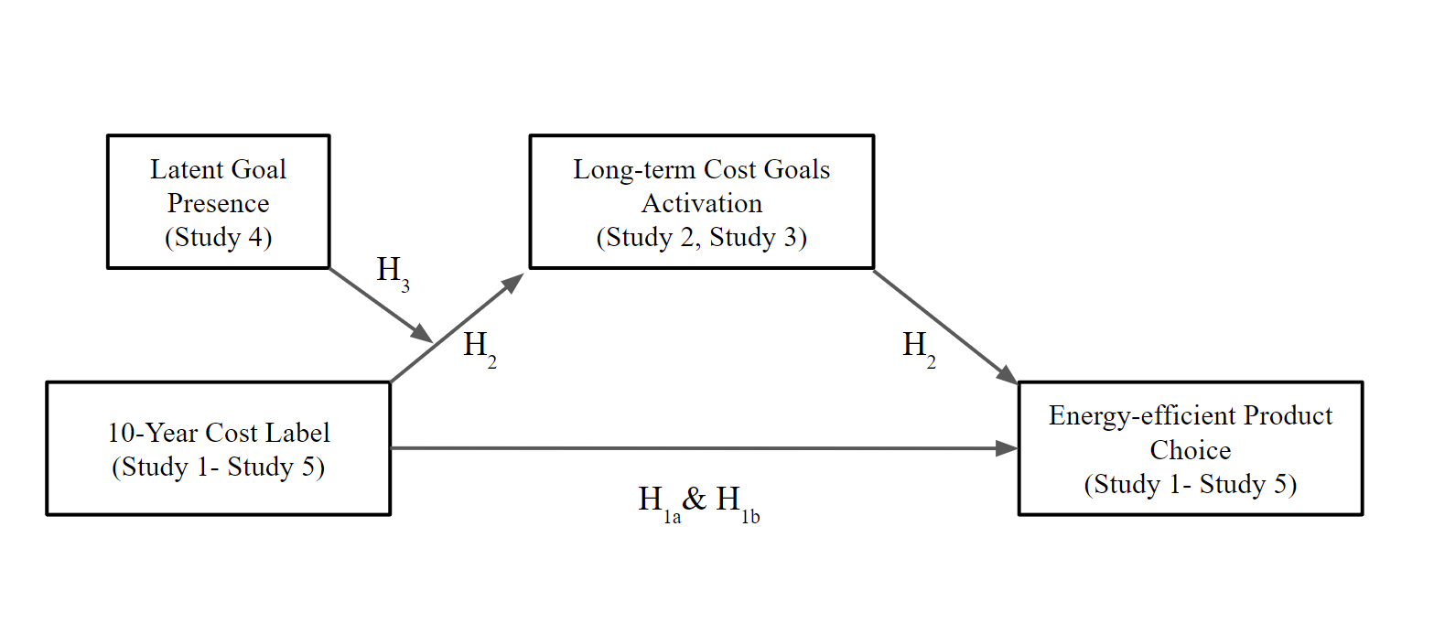
Figure 1. Conceptual framework.
Just as goals can be activated by other memory structures and contextual cues, so too can they be inhibited. In fact, activating one goal often inhibits other goals in a competitive fashion (Brendl et al., 2003); at the time of purchase short-term cost labels are ubiquitous and salient, and may thereby suppress activation of the long-term cost goals. This provides another reason why long-term cost goals are typically not active and do not influence consumer choice. In contrast, activating the long-term cost goal with 10-year cost labels may also reduce the importance of other goals such as product features and up-front cost. This would further encourage consumers to choose more efficient options.
This model implies that goal activation will only be an effective route to behavior change for those people who actually hold the goal in their associative network. For example, when restaurant goers were subtly given dieting reminders in the menu, current and chronic dieters chose healthy options more often, but non-dieters were not affected (Papies & Veling, 2013). Likewise, the 10-year cost labels should only be effective to the extent that they tap into an existing goal in consumers. We test and confirm this hypothesis in our study, showing that those who are motivated by long-term costs were more affected by the 10-year cost label.
The present research contributes to goal-based choice models by (a) proposing a novel nudge that activates the proposed latent long-term cost goal and generating predictions about consumers systematic shifts of choice, (b) adding to the theory of goal activation by positing a novel latent consumer goal and moderator applied in the area of energy-usage, and (c) providing support for the goal-based choice model that cannot be explained by more traditional models of consumer evaluation and choice.
A new perspective on the energy paradox
The 10-year cost label is designed to tackle the “energy paradox,” a term coined by Jaffe & Stavins (1994) to describe the alarmingly low adoption rate of energy-efficient products despite their large financial savings.
What is behind the low adoption rate of energy-efficient products despite their significant savings? One behavioral explanation for the energy paradox is that consumers exhibit a bias that leads to undervaluation of future energy savings relative to their expected value. According to Greene (2011), this bias is mainly produced by the combination of substantial uncertainty about the net value of future energy savings and the loss aversion of typical consumers. Since the net value of the energy-efficient product is the difference between uncertain savings and initial cost, and loss-averse consumers bear considerable risks due to replacement in the case of an energy efficiency standard, they are hesitant to adopt energy-efficient products. However, whereas Greene proposes that the irreducible uncertainty about future savings is driving the low adoption rate, we argue that the main issue is not that consumers are hesitant to purchase energy-efficient products because they are unsure about the potential future benefits, but rather that the consumers’ long-term cost goal is latent and takes specific cues to be activated. We compare these explanations and provide experimental evidence that the activation of long-term cost goals plays a mediating role for the effect of product labels on consumer choice.
We test four different energy-using products, one of which is light bulbs, a prime example to showcase the energy paradox. Compared to traditional incandescent lightbulbs, compact fluorescent lamps (CFLs) and light-emitting diodes (LEDs) use 65 to 80% less energy, and last 10 and 25 times longer respectively. While LED lights, priced at $8 on average, cost about $7 more than a traditional incandescent bulb, they can result in $225 of savings in energy costs per year for the average household (U.S. Department of Energy, n.d.). By 2027, the US Department of Energy estimated that LED lighting could reduce national electricity use equal to the annual electrical output of 44 large electric power plants, leading to total savings of more than $30 billion (Energy Star, n.d.). Some estimates suggest that an overnight global switch to LED lightbulbs could cut 1,400 million tons of CO2 emissions (Council, 2016). Despite the future savings advantage and environmental benefits, less than half of U.S. households reported using LEDs for most or all of their indoor lighting in 2020. The adoption rate is even lower for low-income households earning less than $20,000 –– only 39% of them reported using LED bulbs as their main indoor lighting of choice. Only 12% of U.S. homes use mostly CFL bulbs (EIA, 2022). There are many categories of energy inefficient products with lower up-front costs but which are much more expensive to operate in the long run, for example air-conditioning units and clothes driers. Aggregating across product categories, the U.S. Department of Energy estimates that a typical household can save about 25% on utility bills with energy efficiency measures, which amounts to over $2,200 annually (Energy Efficiency Costs & Benefits Explained, 2023).
For these reasons, inefficient lightbulbs have been outlawed in a number of countries as well as several U.S. states and Canadian provinces. However, such legal prohibitions often have unintended consequences, and some consumers may be pushed in a direction that is not in their judged self-interest (Sahoo & Sawe, 2015). Following the principle of improving consumer choice without regulatory requirements, a number of choice architecture techniques (Thaler & Sunstein, 2008) have been developed. Many of these techniques fall into three categories: defaults, information restructuring, and information feedback (Camilleri & Larrick, 2015). Information restructuring makes some aspects of the product information more salient and useful for consumers and can be used to highlight energy efficiency information, for example by labeling efficient products with the “energy star” certification. This method preserves consumers’ freedom of choice, and “nudges” them in the right direction. Furthermore, it is also intuitively appealing and inexpensive to implement. However, although some studies using information provision to increase energy-efficient choices have found positive effects (Bull, 2012; Camilleri & Larrick, 2013; Min et al., 2014), other studies have found mixed or null results (Abrahamse et al., 2005; Anderson & Claxton, 1982; Waechter et al., 2015). In this research, we propose and test a novel information restructuring technique, the 10-year cost label. We examine how and why it works, and find that it is more effective than other, similar labeling techniques.
Previous research on energy labeling and purchase behavior
Although behavioral scholars have studied energy cost labeling for at least 40 years, to the best of our knowledge there are only thirteen published field studies measuring actual purchase decisions, which we detail in the online supplemental materials (available at http://researchbox.org/4607&PEER_REVIEW_passcode=FDZOCP) Table S1 and summarize here. Overall, the results are mixed, with several studies finding positive effects of energy labelling on energy-efficient purchase decisions (e.g., Anderson & Claxton, 1982; Deutsch, 2010), two studies showing no significant effect (e.g., Carroll et al., 2016; Denny, 2022) and others finding a mixture of positive effects on some products and no effect on other products (e.g., Kallbekken et al., 2013; Solà et al., 2023). Why these varied findings? One possibility is that the two studies finding null results and most of the studies finding mixed results examined adding a new label on top of existing energy labeling (for example, products already have the European A++ style energy labeling, and a novel label is added to this), and/or they examined the effects of adding labels in combination with active, trained sales representatives (who may have other incentives), complicating interpretation of the results. Therefore, in the current research, we focus on testing the “isolated label” effects (without any other confounding labels present, nor any sales representative involvement).
The current paper makes several unique contributions over these previous studies (as summarized in the supplemental materials Table S1). First and most importantly, it advances and tests a goal activation theory of consumer decisions. This brings a novel theoretic lens, as none of these previous papers have discussed goal-related theories, nor have they measured any psychological mechanisms for their findings. Second, the current paper is the first to compare savings versus cost frames in the context of energy choices, which we believe is an important distinction in this domain and for goal-activation theory more broadly. Third, to better understand moderators and robustness, the current paper systematically compares choices and psychological mechanisms across multiple different products, different attribute scales (e.g., kWh vs % cost vs $ cost), and time-horizons (e.g., 1 year vs. 5 years vs. 10 years). This is critical, given the heterogeneity of results seen in previous research.
Why 10-year cost? The role of asymmetric temporal discounting
Taken together, these field studies show modest and somewhat unreliable effects of energy labeling on purchase decisions. Furthermore, they provide little guidance about when or why labeling is effective. The guiding assumption is that the consumer households are in an information deficit – not understanding the benefits that energy efficiency might bring – and thus that better information disclosure would lead to better decision making. However, lab studies of energy labeling have not always supported this assumption. Eye-tracking data suggests that European-style ratings of energy efficiency (e.g., A++) attract consumer attention but do not affect choices (Waechter et al., 2015). 5-year automobile fuel savings labels have no effect on consumer preferences for efficient vehicles in lab studies, but monthly “total cost of ownership” labels do (Dumortier et al., 2015). Likewise, “annual cost” information leads people to choose more energy-efficient lightbulbs in lab studies. Disclosing the annual operating cost also led to a higher consumer willingness to pay (Min et al., 2014).
These apparently divergent findings, that savings labels have no effects on consumer preferences but cost information does, can be explained by the power of dollar-cost frames: consumers respond more strongly to loss-framed energy information than gain-framed (Bull, 2012), and respond more to information labels in dollar frames than to information labels in energy frames (Bull, 2012; Camilleri & Larrick, 2013). While these previous studies had found that disclosing annual cost information leads to more energy-efficient product choices, the critical labeling ingredients and the reasons for their effectiveness were not identified. An additional reason for the ineffectiveness of “energy savings” labeling may be that consumers discount future gains at a much higher rate than losses (Hardisty & Weber, 2020). Thus, emphasizing the future benefits of energy efficiency over time may not have strong effects. Laboratory studies of intertemporal choice reveal that discount rates are much lower for losses than for gains (Hardisty & Weber, 2009; Thaler, 1981), consistent with the finding that future losses and future gains are processed using different brain areas (Xu et al., 2009). Thus, consumers may be motivated to avoid future financial losses—even far future losses—when the effects of energy inefficiency are framed in terms of costs rather than savings.
Why 10-year cost? The role of scaling, transparency, and ease
We propose that the 10-year cost label is an effective tool or nudge to activate consumers’ latent long-term cost goal and link it to their current consumption decision. The 10-year frame ensures that the magnitude of the cumulative long-term cost will be meaningful relative to the upfront purchase cost of the product. This is in accord with literature demonstrating the benefits of “scaling up” the energy cost units from annual operating costs to lifetime costs (Bull, 2012) or from cost per 100 miles to cost per 100,000 miles (Camilleri & Larrick, 2013). Consumers perceive the energy usage difference between products as larger when scales are expanded (e.g., from cost per month to cost per year) and hence place more weight on energy use costs in the decision process. Expanding scales in this way may also lead consumers to broaden their decision frames and to evaluate the consequences over a larger time horizon (D. Read et al., 1999). Furthermore, using the familiar dollar frame provides a fluent and easily comprehended future-cost counterweight to the current purchase price. Consumers evaluate dollar costs on a daily basis, when shopping and viewing advertisements. This repeated exposure and practice may make dollar-cost framing more fluent and meaningful than other frames such as kWh or dollar savings. In addition to familiarity, the dollar frame is scale compatible. The principle of scale compatibility states that attributes of decision alternatives that are compatible with the response mode are weighted more heavily than those that are not (Bleichrodt & Pinto, 2002; Slovic et al., 1990). In this case, the response mode of the purchase decision is dollar cost, which is compatible with the long-term cost framed in dollars.
We prefer the 10-year cost label rather than other long-term dollar cost frames such as “life-cycle cost” or “total cost of ownership” because it requires fewer assumptions, is more easily calculated, and more easily (and transparently) communicated to consumers. As noted by Schubert & Stadelmann (2015), “providing life-cycle information is no easy task and requires several assumptions (e.g., on product lifetime or discount rates), which may be contested”. Furthermore, the 10-year cost label is visually fairly simple and can easily be added to existing price labels (similar to unit cost pricing). This stands in contrast to other energy labels (such as the European label incorporating color codes, letter grades, and numeric information) which require a large and specialized layout. Furthermore, the same energy cost formula can easily be applied across multiple product categories (in contrast to total ownership cost, which has idiosyncratic elements in each product category).
Loss aversion and negativity bias
Our long-term cost goal hypothesis builds on insights on loss aversion (Tversky & Kahneman, 1991) and negativity bias (Rozin and Royzman 2001), but also makes unique predictions. In this section, we outline the similarities and differences between the theories. First, loss aversion and negativity bias both imply that when making decisions, consumers weight losses more heavily than gains. The long-term cost goal hypothesis says that this process is stronger when considering dollars than when considering other attribute frames. Put another way, loss aversion and negativity bias predict a main effect of loss framing, across domains, whereas the goal hypothesis predicts an interaction, with loss framing being stronger in dollars than in other domains. Second, whereas loss aversion is silent on the impact of temporal distance, negativity bias says that negative attributes have a steeper gradient over space and time. Put another way, negativity bias says that immediate negative attributes should be much more impactful than immediate positive attributes, but future negative and positive attributes should be relatively more equal in impact. The long-term cost goal hypothesis says that long-term costs are generally not attended to by consumers and thus receive little weight in the decision process (similar to what negativity bias might say), but when long-term costs are made salient (e.g., through effective labeling), they are much more impactful than equally salient future gains (the opposite of what negativity bias would predict). To reiterate: loss aversion and negativity bias by themselves predict that increasing the salience of both future gains and future losses should have no effect, whereas the long-term cost goal hypothesis says that increasing salience will increase the impact of future losses relative to future gains. In summary, the goal hypothesis makes unique predictions about the moderating influences of domain, time, and salience on the impact of losses vs gains.
Overview of the current research
The 10-year cost label combines several desirable features: goal activation, scale expansion, scale compatibility, transparency, and ease of implementation. It serves as a contextual cue to activate consumers’ long-term cost goal, thereby increasing consumption goal salience and importance in the choice process. The label makes it easier to compare immediate and long-term costs across products, which thus reduces decision effort and potentially satisfies process goals. As we describe in the studies below, it is effective at nudging consumers to choose more energy-efficient products, and outperforms alternative energy labels. For these reasons, we believe that the 10-year cost label is the best energy labeling technique currently available. Based on this logic, the hypotheses we test are:
H_{1a}: The dollar cost frame (as compared to control, dollar savings, energy cost, or energy savings frames) is the most effective for influencing consumer choice of energy-efficient products.
H_{1b}: The 10-year cost label (as compared to 1-year and 5-year cost labeling) leads consumers to choose energy-efficient products more often.
H₂: The effect of long-term cost labeling on choices is mediated by the activation of long-term cost goals.
H₃: The 10-year cost label is selective, having a stronger effect on consumers who self-report having long-term cost reduction goals.
We test these hypotheses in a series of five studies. In Study 1, we show that the long-term cost goal is specific to dollar costs, outperforming other labels such as dollar savings or kWh costs. In Study 2, we show a reliable effect of attribute scaling; we also establish the long-term cost goal activation mechanism and compare it to two other potential mechanisms: planning horizon and information provision. In Study 3, we activate the goal via an alternative method (without providing any additional information) and find the same effect on choices. In Study 4, we show that the 10-year cost label is more effective on consumers who self-report a long-term cost goal. In Studies 5A and 5B, we demonstrate the effectiveness of the 10-year cost nudge across different product categories in both a lab study and a field study respectively. Complete study materials, data, and supplemental studies and analyses are available at https://researchbox.org/4607&PEER_REVIEW_passcode=FDZOCP
STUDY 1: SPECIFICITY OF LONG-TERM COST GOAL
Method
A total of 1155 participants (40% female, mean age = 33) were recruited from Amazon Mechanical Turk in 2015 and randomly assigned to one of seven conditions. The overall design was a 2 Goal Framing (Gain/Loss) x 3 Cost Framing (Dollar/Energy/Percentage) + 1 Control between-subjects design. All participants were asked to choose between a pair of packaged light bulbs where one package was halogen (i.e., less energy-efficient but less expensive upfront) and the other was fluorescent (i.e., more energy-efficient but more expensive upfront). These bulbs were matched on brand name and light quality ("soft white") and similar in level of brightness (1490 lumens halogen vs. 1600 lumens fluorescent). The dependent variable was the proportion of participants choosing the energy-efficient option.
Participants were asked, "Imagine you are shopping for a light bulb. Which one would you like to purchase?" In the Control condition, the information for the light bulbs was presented in accord with the original package information as sold in the store. In the Gain-(Loss)-Framed-Dollar condition, the information presented for each light bulb reflected how much money, in dollars, each product would save (cost) over the course of ten years. Savings estimates were relative to a 100-watt incandescent bulb (this is a standard comparison product for lightbulbs of this brightness). In the Gain-(Loss)-Framed-Energy condition, the information reflected how much energy, in kilowatt-hours, each product would save (cost); in the Gain-(Loss)-Framed-Percentage condition, the information reflected each light bulb’s ten-year energy cost gain (loss), in percentage, as compared to a standard 100-watt incandescent bulb. For each of these conditions, it was noted that the ten-year energy cost presented in the information was based on the product’s electricity use, average number of hours used, and the average electricity rate.
After participants made their choice between the two light bulbs, they were presented with manipulation check questions. Participants were then presented with various demographic questions such as age, gender, ethnicity, country of birth, and income.
Results
As seen in Figure 2, people chose the energy-efficient lightbulb most often in the 10-year-dollar-cost (loss) condition. In the control condition, 56% chose the efficient option, as compared with 84% in the 10-year-dollar-cost condition, 68% in the 10-year-kWh-cost condition, 67% in the percent-energy-cost condition, 71% in the 10-year-dollars-saved condition, 66% in the 10-year-kWh-saved condition, and 73% in the percent-saved-condition.
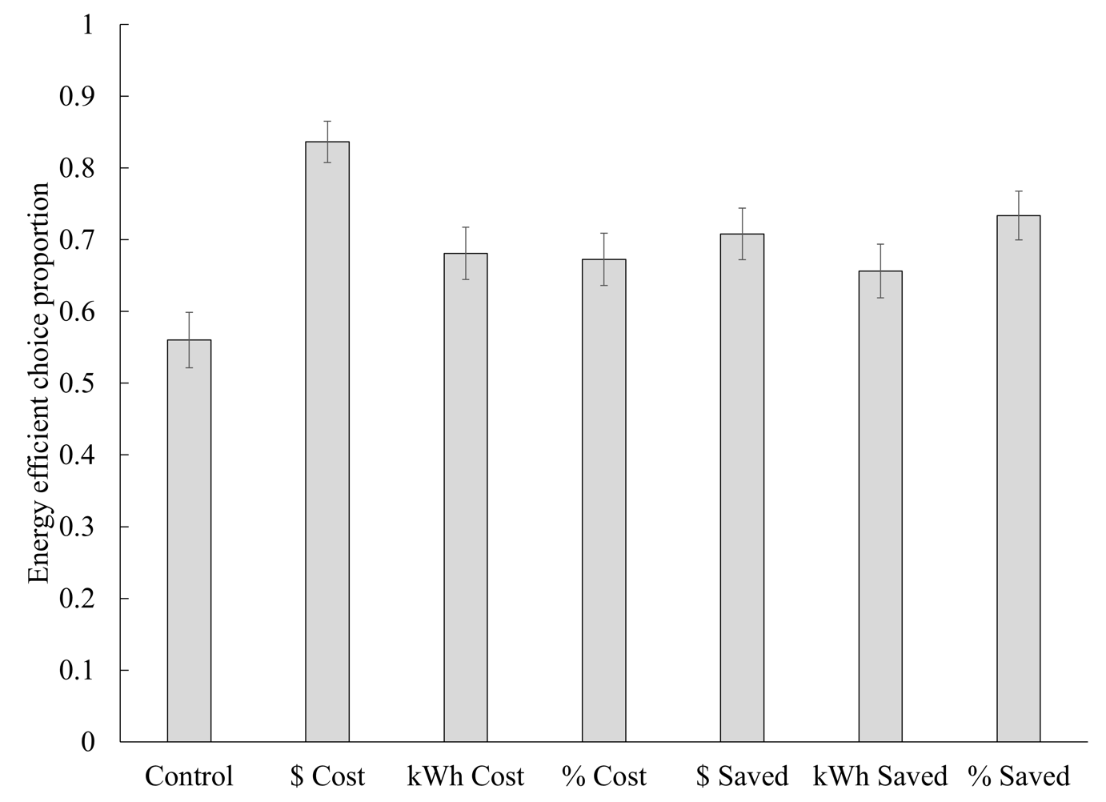
Figure 2. Proportion of energy-efficient choices by labeling condition and product in Study 1. Error bars show +/- one standard error.
An omnibus ANOVA across the seven conditions found a significant effect of condition, F(6,1148) = 5.6, p < .001, η² = .03. A Helmert contrast analysis revealed a significant difference between the control condition and the remaining six treatment conditions combined, t(1148) = -4.05, p < .001, with participants in the control condition being less likely to choose the energy-efficient lightbulb. Additionally, the comparison between 10-year-cost condition and the other five treatment conditions was also significant, t(1148) = 3.74, p < .001, with participants in the 10-year-cost condition being more likely to choose the energy-efficient lightbulb.
Follow-up pairwise contrasts in the ANOVA showed that the 10-year-dollar-cost condition was significantly higher than all the other conditions, all p = .04 or less. The other five non-control conditions were not significantly different from each other, all pairwise comparisons p = .12 or greater. However, they were generally significantly greater than control: dollars saved, p < .01, energy saved, p = .06, percent saved, p < .001, energy cost, p = .02, and percent cost conditions, p = .03.
Due to the binary nature of the choice outcome, a generalized linear mixed model (GLMM) using a binary logistic regression was conducted as well, which replicated the significant main effect of condition on choice, F(6, 1148) = 5.17, p < .001.
Discussion
Study 1 showed that people were most likely to choose energy-efficient options when presented with the long-term cost information. We hypothesize that the 10-year cost label is uniquely effective because it taps into a latent long-term cost goal in consumers. Participants faced with the future dollar cost framing were significantly more likely to choose the energy-efficient option than participants faced with the control message. Moreover, the 10-year dollar cost frame was more effective than all of the alternative frames (currently used in retail stores in North America and Europe) such as dollar savings or percentage energy savings. These alternative frames had effects that were all very similar, whether featuring gains (savings) or losses (costs), which would seem to rule out loss aversion on its own as the critical ingredient driving the long-term cost labeling effect.
However, these alternative frames were somewhat more effective than the "no additional information" control. This suggests that the effectiveness of the long-term cost labeling may have two components. The first component is derived from adding any informative scaled and translated attribute (Ungemach et al. 2017); portraying one product as better increases the attractiveness of that product. The second component is that the dollar cost frame is much more effective than other informational frames, consistent with our proposition that this frame activates a latent long-term cost reduction goal.
The results of Study 1 are consistent with our theory that 10-year cost labeling activates long-term cost goals. However, it is not clear whether there is something special about the effectiveness of long-term cost framing for lightbulbs (which have relatively low upfront cost in comparison to long-term costs), or whether it is more generally effective with a wider range of products, prices, and long-term costs. Therefore, in Study 2 we test three additional product types.
It is important to note that the results of Study 1 may alternately (or additionally) be explained by other mechanisms tied to the 10-year cost labels beyond our goal account. For example, perhaps consumers consistently underestimate long-term costs, and the 10-year cost manipulation increases their estimates and changes their choices. Or, perhaps participants normally focus on a short time horizon (e.g., a few months to a year) when considering product purchases, and the 10-year cost manipulation nudges them to consider a longer time-frame (up to 10-years), thus changing their choices. In Study 2, we compare these three possible mechanisms. Participants first consider a pair of products, then indicate their product goals and planning horizon, then make their choice, and then estimate their personal long-term costs for the inefficient product. Furthermore, in addition to the control and 10-year-cost conditions, we also explore 1-year and 5-year-cost conditions, to test the importance of the "long-term" part of the nudge, which may work partly via metric scaling (Camilleri and Larrick 2013).

STUDY 2: MEASURING LONG-TERM COST GOALS
Method
Two hundred forty-two participants (50% female, mean age = 34) were recruited from Amazon Mechanical Turk in 2014 for a study on decision making. All participants faced a series of four choices between different pairs of products including light bulbs, vacuums, televisions and furnaces (in random order). In each pair, one product had a higher price, but used less energy. The dependent variable was the proportion of choices for this more efficient option. Experimental materials for all studies are provided in the online supplemental materials (available at http://researchbox.org/4607&PEER_REVIEW_passcode=FDZOCP). The participants were randomly assigned to one of four between-subject conditions: control, 1-year-cost, 5-year-cost, and 10-year-cost. We also added several process measures (described below).
For each pair of products, participants first read the instruction "Imagine you are shopping for a [furnace/vacuum/light bulb/TV]. After careful consideration, you narrowed down your choice to the two options below. Please read the product information." After reading the product information, participants answered a question about product goals, "As you consider purchasing a new [vacuum], what product features are most important to you? Please list the three most important product features." This was followed by three free-response fields, labeled "Most important", "Second most important", and "Third most important". On the next page, participants answered a question about planning horizon for that product purchase, "When purchasing a new [vacuum], roughly how far ahead do you plan?". Participants answered using a 7-point scale with labels including "Not at all", "Up to one week", "More than one week up to one month", "More than one month up to one year", "More than one year up to five years", "More than five years up to ten years", and "Ten years or more". On the next page, participants were presented with the product information again and answered the question, "Which one would you purchase?" This was the primary dependent variable.
On the next page, participants were shown the product information for only the inefficient product from that product pair, and answered the question "Please imagine that you purchased the [vacuum] above. How much do you estimate your household would spend on energy to use this [vacuum] in your home, over a period of 10 [1] [5] years? Please enter a dollar amount." Participants in the control condition and 10-year-cost conditions estimated the 10-year-cost, while participants in the other two conditions estimated the 1-year and 5-year-cost, respectively. Note that participants in the 1, 5, and 10-year-cost condition could just copy the product information if they desired, but they may have felt that their personal usage would be different from the average estimated usage and put a different dollar amount instead.
After completing this procedure for all four product pairs, participants answered a number of demographic questions including gender, age, ethnicity, English language, income, available financial resources in case of an emergency, type of residence, home owner or renter, and how long they plan to stay in their current residence. None of these demographic variables moderated the results below, and they will not be discussed further.
Results
Product choices. As seen in Figure 3, participants generally chose the energy-efficient option more often in the 1, 5, and 10-year-cost conditions than in the control condition. This was confirmed with a 4 (condition, between) x 4 (product, within) GLM, which found a main effect of labeling condition, F(3,238) = 7.9, p < .001, η² = .09, a main effect of product, F(3,714) = 57.1, p < .001, η² = .19, and an interaction, F(9,714) = 3.2, p < .01, η² = .04. As seen in Figure 3, the interaction indicates that the effects of 10-year cost labeling were stronger for vacuums and TVs as compared to light bulbs and furnaces. A GLMM using a binary logistic regression was conducted as well, which replicated the significant effects discussed above (see the supplemental materials for these results).
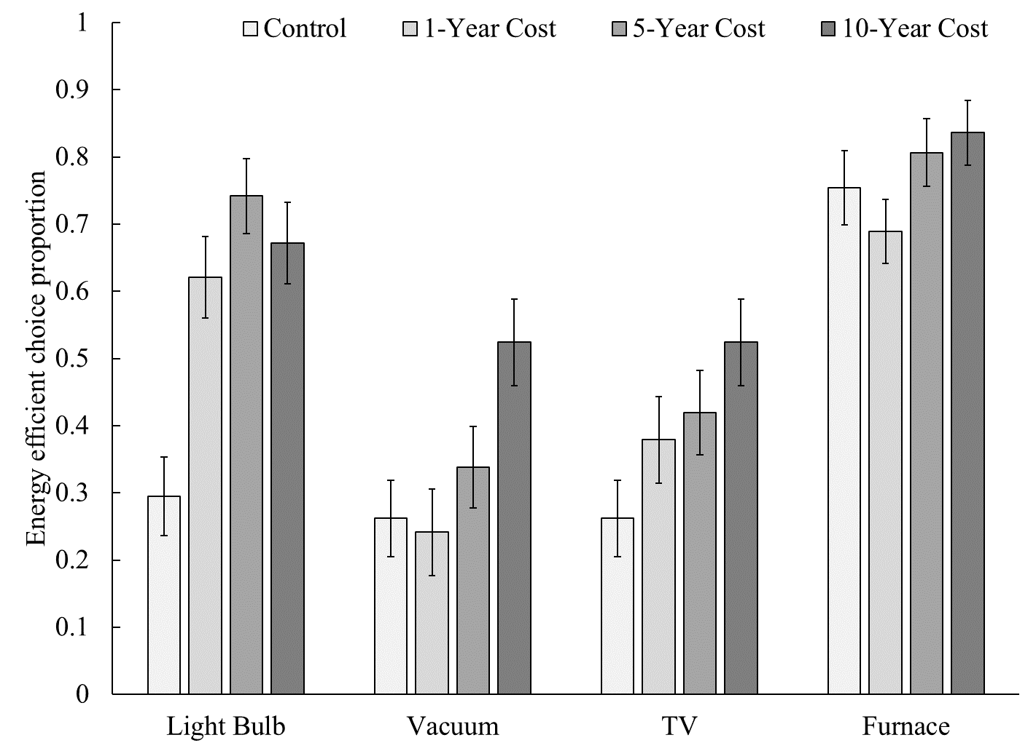
Figure 3. Proportion of energy-efficient choices by labeling condition and product in Study 2. Error bars show +/- one standard error.
A Helmert contrast analysis was conducted, in which we examined two contrasts of interest: The first contrast (“control contrast”) examines the comparison between the control condition and the three treatment conditions combined; The second contrast (“10-year contrast”) examines the comparison between the 10-year-cost condition and the 5- and 1-year-cost conditions combined. The control contrast revealed a significant difference, t(238) = –3.93, p < .001, with participants in the control condition being significantly less likely to choose the more energy-efficient products. The 10-year contrast was also significant, t(238) = 2.34, p = .021, with participants in the 10-year-cost condition being more likely to choose the more energy-efficient products.
Helmert contrasts for each product individually reveal diverse patterns. For both lightbulbs and TVs, the control contrast revealed significant effects for both lightbulbs, t(238) = -5.55, p < .001, and TVs t(238) = -2.49, p = .01, and no other contrasts were significant. For vacuums, the 10-year contrast revealed significant effects, t(238) = 3.22, p = .002, and no other contrasts were significant. For furnaces, neither the control or 10-year contrasts revealed significant effects.
Pairwise contrasts for each product were also conducted. For furnaces, the 10-year condition is marginally higher than the 1-year condition, t(117) = 1.90, p = .06, and no other differences are significant. For lightbulbs, the 1-year, 5-year, and 10-year conditions are significantly above control, each p < .001, but not significantly different from each other. For TVs, the 5-year condition is marginally higher than control, t(121) = 1.85, p = .07, and the 10-year condition is significantly above control, t(120) = 3.05, p < .01, but no other differences are significant. For vacuums, the 10-year condition is significantly higher than every other condition, each p < .04 or stronger, but no other differences are significant.
Is there a reliable effect of long-term attribute scaling? In other words, is 10-year cost more effective than 5-year cost, and in turn more effective than 1-year cost? To answer this question, we calculated the proportion of energy-efficient choices made by each participant (averaging across the four products). Comparing the three "cost" labeling conditions using an ANOVA confirmed a significant effect of scaling, F(2,178) = 4.0, p = .02, η² = .04. Follow-up pairwise comparisons found that people chose efficient products more often in the 10-year condition (mean = .64) than in the 1-year condition (mean = .48), t(117) = 2.7, p = .01. However, the 5-year-cost condition (mean = .58) was not significantly different from either the 1-year-cost condition, t(118) = 1.8, p = .09, or the 10-year-cost condition, t(121) = -1.1, p = .25. Overall, then, greater attribute scaling was generally more effective, although we could not pinpoint the level at which it became effective.
Product goals. The "most important" goal for each product was coded by two independent, naïve coders for whether it mentioned long-term costs or not. The agreement between the two coders for the most important goal for all four products ranges from 88% to 94% (kappa = .88 to .91), and disagreements were resolved by discussion. The second and third most important goal listings for each product were each only coded by one of the two coders. We calculated a measure of long-term cost goal prominence by recoding mention of long-term cost as a 3 if it was the first thing the participant mentioned, a 2 if it was second, a 1 if it was third, or a 0 if it was not mentioned.
As seen in Figure 4, long-term cost labeling generally increased long-term cost goal prominence. Notably, long-term cost goals were generally at or near zero in the control condition, except for furnace purchases, where they were already quite pronounced in the control condition. In the 10-year -cost condition, long-term costs were mentioned as a goal by 64% of the participants, thus indicating that the majority of consumers have this goal when they are prompted by the 10-year cost labels. A 4 (labeling condition, between) x 4 (product, within) GLM confirmed a main effects of labeling condition on long-term goal mentions, F(3,238) = 11.4, p < .001, η² = .13, product, F(3,714) = 32.5, p < .001, η² = .12, and the interaction, F(9,714) = 3.8, p < .001, η² = .05. Long-term cost goal prominence was correlated with choices for light bulbs, r = .33, p < .001, TVs, r = .20, p < .01, and vacuums, r = .35, p < .001, but not furnaces, r = .07, p = .28.

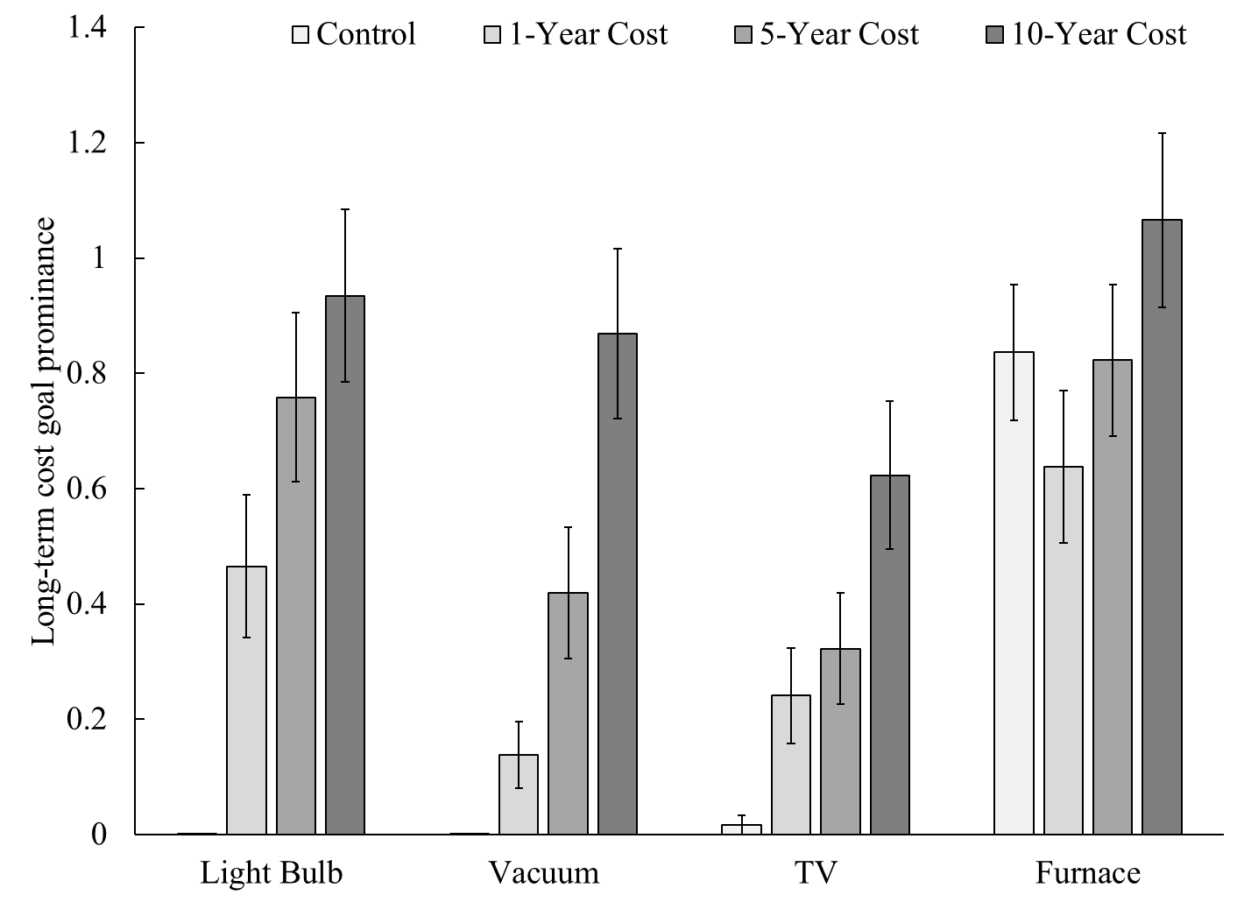
Figure 4. Mean goal prominence by labeling condition and product in Study 2. Error bars show +/- one standard error.
Next, we examined whether the effect of the labeling condition on product choice was consistent with a mediating model where reported goal prominence mediated the label-choice relationship. We used the SPSS Process Model 4 to examine the indirect effect of labeling condition on goal prominence, in turn associated with the average choices of the four products (Hayes, 2013).
The labeling condition effects across the four conditions were decomposed into 3 planned (Helmert) contrasts, and the significance of the indirect effects (a x b) were evaluated through bootstrapped methods using 5000 samples, as shown in Figure 5. For the control contrast, the effect of labeling condition on choice was mediated by goals (β = .05; SE = .01, CI (95%) = .02, .07). For the 10-year cost contrast, the effect was also mediated by goals (β = -.05; SE = .02, CI (95%) = -.09, -.01).
Looking at choices for individual products, the control contrast shows a significant mediation test for lightbulbs (β = .55; SE = .17, CI (95%) = .30, .97). For vacuums, both the control contrast (β = .38; SE = .11, CI (95%) = .19, .64) and the 10-year contrast (β = -.47; SE = .20, CI (95%) = -.94, -.18) show significant mediation tests. Similarly for TVs, both the control contrast (β = .16; SE = .08, CI (95%) = .02, .33) and the 10-year contrast (β = -.14; SE = .10, CI (95%) = -.37, -.002) show significant mediation tests. For furnaces, neither contrast shows significant tests. For detailed mediation results, including both direct and indirect effects across all four products, please refer to the supplemental materials.
These results are generally consistent with a mediating model in which the 10-year cost labels activate long-term cost goals, which in turn predict more energy-efficient choices.
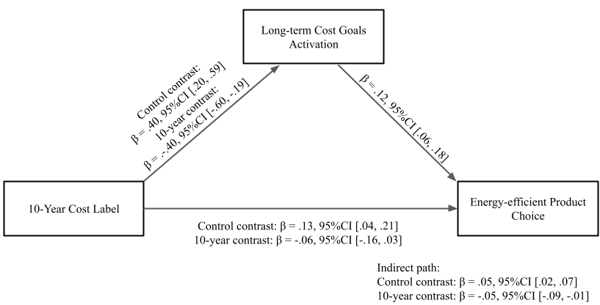
Figure 5: Goal Prominence Mediation Model
Planning horizon. As seen in Figure 6, long-term cost labeling also slightly increased the participants' planning horizons, from 2.7 (roughly “weeks”) (SD = 0.9) in the control condition, to 3.1 (roughly “months”) (SD = 1.0) in the 1-year-cost, 3.2 in the 5-year-cost (SD = 1.2), and 3.1 (SD = 1.0) in the 10-year-cost condition. However, product type had a much larger effect on planning horizon, from 1.9 (roughly “less than a week”) (SD = 1.2) on average for lightbulbs, to 3.4 (SD = 1.1) for TVs, 2.9 (SD = 1.2) for vacuums, and 3.9 (SD = 1.4) for furnaces. A 4 (labeling condition, between) x 4 (product, within) GLM confirmed main effects of labeling condition, F(3,238) = 2.8, p = .04, η² = .03, and product, F(3,714) = 265.8, p < .001, η² = .53, on planning horizon but no interaction, F(9,714) = .85, p = .58, η² = .01. Planning horizon was correlated with choices for light bulbs, r = .22, p < .001, and vacuums, r = .16, p = .01, but not for furnaces, r = .04, p = .53, or TVs, r = .11, p = .08. A mediation analysis using the Helmert coded contrasts was conducted to examine the effect of labeling condition on aggregated choice of the four products. Average planning horizon did significantly mediate the effect in the control contrast (β = .02; SE = .01, CI (95%) = .003, .05), but did not in the 10-year contrast (β = .00; SE = .01, CI (95%) = -.02, .02).
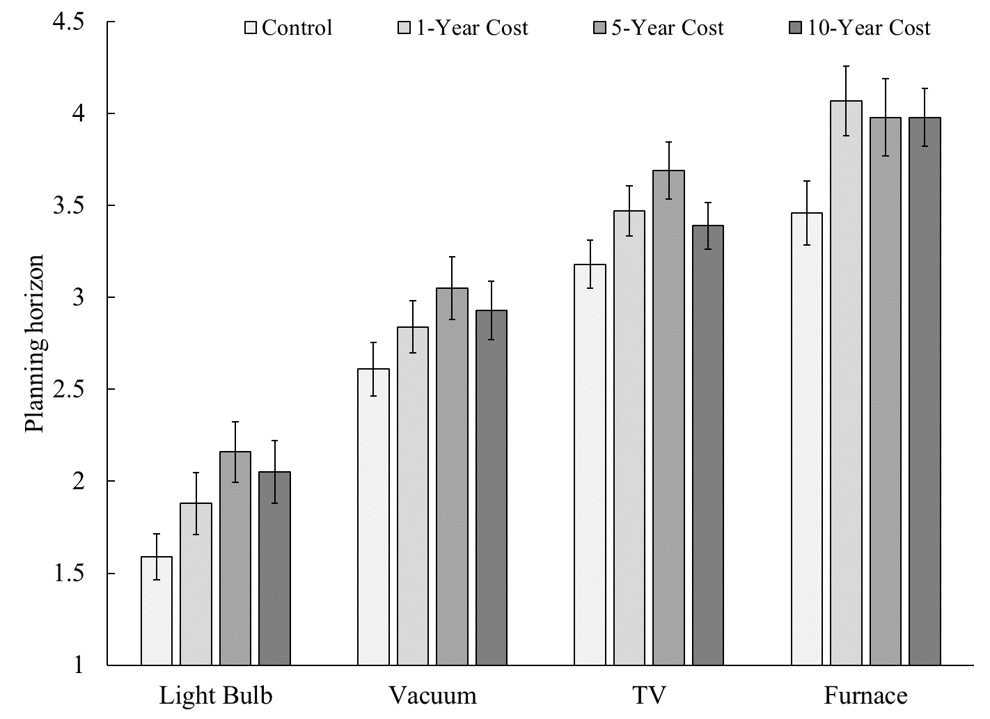
Figure 6. Mean planning horizon by labeling condition and product in Study 2. Error bars show +/- one standard error.
Subjective cost estimates. To put participants' running cost estimates on a common 10-year scale, we multiplied estimates in the 1-year condition by 10, and multiplied estimates in the 5-year condition by 2. The distributions were highly skewed, so we natural log-transformed the resulting estimates. As seen in Figure 7, long-term cost labeling increased participants' long-term cost estimates for the furnace, light bulb, and TV, but had no effect or even decreased estimates for the vacuum. A 4 (labeling condition, between) x 4 (product, within) GLM on cost estimates revealed main effects of labeling condition, F(3,238) = 8.0, p < .001, η² = .09, product, F(3,714) = 322.0, p < .001, η² = .58, and the interaction, F(9,714) = 4.2, p < .001, η² = .05. Cost estimates correlate with choices for TVs, r = .16, p = .01, but not for furnaces, r = .04, p = .58, light bulbs, r = .11, p = .08, or vacuums, r = .03, p = .63. A mediation analysis using the Helmert coded contrasts was conducted to test whether subjective cost estimates mediated the effects of label condition on choices for each product. Neither the control nor 10-year contrast showed significant results for any of the four products, except for the control contrast for TV (β = .26; SE = .22, CI (95%) = .03, .88). See supplemental materials for detailed mediation results across all four products.

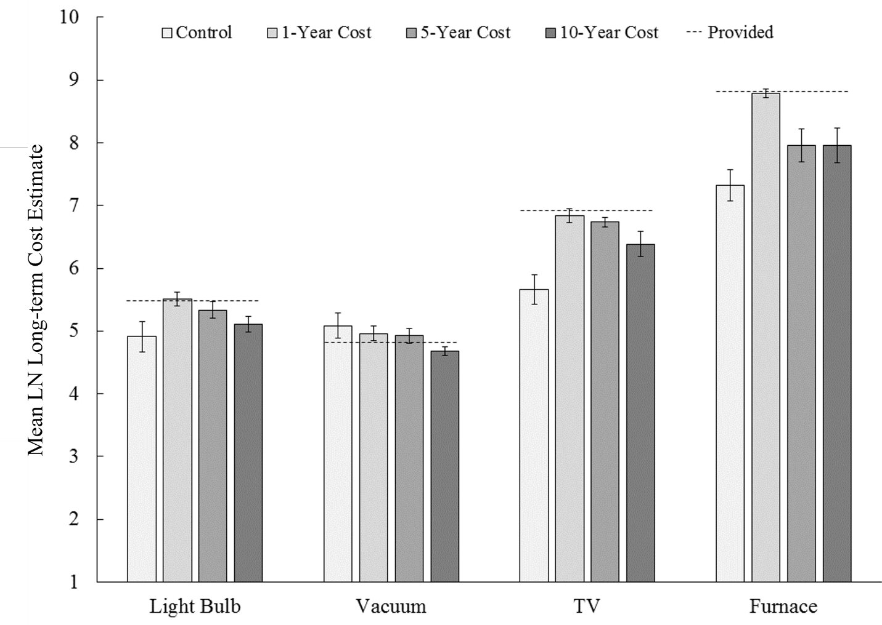
Figure 7. Mean (natural log) long-term cost estimate by condition and product in Study 3. Error bars show +/- one standard error.
Comparison of goal prominence, planning horizon, and subjective cost estimates. Interventions such as the long-term cost label often have multiple factors driving their efficacy. To help determine the relative contribution of each factor measured in this study, we ran a series of four regression models (one for each product), combining labeling condition and all three process measures into the same model with no interactions. Light bulb choices were predicted by goal prominence, F(1,235) = 13.7, p < .001, η² = .06, planning horizon, F(1,235) = 6.5, p = .01, η² = .03, and condition, F(3,235) = 5.0, p < .01, η² = .06, but not (natural log transformed) cost estimates, F(1,235) = 1.1, p = .30, η² = .01. TV choices were predicted by goal prominence, F(1,235) = 6.4, p = .01, η² = .03, and cost estimates, F(1,235) = 5.3, p = .02, η² = .02, marginally predicted by planning horizon, F(1,235) = 2.8, p = .10, η² = .01, and not predicted by condition, F(1,235) = 1.1, p = .36, η² = .01. Vacuum choices were predicted by goal prominence, F(1,235) = 21.6, p < .001, η² = .08, and planning horizon, F(1,235) = 5.3, p = .02, η² = .02, but not cost estimates, F(1,235) = 1.3, p = .25, η² = .01, or condition, F(3,235) = 1.3, p = .29, η² = .02. Furnace was not predicted by any of the factors, all ps > .25. Note that in each model, goal prominence is the best within-condition predictor, except for furnace choices, for which there are no good predictors.
Discussion
Overall, long-term cost labeling led consumers to choose energy-efficient products more often. Furthermore, the effect of 10-year cost labeling was generally stronger than 1-year or 5-year cost labeling, supporting previous findings on scale and metric design (Camilleri and Larrick 2013).
The effect of long-term cost labeling on choices showed significant mediation by activating long-term cost goals for three of the four products studied. In other words, after seeing the 10-year cost labels, consumers say long-term costs are something they care about, and in turn make choices based on this active goal. However, for furnace choice, long-term cost goals were already active in the control condition (even without the 10-year cost label), which may explain why the long-term cost labeling had no effect for furnaces. Increased planning horizon and improved cost estimation seem to play some role in the effectiveness of long-term cost labeling, but their explanatory power is smaller and less reliable.
An alternative explanation for the effectiveness of the long-term cost labels could be that people generally underestimate long-term energy costs, and the labels correct those estimates, leading people to place more weight on energy efficiency in their decision making. Inconsistent with this argument, however, the long-term cost labeling was effective for vacuums even though participants were overestimating the long-term cost (in the control condition). Thus, the long-term cost label actually lowered participants' cost estimates for this product, yet the label still had a notable positive impact on choices. This pattern of results suggests that goal activation is more important than improved cost estimation per se.
Although the results of Study 2 imply that long-term cost goal activation may be an important mediator of the long-term cost nudge, these are self-reported findings and the direction of influence between reported goals and choice is indeterminate. When participants listed their product goals, they had not yet made an explicit choice between the products. It is possible that they quickly made up their mind and then listed goals to rationalize their choices. Thus, rather than goal activation causing choice, it is possible in Study 2 that the causal arrow goes in the other direction and that anticipated choice drives goal activation. We address this in Study 3 by directly manipulating the mechanism (rather than measuring it), and observing the impact on choice. We use a "subjective estimation" condition that is like the control conditions in previous studies except that participants are asked to estimate the long-term cost of each product before making their choice. We hypothesized that this activation manipulation would have the same effect as the explicit long-term cost manipulation. This condition also rules out a pure "information provision" account of the long-term cost condition, as participants in this condition are not given any additional information. We also compared the moderating influence of long-term cost goals vs. other individual differences, such as Consideration of Future Consequences (Strathman et al. 1994).
STUDY 3: ALTERNATIVE GOAL ACTIVATION
Method
Two hundred forty-seven participants were recruited from Amazon Mechanical Turk in 2015 and completed the study. Participants were randomly assigned to one of four conditions: control, lower-energy-cost, 10-year-cost, or subjective-estimation. In all conditions, participants considered four pairs of products (in random order), identical to those used in Study 2. For each pair, participants read the instruction "Imagine you are shopping for a [vacuum] cleaner. After careful consideration, you have narrowed down your choice to the two options below. Please read the product information." The product information was identical in the control, lower-energy-cost, and subjective-estimation conditions, while the 10-year cost was provided in the 10-year-cost condition (the same as in previous studies).
In the lower-energy-cost condition, participants next answered a question about energy efficiency before making their choice: “Which of the two products do you think would have lower energy costs over a period of 10 years?” In the subjective-estimation condition, participants answered two questions before making their choice: "How many dollars do you estimate you would spend on energy costs to use Product A, over a period of 10 years?" and "How many dollars do you estimate you would spend on energy costs to use Product B, over a period of 10 years?" In all conditions, participants then answered the question, "Which one would you purchase?" and made their choice between the more efficient Product A and the less efficient Product B. The proportion of Product A choices was the main dependent variable.
Finally, participants completed the Consideration of Future Consequences (CFC) scale to assess their general tendency to consider the future when making decisions (Strathman et al. 1994) and demographics. The CFC scale consists of twelve statements about being more present-oriented or future oriented, such as "I think it is more important to perform a behavior with important distant consequences than a behavior with less-important immediate consequences", answered on 5-point scales ranging from "extremely characteristic" (+2) to "uncertain" (0) to "extremely uncharacteristic" (-2).
Results
Choices. As summarized in Figure 8, the pattern of choices in the control and 10-year-cost conditions replicated the results of Studies 1 and 2. More importantly, the choices of participants in the subjective-estimation condition were nearly indistinguishable from those in the 10-year-cost condition. In other words, having participants estimate the 10-year cost of each product had the same effect on choices as giving them that information explicitly.
As seen in Figure 8, the lower-energy-cost condition fell between the control and the other two conditions. Interestingly, participants in the lower-energy-cost condition showed a directional trend toward choosing the more energy-efficient product relative to those in the control condition, but they were significantly less likely to do so than those in both the subjective-estimation and 10-year-cost conditions. This suggests that simply asking the participants to pick which product is more energy-efficient is not as effective in activating the consumer’s long-term cost reduction goal as it is to either ask them to actively estimate the long-term cost or to provide them with such cost.
An omnibus GLM predicting choice proportions with labeling condition (4 levels, between) and product (4 levels, within) confirmed a main effect of labeling condition, F(3,243) = 10.9, p < .001, η² = .12, a main effect of product, F(3,729) = 36.6, p < .001, η² = .13, and no interaction, F(9,729) = 1.6, p = .11, η² = .02. A generalized linear mixed model (GLMM) using a binary logistic regression was conducted as well, which replicated the significant main effect of condition on choice, F(3, 972) = 8.89, p < .001, but also found a significant interaction effect of condition and product, F(12, 972) = 9.08, p < .001. As seen in Figure 8, the condition differences were smaller for furnace choices, which may have been due to a ceiling effect and/or that long-term costs are already salient for consumers when purchasing furnaces, thus weakening the power of the treatment conditions.
A Helmert contrast analysis was conducted to compare the effects of treatments. In the control contrast, the comparison between the control condition and the lower-energy-cost, 10-year-cost, and subjective-estimate conditions combined revealed a significant difference, t(243) = –4.5, p < .001, with participants in the control condition being significantly less likely to choose the more energy-efficient products. In the lower-energy-cost condition contrast, the comparison between it and the 10-year-cost condition and subjective-estimate condition revealed a significant difference, t(243) = -3.4, p = .001, with participants in the lower-energy-cost condition being significantly less likely to choose the more energy-efficient products. In the 10-year contrast, the comparison between the 10-year-cost condition and the subject-estimate condition revealed a nonsignificant difference, t(243) = -1.1, p = .28. Helmert contrasts for lightbulbs and TVs reveal the same patterns, where the control contrast and lower-energy-cost contrast are significant and the 10-year contrast is nonsignificant. For vacuums, only the control contrast is significant, whereas for furnaces, only the lower-energy-cost contrast is significant. See the supplemental materials for specific analysis results.

Figure 8. Proportion of energy-efficient choices by labeling condition and product in Study 3. Error bars show +/- one standard error.
Estimates. How accurate were participants' estimates of the 10-year cost? Participants' cost estimates were highly skewed. We analyze average estimates (rather than median or log-transformed estimates) because previous research on the wisdom of crowds has found that mean estimates often outperform median or transformed estimates, and we found this to be the case as well (Surowiecki 2005). Participants' average estimates in the subjective-estimation condition were generally close to the calculated estimates that we used in the 10-year-cost condition. The exception is that participants significantly overestimated the 10-year cost of the efficient light bulb, as well as the 10-year cost of both vacuums. For lightbulbs, we estimated the 10-year cost of the efficient bulb to be $51.87 and the inefficient bulb to be $239.40, while participants estimated $180.92 and $343.38. For the vacuum, we estimated $60.97 and $120.66, while participants estimated $433.27 and $586.93. These were significantly different at p < .05. For TVs, we estimated $600 and $1,000, while participants estimated $883 and $1,147. For furnaces, we estimated $5,500 and $7,500, while participants estimated $5,512 and $6,179. These (TV and furnace estimates) were not significantly different from our own estimates. Of course, we do not know if our estimates of average usage or the participants' average estimates of their own usage are closer to the truth; previous research suggests that the wisdom of crowds often outperforms the judgment of an expert (Galton 1907).
Do subjective estimates predict choices? In other words, are participants who estimate larger costs more likely to choose the efficient option? To answer this question, we used participants' estimates of energy cost (estimates for each product alternative, as well as difference scores between the cost estimates for the two alternatives for each product) to predict their choices in a series of logistic regressions. None of these were significant, all p > .05. As there is substantial skew (and large outliers) in participants' estimates, we also examined non-parametric (rank) correlations between estimates and choices. Although individual product estimates are not correlated with choices (all p > .05), difference scores are modestly correlated with choices for bulbs, rho = .27, p = .05, vacuums, rho = .31, p = .02, TVs, rho = .24, p = .07, and furnaces, rho = .22, p = .10. In other words, participants who estimate a larger cost difference between products are modestly more likely to choose the efficient product.
Individual differences. Participants who were more future-oriented as measured by higher score on the Consideration of Future Consequences (CFC) scale were more likely to choose the energy-efficient product, F(1,239) = 7.9, p < .01, η² = .03. There is no significant interaction with condition. A significant interaction with product type, F(3, 717) = 3.7, p = .01, η² = .02, indicates that this was more marked for some products than others. Correlations between CFC score and choice showed that lightbulb, TV, and furnace choices were positive correlated with CFC, all p <.07. The correlation with vacuum choice was also positive but not significant.
None of the demographic or individual difference measures moderated the effects of our experimental conditions. We ran a series of GLMs with condition, product type, and the individual difference variable of interest (e.g., age). None of the individual difference variables we collected (including CFC, gender, age, gender, financial resources, income, own or rent, and how long they expect to stay in their current residence) had any significant interactions with experimental condition. Both the 10-year-cost labeling technique and the subjective estimation technique seem to be robust to individual differences.
Discussion
Asking participants to estimate the 10-year cost of each product had the same general effect as telling them the 10-year cost of each product. This supports our account of the causal role of goal activation for influencing choices. Furthermore, it rules out "provision of information" as a necessary component of the long-term cost labeling effect. In other words, the key ingredient of the long-term cost intervention is to get consumers to think about long-term cost; the exact numbers used are not as important.
An implication of the long-term cost goal activation hypothesis is that consumers who self-identify as having a long-term cost goal should respond more strongly to the label than those who do not. In other words, the nudge should be selective. We explore this in Study 4, examining the effectiveness of the long-term dollar cost nudge (vs. % energy savings labels or control) for people with strong vs. weak long-term cost goals. We demonstrate that the 10-year cost label is selective, having a stronger effect on consumers who self-report having the relevant goal. In addition to CFC, we also compared the moderating influence of another individual difference measure, temporal discounting (Frederick et al. 2002). We counterbalanced the order of product choices and individual difference measures, and although order of measurement was not predicted to make a difference, it did.
STUDY 4: SELECTIVITY OF LONG-TERM DOLLAR COST NUDGE
Method
Seven hundred and three participants were recruited from Mturk in 2017 and completed the study. All participants completed four blocks of questions: product choices, distractor items, goal measures, and finally demographics in one order; goal measures, distractor items, product choices, and demographics in the other. For the product choices, participants were randomly assigned to one of three labeling conditions: no-information control, percent-energy-savings, or 10-year-cost. Thus, the overall design was 3 (label condition) x 2 (block order) between subjects.
Participants in the "choice first" condition first made a series of four choices between efficient and inefficient lightbulbs, TVs, vacuums, and furnaces, in one of the three energy labeling conditions (between-subjects). The product pairs were the same as in Studies 2 and 3. The control and 10-year-cost conditions were the same as in previous studies, and the "% energy savings" condition was similar to Study 1. For savings information, a benchmark must be chosen, and this benchmark was specified in a note below the products. The complete stimuli can be found in the supplemental materials and at: https://researchbox.org/4607&PEER_REVIEW_passcode=FDZOCP
Participants completed two individual difference measures meant to serve as distractor activities: the Regulatory Focus Questionnaire (RFQ, Higgins et al. 2001) and the Maximization Scale – short form (Nenkov et al. 2008). Participants also completed three individual difference measures related to future outcomes: discounting of losses, future product cost goals, and the CFC scale (Strathman et al. 1994). The discounting of losses scale had participants make a series of eight choices between paying $30 immediately or paying a different amount in one year. The future amount was $25, $30, $35, $40, $45, $50, $75, or $100. The measure of future product goals consisted of two statements: "When I am shopping for a product for my home, I tend to seek information about long-term costs", and "I care more about the upfront price of the product than the long-term cost" (reverse coded), answered on 7-point scale ranging from "strongly disagree" (-3) to "uncertain" (0) to "strongly agree" (+3). (These two questions were initially developed in an exploratory fashion as part of a larger set of eight items, and chosen for the highest r2 for predicting energy-efficient product choices.) Demographic measures included age, gender, income, ethnicity, education, available resources, whether the person owns or rents their residence, and how long the person intends to stay in their current residence.
Results
Choices. Participants chose energy-efficient products more often with the 10-year cost label than with a no-added-information control or an alternative energy metric (% energy savings), replicating the results of previous studies. However, there was also an order effect, such that the effect of the energy labeling condition was stronger when participants completed the product choice task first than when they completed it later in the study. When participants made their product choices first, they chose the energy-efficient option 32% of the time in the control condition, 38% in the percent-savings condition, and 56% in the 10-year-cost condition. In contrast, when participants made their product choices near the end of the study, they chose the energy-efficient option 43% of the time in the control condition, 41% in the percent-savings condition, and 52% in the 10-year-cost condition. A repeated-measures GLM with labeling condition, order condition, and product type predicting choice confirms a main effect of labeling condition, F(2,697) = 18.4, p < .001, η² = .05, no main effect of order, F(1,697) = 2.0, p = .16, η² = .00, but a significant label by order interaction, F(2,697) = 3.5, p = .03, η² = .01. A possible explanation for this interaction is an attention effect: after completing the numerous individual difference measures, participants may have been less careful in their reading and responding, thus moving all choice proportions closer to 50%. Nonetheless, follow-up ANOVAs show that the effect of label is significant both when choices are first, F(2,360) = 19.7, p < .001, η² = .10, and when choices are last, F(2,337) = 3.2, p = .04, η² = .02. A labeling condition by product interaction, F(6,697) = 10.6, p < .001, η² = .03, revealed that the effect of 10-year cost labeling was significantly stronger for lightbulbs and furnaces than for TVs and vacuums, though the pattern was similar for all products. The furnace data was generally the weakest in previous studies, yet it was stronger than TVs and vacuums in this study. The three-way interaction of product, labeling, and order was not significant, F(6,697) = 1.5, p = .17, η² = .00. A generalized linear mixed model (GLMM) using a binary logistic regression replicated the results of the repeated measures GLM above (see the supplemental materials for the specific results).
Long-term cost goals. The two long-term cost goal questions were correlated r = .32, p < .001, Cronbach's α = .49, and were averaged to create a single index (mean = 0.2, SD = 1.3, min = -3.0, max = 3.0). As expected (due to the distractor items), long-term cost goals were not influenced by order of measurement, labeling condition, or the interaction, all p > .19. (Note that results are similar with either individual measure of long-term cost goals. However, the greatest main-effect explanatory power for predicting energy-efficient choices comes from the combination of these two items, so we have chosen this index for all our analyses.) Next, we looked at whether long-term cost goals predicted choices and/or moderated the effect of labeling. A repeated-measures GLM with label condition, order, long-term cost goals (as a continuous predictor), and product found a significant coefficient for long-term cost goals, F(1,691) = 92.5, p < .001, η² = .12, indicating that people who cared more about future product costs were more likely to choose the energy-efficient option (collapsing across condition). This was qualified by a long-term cost goal by labeling condition interaction, F(2,691) = 3.2, p = .04, η² = .01, indicating that long-term cost goals had a greater association with choice in the 10-year-cost condition than in the other labeling conditions. Figure 9 illustrates a simplified form of this moderation by comparing the effect of labeling on people that are low (-1 SD) vs. high (+1 SD) on long-term cost goals. Regressions using long-term cost goals to predict choice explain 6% of variance in the control condition, 12% of variance in the percent-energy-savings condition, and 20% of variance in 10-year-cost condition. This is consistent with the theory that 10-year cost labeling activates latent long-term cost goals. There were no significant interactions between long-term cost goals and order of measurement, all p > .20.

Figure 9. Proportion of energy-efficient choices by condition in Study 4, collapsing across product type and order, as a function of whether participants reported low long-term cost goals (-1 SD) or high long-term cost goals (+1 SD). Error bars show +/- one standard error.
Other individual difference measures. Discounting of future losses did not predict choices, F(1,691) = 0.8, p = .36, η² = .00, nor did it interact with labeling, p = .54, nor did it interact with order or product or any combinations. CFC predicted choices of the energy-efficient product, F(1,691) = 5.6, p < .001, η² = .01, but did not interact with labeling condition, F(2,691) = .39, p = .68, η² = .00, and did not interact with order or product or any combinations.
Demographic measures. There were no significant main effects or interactions for education, income, available resources, owning vs. renting, or how long the person plans to stay in his/her current residence.
Discussion
Study 4 showed that people were more likely to choose energy-efficient options when presented with the 10-year cost, replicating the results of previous studies. Again, the 10-year cost label was more effective than an alternative energy label (the % energy savings label, in this case). Participants who self-reported being motivated by long-term costs were more affected by the 10-year cost labels, thus demonstrating that this nudge is somewhat selective. In other words, it has a stronger effect on those consumers who express a nudge-consistent goal. In contrast, other individual difference measures such as general concern with the future (i.e., the CFC), did not moderate the effect of the long-term cost nudge.
Studies 1-4 were all conducted on Mechanical Turk. In Study S1 (reported in the supplemental materials), we sampled a different population—energy customers in an energy company survey panel—and replicated the key result across product categories. Finally, to test the effects on real purchase decisions of consumers in the field, we partnered with a major drug and home goods retailer in Study 5.
STUDY 5: LONG-TERM COST LABELING IN THE FIELD
Method
Study 5 was run in five branches of a major drug and home goods retailer in a major North-American city over a period of six weeks in 2015, during which time we measured the sales of two target light bulbs. One was a 72w Halogen bulb 2-pack for $4.29, and the other was a 23w CFL bulb 2-pack for $12.99, the same products used in Study 1. We manipulated the price labels used for the bulbs, alternating stores between control weeks and 10-year-cost framing weeks. During control weeks, the assigned stores used the regular store labels (see photos in the supplemental materials), and during 10-year-cost framing weeks, the assigned stores used a similar label that also displayed the 10-year energy cost of each option ($207 for the halogen bulbs and $66 for the fluorescent bulbs). We calculated the 10-year costs based on the watts, 3.5 hours of usage per day (many lightbulb packages estimate usage at 3-4 hours per day) and the typical residential electricity rate ($0.1127 per kWh) in the local area. These costs were then multiplied by two because there were two lightbulbs in each package. Note that we did not discount long-term costs, because 1) this would be confusing to many lay people, and 2) most people psychologically discount future outcomes, which would lead to "double discounting" if we also formally discounted future outcomes on their behalf.
In the first week of the study, all five stores displayed the control labels. In week 2, three stores had the 10-year cost labels and two had the control labels. In week 3, the store labels were reversed, such that there were two stores with the 10-year cost label and three with the control label. Weeks 4-6 continued this process, switching the labels back and forth each week. The labels were changed by the store managers, and the displays were photographed each week to document the experimental condition and general store environment.
On one endcap (i.e., shelves of products that are presented at the end of the aisles) at each store, the two target bulb packages were available for purchase, and no other lightbulbs were displayed. This setup closely mirrors the dichotomous choice paradigm used in our lab studies. (The store also gave us the opportunity to manipulate the labels on two of the many lightbulbs in the aisle. The results of this exploratory condition, presented in the supplemental materials, provide an interesting wrinkle on dichotomous vs. multi-option choice.) Store employees recorded the number of bulbs taken from each location each week, and this was checked against sales data from the registers. The dependent variable was the proportion of efficient CFLs purchased.
Results
Over the six-week study period, there were 26 bulbs purchased in the control condition, and 29 purchased in the 10-year-cost framing condition. We coded each purchase as "1" if it was a CFL purchase, and "0" if it was a Halogen purchase. The energy-efficient CFLs made up 12% of the purchases made with control labels, and 48% of the purchases made with the 10-year cost labels. A chi-square test of independence revealed a significant relationship between condition and choice, χ² (1, N = 55) = 8.66, p = .003.
Discussion
When lightbulbs were sold on store endcaps, shoppers purchased the energy-efficient option relatively more often (i.e., 4 times as often) with 10-year-cost labeling than with control labeling. This field study is consistent with our latent goal theorizing and the results of all earlier studies, which adds external validity to the findings.
GENERAL DISCUSSION
The current research makes several contributions to the literature on consumer goals and choice architecture. First, we introduce and situate long-term cost goals in the framework of the goal-based view of consumer choice and goal activation theory. Second, we demonstrate the importance of activating latent goals and matching nudges to consumer goals (Ungemach et al. 2017) by proposing a novel energy label of “10-year cost.” Third, we show that this type of nudge is somewhat selective, helping to move consumers towards their stated goals while not manipulating others who do not share that goal. Lastly, this nudge addresses the “energy paradox” (Jaffe and Stavins 1994) and can potentially be applied to other decisions with long-term costs.
The proposed 10-year cost labeling technique has the potential to improve long-term outcomes for consumers (through reduced long-term costs) and the environment (through decreased carbon emissions). This intervention could also be applied to other products that entail significant long-term costs, such as printers (and printer ink), electric razors (vs. disposables), or batteries. We show that this intervention is driven (at least in part) by activating consumers' latent goal to minimize long-term costs, and that having consumers "self-activate" this goal has a similar impact on choices. Furthermore, we show that the "dollar cost" energy label has a stronger impact on choices than other similar labels, such as dollar savings, kWh cost, or % energy cost, and that it is somewhat selective, having a greater impact on consumers who report a goal of minimizing future product costs.
An additional process driver we did not investigate is perceived risk (Qiu et al. 2014). Consumers may worry that they will not receive the promised future advantages of energy-efficient options. It is possible that the long-term cost label made future outcomes more tangible and concrete, and thus decreased the perceived risk of energy-efficient options. Similarly, our long-term cost manipulation (provided by the experimenter or by the local store) may have increased trust in the long-term cost claims (relative to labeling by the brand). However, this alternative does not account for the effects of the "subjective estimation" manipulation in Study 3.
The long-term cost labels are consistent with the "SCORE" principles outlined by Larrick, Soll, and Keeney (2015). Long-term cost labels are relatively simple (especially compared with total cost of ownership), they focus on consumption (rather than efficiency, as the European style labels do), they link energy information to an objective (i.e., minimizing future dollar costs) that people value, they enable relative comparisons between products (unlike energy star labels), and they provide information on an expanded scale (10-year energy cost rather than annual energy cost). One open research question is how far the scale can be expanded. Would 30-year energy cost be more persuasive than 10-year energy cost? What about 100-year energy cost? At some point, disfluency, irrelevancy, and reactance may overtake the benefits of an expanded scale. A related question is whether 10-year cost may be more effective than 9-year cost or 11-year cost, due to greater familiarity and fluency with a round number.
Another interesting future direction would be to calculate the impact that long-term cost labels have on discount rates (similar to Min et al. 2014) and see whether the resulting implicit discount rates approach market rates for investment and borrowing (e.g., credit card interest rates). If so, 10-year energy cost labels could address the challenge raised by Allcott and Taubinsky (2014, pg. 21), "The theoretically ideal way to address imperfect information and inattention would be a powerful and costless nationwide information disclosure technology. Subsidies and standards have been proposed as second-best policies with the idea that practically feasible information disclosure programs either do not fully remove bias or are too costly to scale."

References
Abaluck, J., & Gruber, J. (2011). Choice inconsistencies among the elderly: Evidence from plan choice in the Medicare Part D program. The American Economic Review, 101(4), 1180–1210.
Abrahamse, W., Steg, L., Vlek, C., & Rothengatter, T. (2005). A review of intervention studies aimed at household energy conservation. Journal of Environmental Psychology, 25(3), 273–291.
Allcott, H., & Sweeney, R. (2015). Can Retailers Inform Consumers about Energy Costs? Evidence from a Field Experiment. E2e, Working paper 008.
Allcott, H., & Taubinsky, D. (2015). Evaluating behaviorally motivated policy: Experimental evidence from the lightbulb market. The American Economic Review, 105(8), 2501–2538.
Anderson, C. D., & Claxton, J. D. (1982). Barriers to consumer choice of energy efficient products. Journal of Consumer Research, 9(2), 163–170.
Bleichrodt, H., & Pinto, J. L. (2002). Loss Aversion and Scale Compatibility in Two-Attribute Trade-Offs. Journal of Mathematical Psychology, 46(3), 315–337. https://doi.org/10.1006/jmps.2001.1390
Brendl, C. M., Markman, A. B., & Messner, C. (2003). The devaluation effect: Activating a need devalues unrelated objects. Journal of Consumer Research, 29(4), 463–473.
Bull, J. (2012). Loads of green washing—Can behavioural economics increase willingness-to-pay for efficient washing machines in the UK? Energy Policy, 50, 242–252.
Camilleri, A. R., & Larrick, R. P. (2013). Metric and Scale Design as Choice Architecture Tools. Journal of Public Policy & Marketing, 33(1), 108–125.
Camilleri, A. R., & Larrick, R. P. (2015). Choice architecture.
Carroll, J., Denny, E., & Lyons, S. (2016). The Effects of Energy Cost Labelling on Appliance Purchasing Decisions: Trial Results from Ireland. Journal of Consumer Policy, 39(1), 23–40. https://doi.org/10.1007/s10603-015-9306-4
Council, B. (2016). Annual Report and Accounts 2015-16. British Council. https://www. britishcouncil. org/sites/default/files ….
Denny, E. (2022). Long-term Energy Cost Labelling for Appliances: Evidence from a Randomised Controlled Trial in Ireland. Journal of Consumer Policy, 45(3), 369–409. https://doi.org/10.1007/s10603-022-09516-5
Deutsch, M. (2010). Life Cycle Cost Disclosure, Consumer Behavior, and Business Implications: Evidence From an Online Field Experiment. Journal of Industrial Ecology, 14(1), 103–120. https://doi.org/10.1111/j.1530-9290.2009.00201.x
Dumortier, J., Siddiki, S., Carley, S., Cisney, J., Krause, R. M., Lane, B. W., Rupp, J. A., & Graham, J. D. (2015). Effects of providing total cost of ownership information on consumers’ intent to purchase a hybrid or plug-in electric vehicle. Transportation Research Part A: Policy and Practice, 72, 71–86.
EIA. (2022, March 31). Nearly half of U.S. households use LED bulbs for all or most of their indoor lighting—U.S. Energy Information Administration (EIA) [Gov]. https://www.eia.gov/todayinenergy/detail.php?id=51858
Energy Efficiency Costs & Benefits Explained. (2023, April 5). EnergySage. https://www.energysage.com/energy-efficiency/costs-benefits/
Energy Star. (n.d.). Upgrade Your Lighting | ENERGY STAR. Retrieved March 19, 2024, from https://www.energystar.gov/buildings/save-energy-commercial-buildings/ways-save/upgrade-lighting
Gabaix, X., & Laibson, D. (2006). Shrouded attributes, consumer myopia, and information suppression in competitive markets. The Quarterly Journal of Economics, 121(2), 505–540.
Greene, D. L. (2011). Uncertainty, loss aversion, and markets for energy efficiency. Energy Economics, 33(4), 608–616. https://doi.org/10.1016/j.eneco.2010.08.009
Hardisty, D. J., & Weber, E. U. (2009). Discounting Future Green: Money Versus the Environment. Journal of Experimental Psychology: General, 138(3), 329–340. https://doi.org/10.1037/a0016433
Hardisty, D. J., & Weber, E. U. (2020). Impatience and Savoring vs. Dread: Asymmetries in Anticipation Explain Consumer Time Preferences for Positive vs. Negative Events. Journal of Consumer Psychology.
Hausman, J. A. (1979). Individual Discount Rates and the Purchase and Utilization of Energy-Using Durables. The Bell Journal of Economics, 10(1), 33. https://doi.org/10.2307/3003318
Jaffe, A. B., & Stavins, R. N. (1994). The energy paradox and the diffusion of conservation technology. Resource and Energy Economics, 16(2), 91–122.
Kallbekken, S., Sælen, H., & Hermansen, E. A. (2013). Bridging the energy efficiency gap: A field experiment on lifetime energy costs and household appliances. Journal of Consumer Policy, 36(1), 1–16.
Kruglanski, A. W., Shah, J. Y., Fishbach, A., Friedman, R., Chun, W. Y., & Sleeth-Keppler, D. (2002). A theory of goal systems. Advances in Experimental Social Psychology, 34, 331–378.
Min, J., Azevedo, I. L., Michalek, J., & de Bruin, W. B. (2014). Labeling energy cost on light bulbs lowers implicit discount rates. Ecological Economics, 97, 42–50.
Papies, E. K., & Veling, H. (2013). Healthy dining. Subtle diet reminders at the point of purchase increase low-calorie food choices among both chronic and current dieters. Appetite, 61, 1–7.
Read, D., Loewenstein, G., & Rabin, M. (1999). Choice Bracketing. Journal of Risk and Uncertainty, 19, 171–197.
Read, D., Olivola, C. Y., & Hardisty, D. J. (2016). The value of nothing: Asymmetric attention to opportunity costs drives intertemporal decision making. Management Science.
Read, S. J. (1987). Constructing causal scenarios: A knowledge structure approach to causal reasoning. Journal of Personality and Social Psychology, 52(2), 288–302.
Sahoo, A., & Sawe, N. (2015). The Heterogeneous Effects of Eco-labels on Internalities and Externalities. Steyer-Taylor Center for Energy Policy and Finance.
Saul, J., Nicoletti, L., Pogkas, D. B. & Malik, N. (2025, Sep 29). AI data centers are sending power bills soaring. Bloomberg Technology. https://www.bloomberg.com/graphics/2025-ai-data-centers-electricity-prices/
Schubert, R., & Stadelmann, M. (2015). Energy-using Durables–Why Consumers Refrain From Economically Optimal Choices. Frontiers in Energy Research, 3, 7.
Slovic, P., Griffin, D., & Tversky, A. (1990). Compatibility effects in judgment and choice. In Insights in decision making: A tribute to Hillel J. Einhorn (pp. 5–27). University of Chicago Press.
Solà, M. D. M., Escapa, M., & Galarraga, I. (2023). Effectiveness of monetary information in promoting the purchase of energy-efficient appliances: Evidence from a field experiment in Spain. Energy Research & Social Science, 95, 102887. https://doi.org/10.1016/j.erss.2022.102887
Thaler, R. (1981). Some Empirical Evidence on Dynamic Inconsistency. Economics Letters, 8, 201–207. https://doi.org/10.1016/0165-1765(81)90067-7
Thaler, R., & Sunstein, C. R. (2008). Nudge: Improving decisions about health, wealth, and happiness. Yale University Press.
Tversky, A., & Kahneman, D. (1991). Loss aversion in riskless choice: A reference-dependent model. The Quarterly Journal of Economics, 106(4), 1039–1061. https://doi.org/10.2307/2937956
U.S. Department of Energy. (n.d.). Lighting Choices to Save You Money. Energy.Gov. Retrieved March 19, 2024, from https://www.energy.gov/energysaver/lighting-choices-save-you-money
Van Osselaer, S. M., & Janiszewski, C. (2012). A goal-based model of product evaluation and choice. Journal of Consumer Research, 39(2), 260–292.
Van Osselaer, S. M., Ramanathan, S., Campbell, M. C., Cohen, J. B., Dale, J. K., Herr, P. M., Janiszewski, C., Kruglanski, A. W., Lee, A. Y., & Read, S. J. (2005). Choice based on goals. Marketing Letters, 16(3), 335–346.
Waechter, S., Sütterlin, B., & Siegrist, M. (2015). Desired and undesired effects of energy labels—An eye-tracking study. PloS One, 10(7), e0134132.
Xu, L., Lian, Z.-Y., Wang, K., Li, S., & Jiang, T. (2009). Neural mechanism of intertemporal choice: From discounting future gains to future losses. Brain Research, 1261, 65–74. https://doi.org/10.1016/j.brainres.2008.12.061

